**Account Holder Details**

**//Welcome.java**

**package** com.ahd;

**import** java.awt.Color;

**import** java.awt.Font;

**import** java.awt.event.ActionEvent;

**import** java.awt.event.ActionListener;

**import** javax.swing.JButton;

**import** javax.swing.JFrame;

**import** javax.swing.JLabel;

//Main Class

**public** **class** Welcome **implements** ActionListener{

//Swing components declaration

**static** JLabel *l1*;

**static** JButton *b1*;

**static** JFrame *f*;

//Constructor

**protected** Welcome(){

//JFrame object creation

*f* = **new** JFrame("Account Holder Details!");

//JLabel object creation

*l1*=**new** JLabel("WELCOME!");

//JLabel properties

*l1*.setBounds(360,-10, 300,100);

*l1*.setFont(**new** Font("Verdana", Font.***PLAIN***, 15));

*l1*.setForeground(**new** Color(255, 0, 0));

//JButton properties

*b1* = **new** JButton("Click here to proceed!");

*b1*.setBounds(280, 170, 260, 40);

*b1*.setFont(**new** Font("Verdana", Font.***PLAIN***, 15));

*b1*.setForeground(**new** Color(255,255,255));

*b1*.setBackground(**new** Color(0,204,0));

//Adding and setting properties of JFrame components

*f*.add(*l1*);

*f*.add(*b1*);

*f*.setSize(800,800);

*f*.setLayout(**null**);

*f*.setLocationRelativeTo(**null**);

*f*.getContentPane().setBackground(Color.***WHITE***);

*f*.setVisible(**true**);

//Declaring ActionListener

*b1*.addActionListener(**this**);

}

//Overridden method for Action Listener

@Override

**public** **void** actionPerformed(ActionEvent e) {

**if**(e.getSource()==*b1*) {

**new** Login();

}

}

//Main method

**public** **static** **void** main(String[] args) {

//Call to constructor

**new** Welcome();

}

}

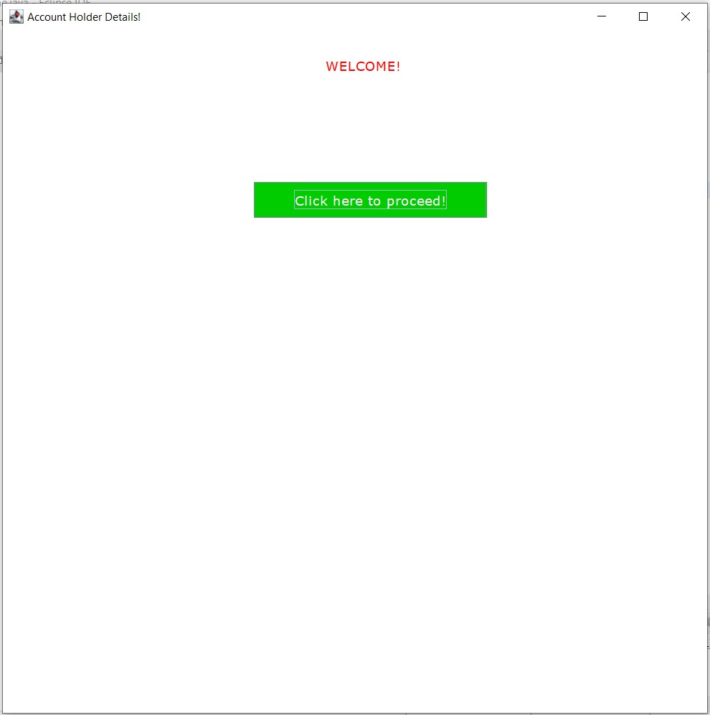

**//Register.java**

**package** com.ahd;

**import** java.awt.Color;

**import** java.awt.Font;

**import** java.awt.event.ActionEvent;

**import** java.awt.event.ActionListener;

**import** java.sql.Connection;

**import** java.sql.DriverManager;

**import** java.sql.PreparedStatement;

**import** java.util.regex.Matcher;

**import** java.util.regex.Pattern;

**import** javax.swing.JButton;

**import** javax.swing.JFrame;

**import** javax.swing.JLabel;

**import** javax.swing.JOptionPane;

**import** javax.swing.JPasswordField;

**import** javax.swing.JTextField;

//Main Class

**public** **class** Register **implements** ActionListener{

//Swing components declaration

**static** JTextField *tf1*;

**static** JPasswordField *pf*;

**static** JLabel *l1*,*l2*,*l3*,*l4*;

**static** JButton *b1*,*b2*,*b3*;

**static** JFrame *f*;

//Constructor

**protected** Register(){

//JFrame object creation

JFrame f = **new** JFrame("Register User");

//JLabel object creation

*l1*=**new** JLabel("WELCOME!");

*l2*=**new** JLabel("Register User");

*l3*=**new** JLabel("Enter Username:");

*l4*=**new** JLabel("Enter Password:");

//Properties of JLabel

*l1*.setBounds(360,-10, 300,100);

*l2*.setBounds(340,10, 300,200);

*l1*.setFont(**new** Font("Verdana", Font.***PLAIN***, 15));

*l1*.setForeground(**new** Color(255, 0, 0));

*l2*.setFont(**new** Font("Verdana", Font.***PLAIN***, 20));

*l2*.setForeground(**new** Color(255, 0, 0));

*l3*.setBounds(130,130, 300,100);

*l3*.setFont(**new** Font("Verdana", Font.***PLAIN***, 15));

*l3*.setForeground(**new** Color(255, 0, 0));

*l4*.setBounds(130,180, 300,100);

*l4*.setFont(**new** Font("Verdana", Font.***PLAIN***, 15));

*l4*.setForeground(**new** Color(255, 0, 0));

//JTextField object creation

*tf1* = **new** JTextField();

*pf* = **new** JPasswordField();

//JTextField properties

*tf1*.setBounds(280,170,250,30);

*pf*.setBounds(280,220,250,30);

//JButton object creation

*b1* = **new** JButton("Register");

*b2* = **new** JButton("Login");

*b3* = **new** JButton("Reset");

//JButton Properties

*b1*.setBounds(295, 290, 100, 40);

*b1*.setFont(**new** Font("Verdana", Font.***PLAIN***, 15));

*b1*.setForeground(**new** Color(255,255,255));

*b1*.setBackground(**new** Color(0,204,0));

*b2*.setBounds(415, 290, 100, 40);

*b2*.setFont(**new** Font("Verdana", Font.***PLAIN***, 15));

*b2*.setForeground(**new** Color(255,255,255));

*b2*.setBackground(**new** Color(0,204,0));

*b3*.setBounds(550, 290, 100, 40);

*b3*.setFont(**new** Font("Verdana", Font.***PLAIN***, 15));

*b3*.setForeground(**new** Color(255,255,255));

*b3*.setBackground(**new** Color(255,0,0));

//Adding and setting components of JFrame

f.add(*tf1*);

f.add(*pf*);

f.add(*l1*);

f.add(*l2*);

f.add(*l3*);

f.add(*l4*);

f.add(*b1*);

f.add(*b2*);

f.add(*b3*);

f.setSize(800,800);

f.setLayout(**null**);

f.setLocationRelativeTo(**null**);

f.getContentPane().setBackground(Color.***WHITE***);

f.setVisible(**true**);

//Button ActionListener

*b1*.addActionListener(**this**);

*b2*.addActionListener(**new** ActionListener(){

**public** **void** actionPerformed(ActionEvent e){

**new** Login();

}

});;

}

//Overridden ActionListener Method

@SuppressWarnings("deprecation")

@Override

**public** **void** actionPerformed(ActionEvent e) {

//if-else block for performing registration operation based on button clicked

**if**(e.getSource()==*b1*) {

**try**{

String txt1,txt2;

txt1 = *tf1*.getText();

txt2 = *pf*.~~getText~~();

//Regular Expression

Pattern pt1 = Pattern.*compile*("[$#@a-zA-Z0-9\\.]{1,20}");

Pattern pt2 = Pattern.*compile*("[a-zA-Z\\.0-9@$#]{8,20}");

Matcher mtr1 = pt1.matcher(txt1);

Matcher mtr2 = pt2.matcher(txt2);

**boolean** matches1 = mtr1.matches();

**boolean** matches2 = mtr2.matches();

//Database Connectivity

Class.*forName*("com.mysql.cj.jdbc.Driver");

Connection con = DriverManager.*getConnection*("jdbc:mysql://localhost:3307/account_holder","root","root");

//Checking Regular Expressions

**if**(matches1 ==**true** && matches2==**true**){

//DML

PreparedStatement ps = con.prepareStatement("insert into registration values(?,?)");

ps.setString(1,txt1);

ps.setString(2,txt2);

ps.executeUpdate();

JOptionPane.*showMessageDialog*(*f*,"User registered successfully!","Alert",JOptionPane.***WARNING_MESSAGE***);

con.close();

}

**else**{

//Error Message

**if**(matches1==**false**){

JOptionPane.*showMessageDialog*(*f*,"Invalid entry! Enter proper Username.","Alert",JOptionPane.***WARNING_MESSAGE***);

}

**else** **if**(matches2==**false**){

JOptionPane.*showMessageDialog*(*f*,"Invalid entry! Enter proper Password.","Alert",JOptionPane.***WARNING_MESSAGE***);

}

}

}

**catch**(Exception e1){

System.***out***.println(e1);

}

}

**else** **if**(e.getSource()==*b3*) {

*tf1*.setText("");

*pf*.setText("");

}

**else** {

System.***out***.println("Error");

}

}

//Main method

**public** **static** **void** main(String[] args) {

//Call to constructor

**new** Register();

}

}

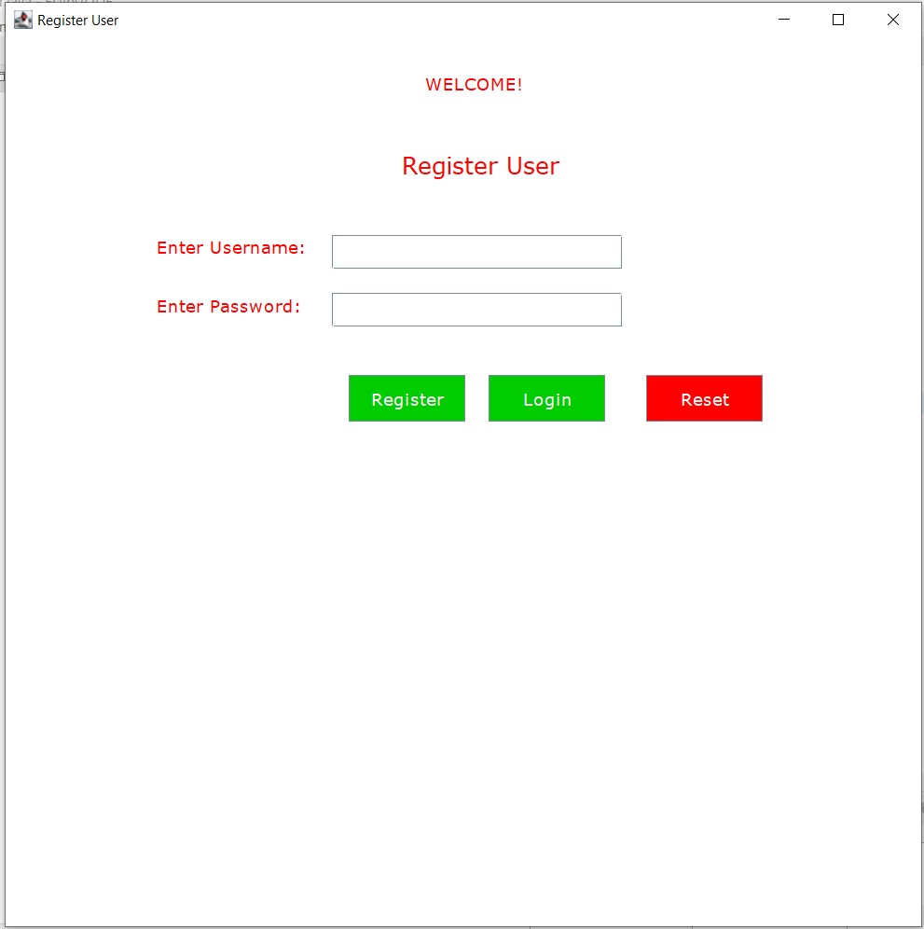

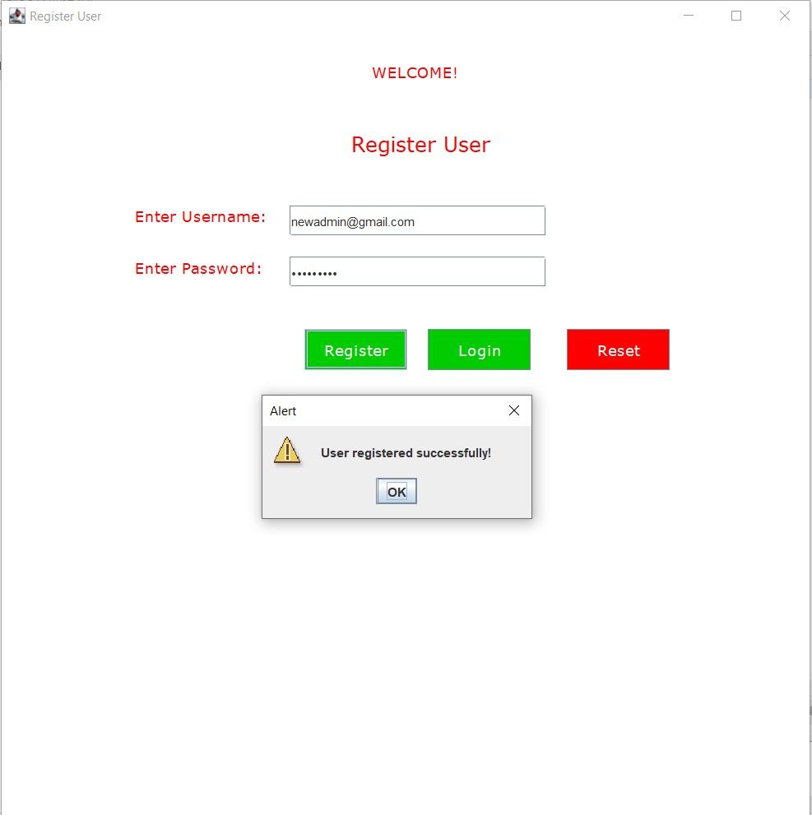

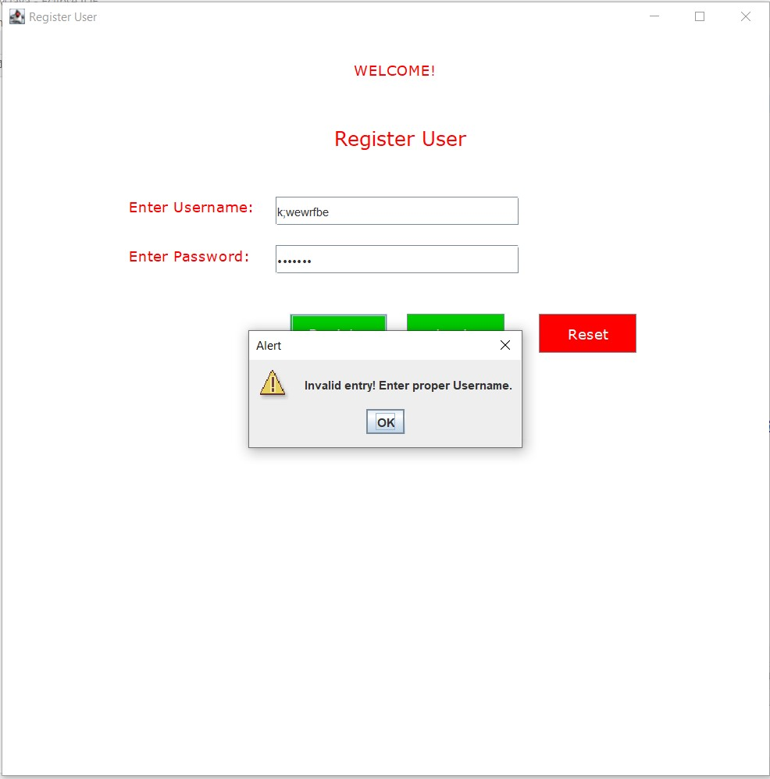

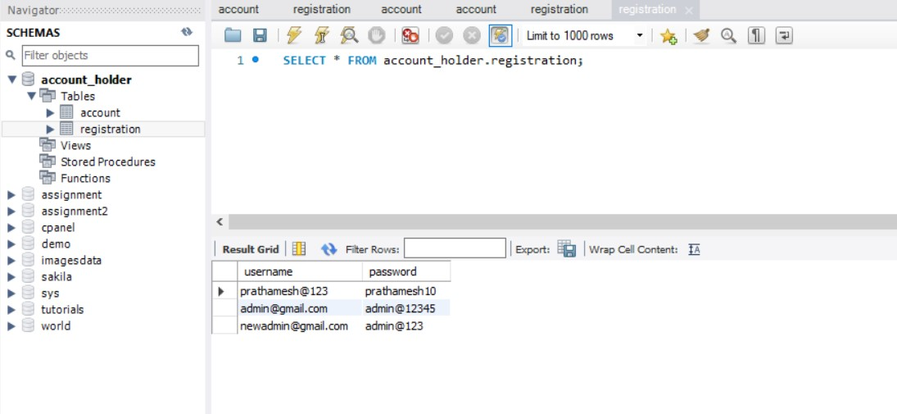

**//Login.java**

**package** com.ahd;

**import** java.awt.Color;

**import** java.awt.Font;

**import** java.awt.event.ActionEvent;

**import** java.awt.event.ActionListener;

**import** java.sql.Connection;

**import** java.sql.DriverManager;

**import** java.sql.PreparedStatement;

**import** java.sql.ResultSet;

**import** java.util.regex.Matcher;

**import** java.util.regex.Pattern;

**import** javax.swing.JButton;

**import** javax.swing.JFrame;

**import** javax.swing.JLabel;

**import** javax.swing.JOptionPane;

**import** javax.swing.JPasswordField;

**import** javax.swing.JTextField;

//Main Class

**public** **class** Login **implements** ActionListener{

//Swing Components declaration

**static** JTextField *tf1*;

**static** JPasswordField *pf*;

**static** JLabel *l1*,*l2*,*l3*,*l4*;

**static** JButton *b1*,*b2*,*b3*;

**static** JFrame *f*;

//Constructor

**protected** Login(){

//JFrame object creation

JFrame f = **new** JFrame("User Login");

//JLabel object creation

*l1*=**new** JLabel("WELCOME!");

*l2*=**new** JLabel("User Login");

*l3*=**new** JLabel("Enter Username:");

*l4*=**new** JLabel("Enter Password:");

//JTextField object creation

*tf1* = **new** JTextField();

*pf* = **new** JPasswordField();

//JButton object creation

*b1* = **new** JButton("Login");

*b2* = **new** JButton("Register");

*b3* = **new** JButton("Reset");

//JLabel properties

*l1*.setBounds(360,-10, 300,100);

*l1*.setFont(**new** Font("Verdana", Font.***PLAIN***, 15));

*l1*.setForeground(**new** Color(255, 0, 0));

*l2*.setBounds(350,10, 300,200);

*l2*.setFont(**new** Font("Verdana", Font.***PLAIN***, 20));

*l2*.setForeground(**new** Color(255, 0, 0));

*l3*.setBounds(130,130, 300,100);

*l3*.setFont(**new** Font("Verdana", Font.***PLAIN***, 15));

*l3*.setForeground(**new** Color(255, 0, 0));

*l4*.setBounds(130,180, 300,100);

*l4*.setFont(**new** Font("Verdana", Font.***PLAIN***, 15));

*l4*.setForeground(**new** Color(255, 0, 0));

//JTextField properties

*tf1*.setBounds(280,170,250,30);

*pf*.setBounds(280,220,250,30);

//JButton Properties

*b1*.setBounds(295, 290, 100, 40);

*b1*.setFont(**new** Font("Verdana", Font.***PLAIN***, 15));

*b1*.setForeground(**new** Color(255,255,255));

*b1*.setBackground(**new** Color(0,204,0));

*b2*.setBounds(415, 290, 100, 40);

*b2*.setFont(**new** Font("Verdana", Font.***PLAIN***, 15));

*b2*.setForeground(**new** Color(255,255,255));

*b2*.setBackground(**new** Color(0,204,0));

*b3*.setBounds(550, 290, 100, 40);

*b3*.setFont(**new** Font("Verdana", Font.***PLAIN***, 15));

*b3*.setForeground(**new** Color(255,255,255));

*b3*.setBackground(**new** Color(255,0,0));

//Adding and setting components to JFrame

f.add(*tf1*);

f.add(*pf*);

f.add(*l1*);

f.add(*l2*);

f.add(*l3*);

f.add(*l4*);

f.add(*b1*);

f.add(*b2*);

f.add(*b3*);

f.setSize(800,800);

f.setLayout(**null**);

f.setLocationRelativeTo(**null**);

f.getContentPane().setBackground(Color.***WHITE***);

f.setVisible(**true**);

//ActionListener for Butttons

*b1*.addActionListener(**this**);

*b2*.addActionListener(**new** ActionListener(){

**public** **void** actionPerformed(ActionEvent e){

**new** Register();

}

});;

*b3*.addActionListener(**this**);

}

//Overridden method for ActionListener

@SuppressWarnings("deprecation")

@Override

**public** **void** actionPerformed(ActionEvent e) {

//if-else block for performing registration operation based on button clicked

**if**(e.getSource()==*b1*) {

**try**{

String txt1,txt2;

txt1 = *tf1*.getText();

txt2 = *pf*.~~getText~~();

//Regular Expression

Pattern pt1 = Pattern.*compile*("[$#@a-zA-Z0-9\\.]{1,20}");

Pattern pt2 = Pattern.*compile*("[a-zA-Z\\.0-9@$#]{8,20}");

Matcher mtr1 = pt1.matcher(txt1);

Matcher mtr2 = pt2.matcher(txt2);

**boolean** matches1 = mtr1.matches();

**boolean** matches2 = mtr2.matches();

//Database Connectivity

Class.*forName*("com.mysql.cj.jdbc.Driver");

Connection con = DriverManager.*getConnection*("jdbc:mysql://localhost:3307/account_holder","root","root");

//Checking Regular Expressions

**if**(matches1 ==**true** && matches2==**true**){

//DML

PreparedStatement ps = con.prepareStatement("select username,password from registration where username=? and password=?");

ps.setString(1,txt1);

ps.setString(2,txt2);

ResultSet rs = ps.executeQuery();

//Opening create account page after login

**if**(rs.next()) {

**new** CAccount();

}

**else** {

JOptionPane.*showMessageDialog*(*f*,"User not found!","Alert",JOptionPane.***WARNING_MESSAGE***);

}

con.close();

}

**else**{

//Error Message

**if**(matches1==**false**){

JOptionPane.*showMessageDialog*(*f*,"Invalid entry! Enter proper Username.","Alert",JOptionPane.***WARNING_MESSAGE***);

}

**else** **if**(matches2==**false**){

JOptionPane.*showMessageDialog*(*f*,"Invalid entry! Enter proper Password.","Alert",JOptionPane.***WARNING_MESSAGE***);

}

}

}

**catch**(Exception e1){

System.***out***.println(e1);

}

}

**else** **if**(e.getSource()==*b3*) {

*tf1*.setText("");

*pf*.setText("");

}

**else** {

System.***out***.println("Error");

}

}

//Main method

**public** **static** **void** main(String[] args) {

//Call to constructor

**new** Login();

}

}

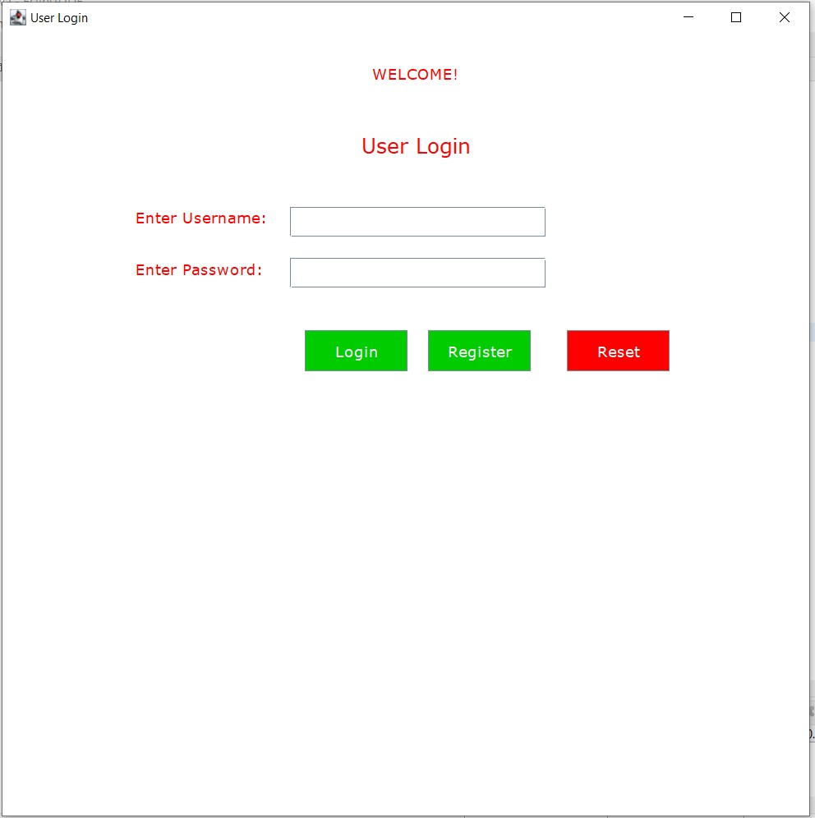

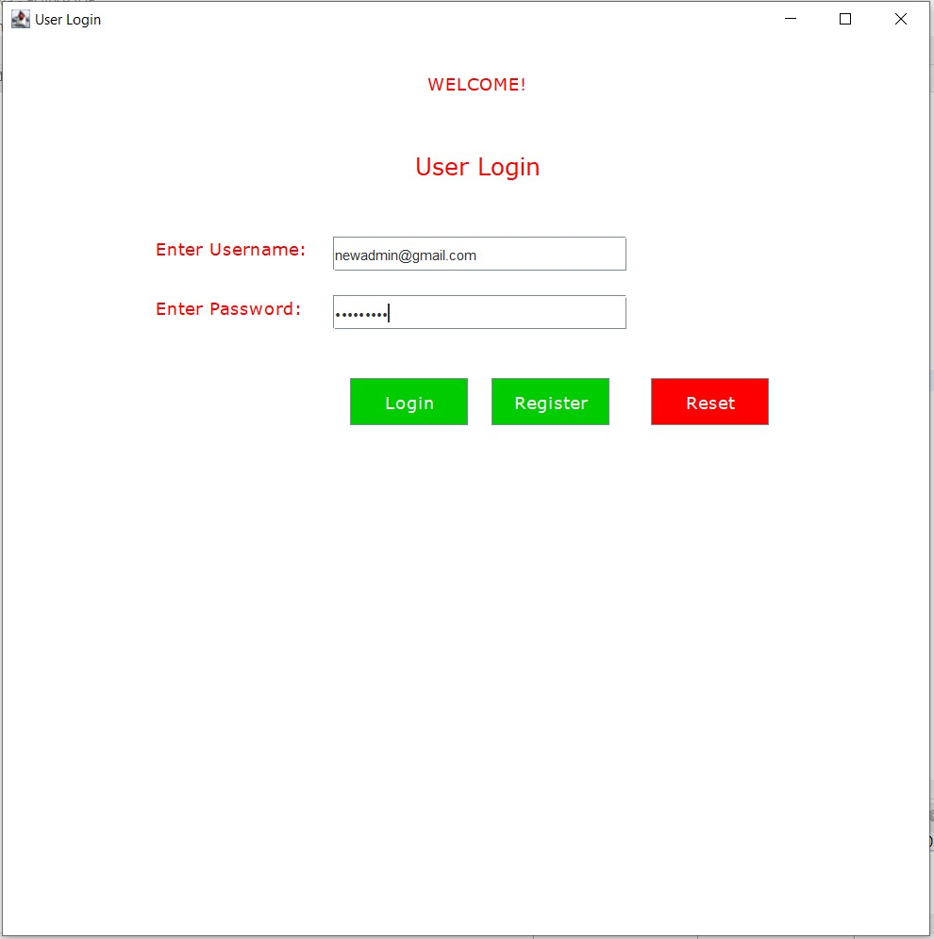

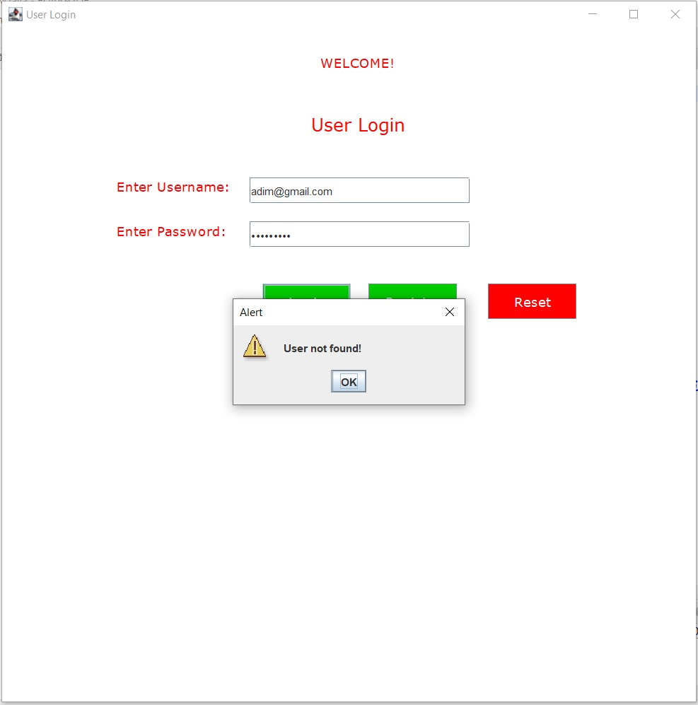

**//CAccount.java**

**package** com.ahd;

**import** java.awt.Color;

**import** java.awt.Font;

**import** java.awt.event.ActionEvent;

**import** java.awt.event.ActionListener;

**import** java.sql.Connection;

**import** java.sql.DriverManager;

**import** java.sql.PreparedStatement;

**import** java.util.regex.Matcher;

**import** java.util.regex.Pattern;

**import** javax.swing.JButton;

**import** javax.swing.JFrame;

**import** javax.swing.JLabel;

**import** javax.swing.JMenu;

**import** javax.swing.JMenuBar;

**import** javax.swing.JMenuItem;

**import** javax.swing.JOptionPane;

**import** javax.swing.JTextField;

//Main Class

**public** **class** CAccount **implements** ActionListener {

//Declaring Swing Components

**static** JTextField *tf1*,*tf2*,*tf3*,*tf4*,*tf5*,*tf6*,*tf7*;

**static** JLabel *l1*,*l2*,*l3*,*l4*,*l5*,*l6*,*l7*,*l8*,*l9*;

**static** JMenu *menu*,*menu2*;

**static** JMenuBar *mb*;

**static** JMenuItem *item1*, *item2*, *item3*, *item4*,*item01*,*item02*,*item03*,*item04*,*item05*,*item06*,*item07*;

**static** JButton *b1*,*b2*;

**static** JFrame *f*;

//Constructor

**protected** CAccount(){

//JFrame object creation

JFrame f = **new** JFrame("CREATE ACCOUNT");

//JMenuBar object creation

*mb*=**new** JMenuBar();

//JMenu object creation

*menu*=**new** JMenu("Menu");

//JMenuItem object creation

*item1*=**new** JMenuItem("CREATE ACCOUNT");

*item2*=**new** JMenuItem("UPDATE ACCOUNT");

*item3*=**new** JMenuItem("DELETE ACCOUNT");

*item4*=**new** JMenuItem("RETRIEVE ACCOUNT");

//JLabel object creation

*l1*=**new** JLabel("WELCOME!");

*l2*=**new** JLabel("CREATE ACCOUNT");

*l3*=**new** JLabel("Enter Account ID:");

*l4*=**new** JLabel("Enter Name:");

*l5*=**new** JLabel("Enter Mobile No.:");

*l6*=**new** JLabel("Enter Email ID:");

*l7*=**new** JLabel("Enter Address:");

*l8*=**new** JLabel("Enter Gender:");

*l9*=**new** JLabel("Enter DOB:");

//JTextField object creation

*tf1* = **new** JTextField("e.g. 101,ABC101,abc");

*tf2* = **new** JTextField("e.g. Sam Curran");

*tf3* = **new** JTextField("e.g. 9897969594");

*tf4* = **new** JTextField("e.g. abc@gmail.com");

*tf5* = **new** JTextField("e.g. Mumbai");

*tf6* = **new** JTextField("e.g. MALE,Female,Transgender");

*tf7* = **new** JTextField("e.g. 01/01/2022");

//JButton object creation

*b1* = **new** JButton("Submit");

*b2* = **new** JButton("Reset");

//JLabel Properties

*l1*.setBounds(360,-10, 300,100);

*l1*.setFont(**new** Font("Verdana", Font.***PLAIN***, 15));

*l1*.setForeground(**new** Color(255, 0, 0));

*l2*.setBounds(310,10, 300,200);

*l2*.setFont(**new** Font("Verdana", Font.***PLAIN***, 20));

*l2*.setForeground(**new** Color(255, 0, 0));

*l3*.setBounds(130,130, 300,100);

*l3*.setFont(**new** Font("Verdana", Font.***PLAIN***, 15));

*l3*.setForeground(**new** Color(255, 0, 0));

*l4*.setBounds(130,180, 300,100);

*l4*.setFont(**new** Font("Verdana", Font.***PLAIN***, 15));

*l4*.setForeground(**new** Color(255, 0, 0));

*l5*.setBounds(130,230, 300,100);

*l5*.setFont(**new** Font("Verdana", Font.***PLAIN***, 15));

*l5*.setForeground(**new** Color(255, 0, 0));

*l6*.setBounds(130,280, 300,100);

*l6*.setFont(**new** Font("Verdana", Font.***PLAIN***, 15));

*l6*.setForeground(**new** Color(255, 0, 0));

*l7*.setBounds(130,330, 300,100);

*l7*.setFont(**new** Font("Verdana", Font.***PLAIN***, 15));

*l7*.setForeground(**new** Color(255, 0, 0));

*l8*.setBounds(130,380, 300,100);

*l8*.setFont(**new** Font("Verdana", Font.***PLAIN***, 15));

*l8*.setForeground(**new** Color(255, 0, 0));

*l9*.setBounds(130,430, 300,100);

*l9*.setFont(**new** Font("Verdana", Font.***PLAIN***, 15));

*l9*.setForeground(**new** Color(255, 0, 0));

//JTextField properties

*tf1*.setBounds(280,170,250,30);

*tf2*.setBounds(280,220,250,30);

*tf3*.setBounds(280,270,250,30);

*tf4*.setBounds(280,320,250,30);

*tf5*.setBounds(280,370,250,30);

*tf6*.setBounds(280,420,250,30);

*tf7*.setBounds(280,470,250,30);

//JButton properties

*b1*.setBounds(285, 550, 130, 40);

*b1*.setFont(**new** Font("Verdana", Font.***PLAIN***, 15));

*b1*.setForeground(**new** Color(255,255,255));

*b1*.setBackground(**new** Color(0,204,0));

*b2*.setBounds(420, 550, 100, 40);

*b2*.setFont(**new** Font("Verdana", Font.***PLAIN***, 15));

*b2*.setForeground(**new** Color(255,255,255));

*b2*.setBackground(**new** Color(255,0,0));

//Adding items to menu and menu bar

*menu*.add(*item1*);

*menu*.add(*item2*);

*menu*.add(*item3*);

*menu*.add(*item4*);

*mb*.add(*menu*);

//Adding and setting JFrame components

f.add(*tf1*);

f.add(*tf2*);

f.add(*tf3*);

f.add(*tf4*);

f.add(*tf5*);

f.add(*tf6*);

f.add(*tf7*);

f.add(*l1*);

f.add(*l2*);

f.add(*l3*);

f.add(*l4*);

f.add(*l5*);

f.add(*l6*);

f.add(*l7*);

f.add(*l8*);

f.add(*l9*);

f.add(*b1*);

f.add(*b2*);

f.setSize(800,800);

f.setLayout(**null**);

f.setLocationRelativeTo(**null**);

f.getContentPane().setBackground(Color.***WHITE***);

f.setJMenuBar(*mb*);

f.setVisible(**true**);

//ActionListener for Menu

*item1*.addActionListener(**new** ActionListener(){

**public** **void** actionPerformed(ActionEvent e){

**new** CAccount();

}

});;

*item2*.addActionListener(**new** ActionListener(){

**public** **void** actionPerformed(ActionEvent e){

**new** UAccount();

}

});

*item3*.addActionListener(**new** ActionListener(){

**public** **void** actionPerformed(ActionEvent e){

**new** DAccount();

}

});

*item4*.addActionListener(**new** ActionListener(){

**public** **void** actionPerformed(ActionEvent e){

**new** RAccount();

}

});

//ActionListener for buttons

*b1*.addActionListener(**this**);

*b2*.addActionListener(**this**);

}

//Overridden method for ActionListener

@Override

**public** **void** actionPerformed(ActionEvent e) {

//if-else loop performing operation depending on button clicked

**if**(e.getSource()==*b1*) {

**try**{

String txt1,txt2,txt3,txt4,txt5,txt6,txt7;

txt1 = *tf1*.getText();

txt2 = *tf2*.getText();

txt3 = *tf3*.getText();

txt4 = *tf4*.getText();

txt5 = *tf5*.getText();

txt6 = *tf6*.getText();

txt7 = *tf7*.getText();

//Regular Expressions

Pattern pt1 = Pattern.*compile*("^[a-zA-Z0-9]{1,10}$");

Pattern pt2 = Pattern.*compile*("^[a-zA-Z. ]{2,50}$");

Pattern pt3 = Pattern.*compile*("[6-9]{1}[0-9]{9}");

Pattern pt4 = Pattern.*compile*("^[a-z0-9]+@[a-z]+\\.[a-z]{2,3}$");

Pattern pt5 = Pattern.*compile*("^[a-zA-Z. ,0-9]{2,50}$");

Pattern pt6 = Pattern.*compile*("^(male)|(Male)|(MALE)|(Female)|(FEMALE)|(female)|(Transgender)|(TRANSGENDER)|(transgender)|$");

Pattern pt7 = Pattern.*compile*("^(1[0-2]|0[1-9])\\/(3[01]|[12][0-9]|0[1-9])\\/[0-9]{4}$");

Matcher mtr1 = pt1.matcher(txt1);

Matcher mtr2 = pt2.matcher(txt2);

Matcher mtr3 = pt3.matcher(txt3);

Matcher mtr4 = pt4.matcher(txt4);

Matcher mtr5 = pt5.matcher(txt5);

Matcher mtr6 = pt6.matcher(txt6);

Matcher mtr7 = pt7.matcher(txt7);

**boolean** matches1 = mtr1.matches();

**boolean** matches2 = mtr2.matches();

**boolean** matches3 = mtr3.matches();

**boolean** matches4 = mtr4.matches();

**boolean** matches5 = mtr5.matches();

**boolean** matches6 = mtr6.matches();

**boolean** matches7 = mtr7.matches();

//Database Connectivity

Class.*forName*("com.mysql.cj.jdbc.Driver");

Connection con = DriverManager.*getConnection*("jdbc:mysql://localhost:3307/account_holder","root","root");

//Checking Regular Expressions

**if**(matches1==**true** && matches2==**true** && matches3==**true** && matches4==**true** && matches5==**true** && matches6==**true** && matches7==**true**) {

//DML

PreparedStatement ps = con.prepareStatement("insert into account values(?,?,?,?,?,?,?)");

ps.setString(1,txt1);

ps.setString(2,txt2);

ps.setString(3,txt3);

ps.setString(4,txt4);

ps.setString(5,txt5);

ps.setString(6,txt6);

ps.setString(7,txt7);

ps.executeUpdate();

JOptionPane.*showMessageDialog*(*f*,"Account created successfully!","Alert",JOptionPane.***WARNING_MESSAGE***);

}

**else** {

//Error Message

JOptionPane.*showMessageDialog*(*f*,"Invalid entry! Re-Enter data.","Alert",JOptionPane.***WARNING_MESSAGE***);

**if**(matches1==**false**){

JOptionPane.*showMessageDialog*(*f*,"Invalid ID!","Alert",JOptionPane.***WARNING_MESSAGE***);

}

**else** **if**(matches2==**false**){

JOptionPane.*showMessageDialog*(*f*,"Invalid Name!","Alert",JOptionPane.***WARNING_MESSAGE***);

}

**else** **if**(matches3==**false**){

JOptionPane.*showMessageDialog*(*f*,"Invalid Mobile!","Alert",JOptionPane.***WARNING_MESSAGE***);

}

**else** **if**(matches4==**false**){

JOptionPane.*showMessageDialog*(*f*,"Invalid Email!","Alert",JOptionPane.***WARNING_MESSAGE***);

}

**else** **if**(matches5==**false**){

JOptionPane.*showMessageDialog*(*f*,"Invalid Address!","Alert",JOptionPane.***WARNING_MESSAGE***);

}

**else** **if**(matches6==**false**){

JOptionPane.*showMessageDialog*(*f*,"Invalid Gender!","Alert",JOptionPane.***WARNING_MESSAGE***);

}

**else** **if**(matches7==**false**){

JOptionPane.*showMessageDialog*(*f*,"Invalid DOB!","Alert",JOptionPane.***WARNING_MESSAGE***);

}

**else** {

System.***out***.println("error");

}

}

con.close();

}

**catch**(Exception e1){

System.***out***.println(e1);

}

}

//Logic for Reset

**else** **if**(e.getSource()==*b2*) {

*tf1*.setText("");

*tf2*.setText("");

*tf3*.setText("");

*tf4*.setText("");

*tf5*.setText("");

*tf6*.setText("");

*tf7*.setText("");

}

**else** {

System.***out***.println("Error");

}

}

//Main method

**public** **static** **void** main(String args[]) {

//Call to constructor

**new** CAccount();

}

}

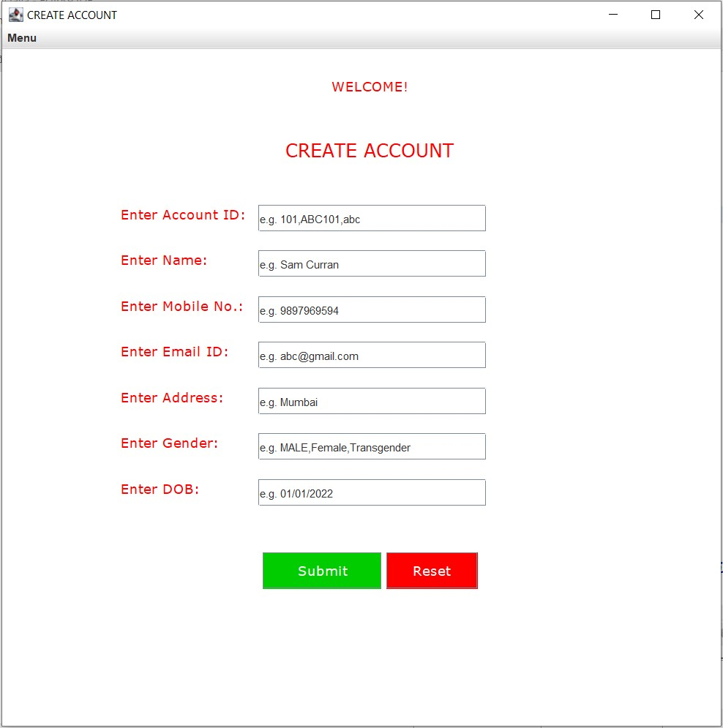

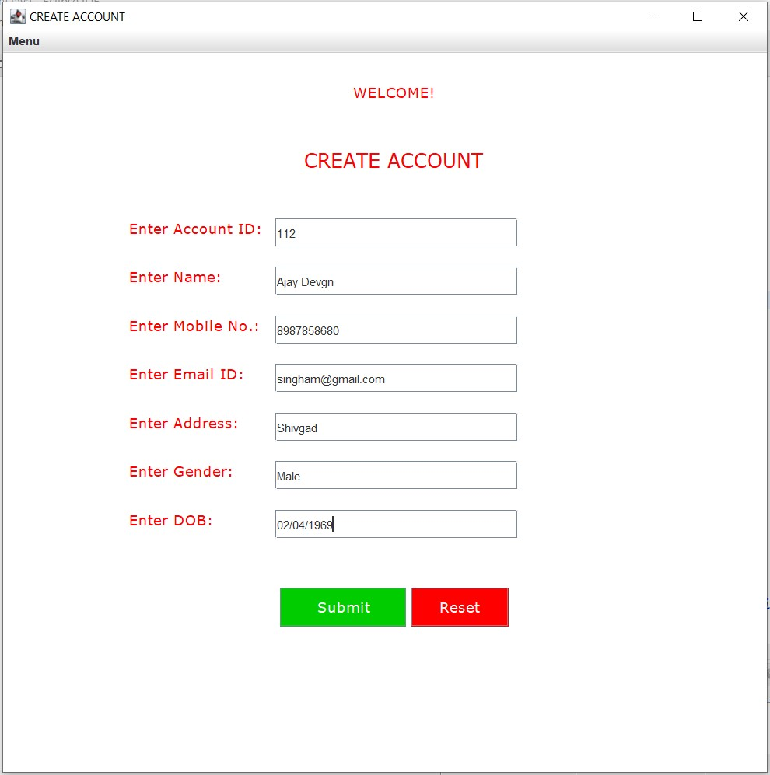

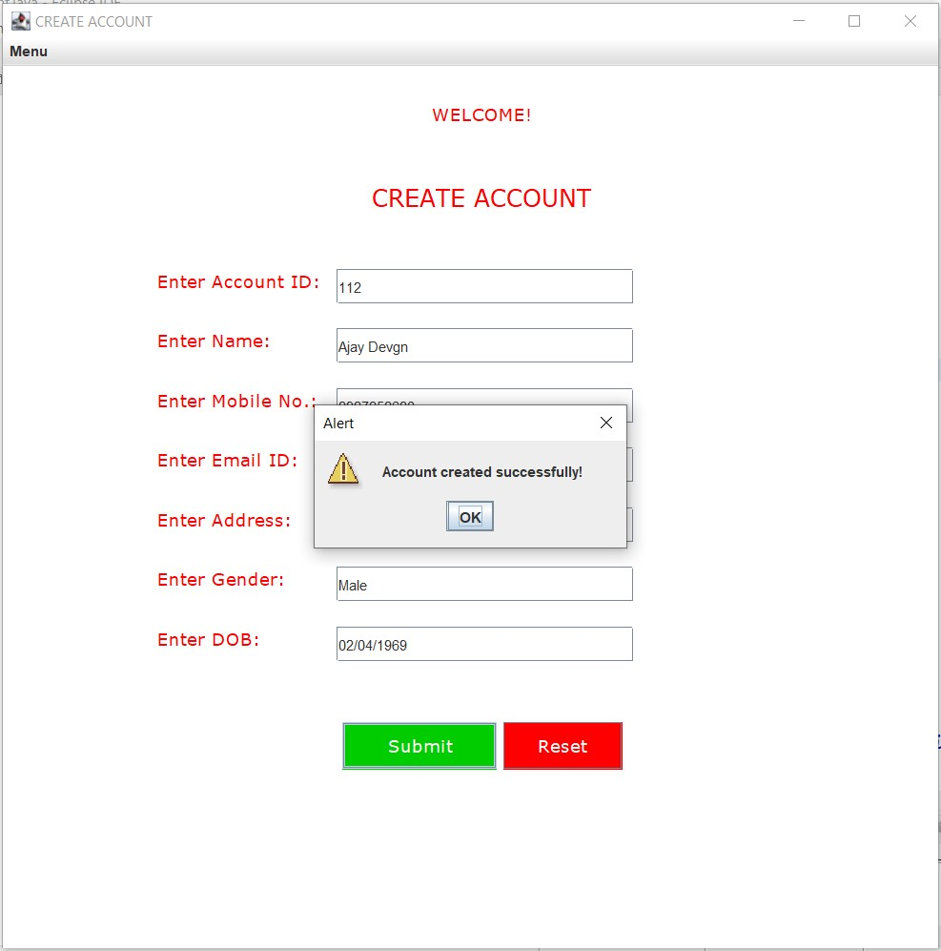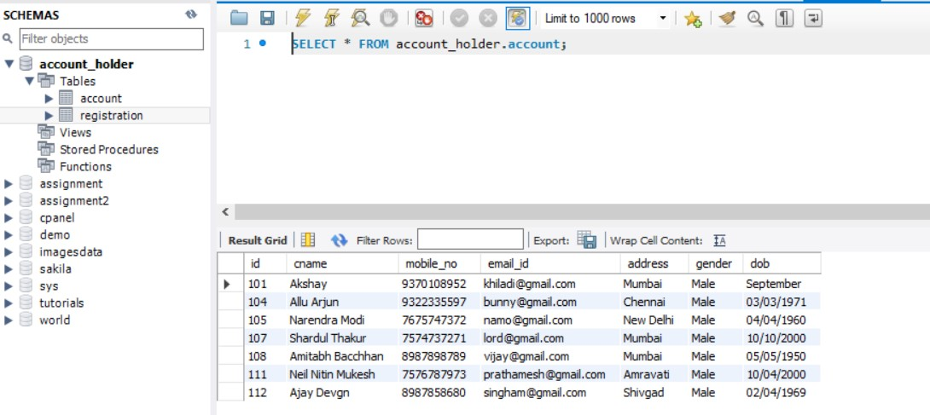

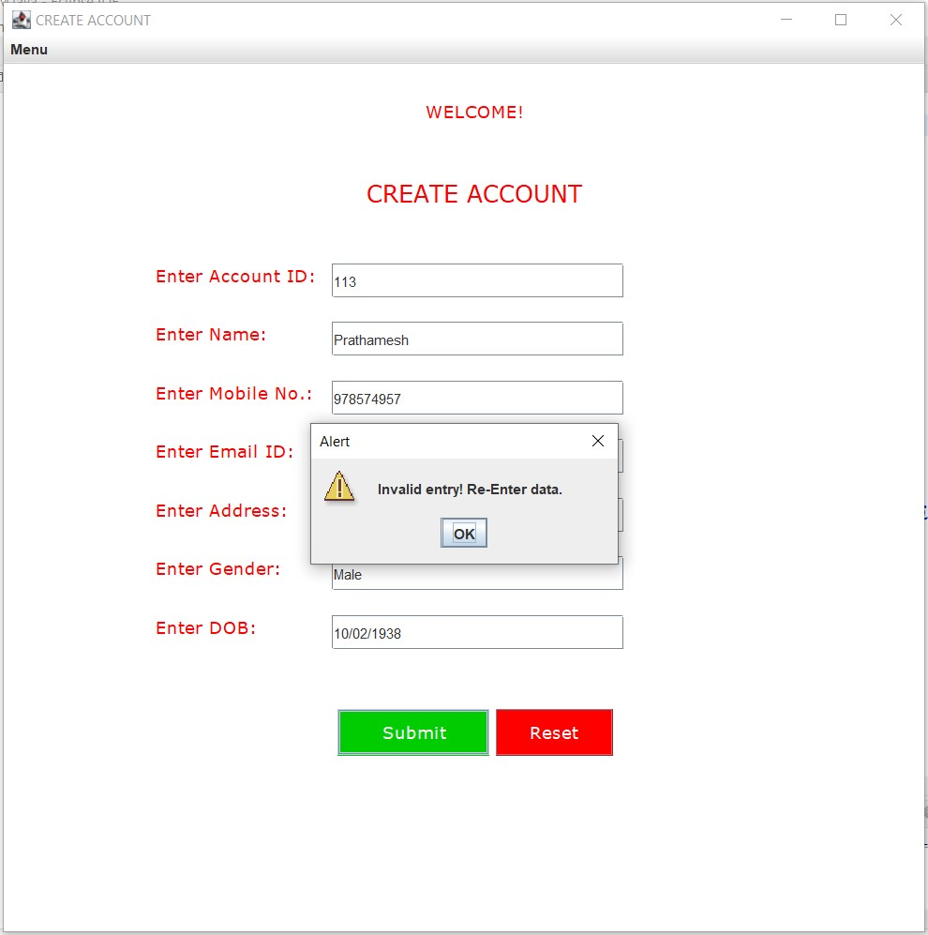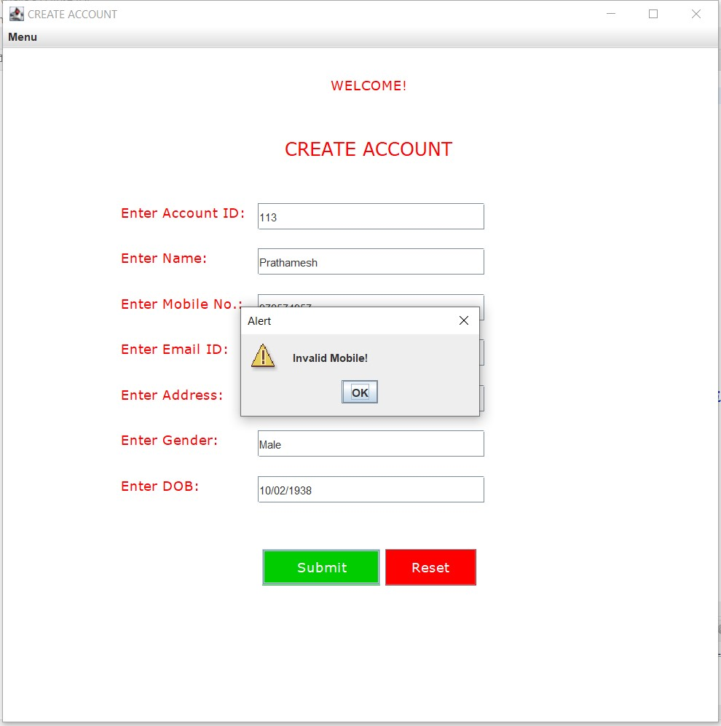

**//UAccount.java**

**package** com.ahd;

**import** java.awt.Color;

**import** java.awt.Font;

**import** java.awt.event.ActionEvent;

**import** java.awt.event.ActionListener;

**import** java.sql.Connection;

**import** java.sql.DriverManager;

**import** java.sql.PreparedStatement;

**import** java.util.regex.Matcher;

**import** java.util.regex.Pattern;

**import** javax.swing.JButton;

**import** javax.swing.JFrame;

**import** javax.swing.JLabel;

**import** javax.swing.JMenu;

**import** javax.swing.JMenuBar;

**import** javax.swing.JMenuItem;

**import** javax.swing.JOptionPane;

**import** javax.swing.JTextField;

//Main Class

**public** **class** UAccount **implements** ActionListener{

//Declaring Swing Components

**static** JTextField *tf1*,*tf2*,*tf3*,*tf4*,*tf5*,*tf6*,*tf7*;

**static** JLabel *l1*,*l2*,*l3*,*l4*,*l5*,*l6*,*l7*,*l8*,*l9*;

**static** JMenu *menu*,*menu2*;

**static** JMenuBar *mb*;

**static** JMenuItem *item1*, *item2*, *item3*, *item4*,*item01*,*item02*,*item03*,*item04*,*item05*,*item06*,*item07*;

**static** JButton *b1*,*b2*;

**static** JFrame *f*;

//Constructor

**protected** UAccount(){

//JFrame object creation

*f* = **new** JFrame("UPDATE ACCOUNT");

//JLabel object creation

*l1*=**new** JLabel("WELCOME!");

*l2*=**new** JLabel("UPDATE ACCOUNT");

*l3*=**new** JLabel("Enter Account ID:");

*l4*=**new** JLabel("Enter Name:");

*l5*=**new** JLabel("Enter Mobile No.:");

*l6*=**new** JLabel("Enter Email ID:");

*l7*=**new** JLabel("Enter Address:");

*l8*=**new** JLabel("Enter Gender:");

*l9*=**new** JLabel("Enter DOB:");

//JMenuBar object creation

*mb*=**new** JMenuBar();

//JMenu object creation

*menu*=**new** JMenu("Menu");

*menu2*=**new** JMenu("UPDATE");

//JMenuItem object creation

*item1*=**new** JMenuItem("CREATE ACCOUNT");

*item2*=**new** JMenuItem("UPDATE ACCOUNT");

*item3*=**new** JMenuItem("DELETE ACCOUNT");

*item4*=**new** JMenuItem("RETRIEVE ACCOUNT");

*item01*=**new** JMenuItem("Update ID");

*item02*=**new** JMenuItem("Update Name");

*item03*=**new** JMenuItem("Update Mobile");

*item04*=**new** JMenuItem("Update Email");

*item05*=**new** JMenuItem("Update Address");

*item06*=**new** JMenuItem("Update Gender");

*item07*=**new** JMenuItem("Update DOB");

//JTextField object creation

*tf1* = **new** JTextField("e.g. 101,ABC101,abc");

*tf2* = **new** JTextField("e.g. Sam Curran");

*tf3* = **new** JTextField("e.g. 9897969594");

*tf4* = **new** JTextField("e.g. abc@gmail.com");

*tf5* = **new** JTextField("e.g. Mumbai");

*tf6* = **new** JTextField("e.g. MALE,Female,Transgender");

*tf7* = **new** JTextField("e.g. 01/01/2022");

//JLabel properties

*l1*.setBounds(360,-10, 300,100);

*l1*.setFont(**new** Font("Verdana", Font.***PLAIN***, 15));

*l1*.setForeground(**new** Color(255, 0, 0));

*l2*.setBounds(310,10, 300,200);

*l2*.setFont(**new** Font("Verdana", Font.***PLAIN***, 20));

*l2*.setForeground(**new** Color(255, 0, 0));

*l3*.setBounds(130,130, 300,100);

*l3*.setFont(**new** Font("Verdana", Font.***PLAIN***, 15));

*l3*.setForeground(**new** Color(255, 0, 0));

*l4*.setBounds(130,180, 300,100);

*l4*.setFont(**new** Font("Verdana", Font.***PLAIN***, 15));

*l4*.setForeground(**new** Color(255, 0, 0));

*l5*.setBounds(130,230, 300,100);

*l5*.setFont(**new** Font("Verdana", Font.***PLAIN***, 15));

*l5*.setForeground(**new** Color(255, 0, 0));

*l6*.setBounds(130,280, 300,100);

*l6*.setFont(**new** Font("Verdana", Font.***PLAIN***, 15));

*l6*.setForeground(**new** Color(255, 0, 0));

*l7*.setBounds(130,330, 300,100);

*l7*.setFont(**new** Font("Verdana", Font.***PLAIN***, 15));

*l7*.setForeground(**new** Color(255, 0, 0));

*l8*.setBounds(130,380, 300,100);

*l8*.setFont(**new** Font("Verdana", Font.***PLAIN***, 15));

*l8*.setForeground(**new** Color(255, 0, 0));

*l9*.setBounds(130,430, 300,100);

*l9*.setFont(**new** Font("Verdana", Font.***PLAIN***, 15));

*l9*.setForeground(**new** Color(255, 0, 0));

//JTextField properties

*tf1*.setBounds(280,170,250,30);

*tf2*.setBounds(280,220,250,30);

*tf3*.setBounds(280,270,250,30);

*tf4*.setBounds(280,320,250,30);

*tf5*.setBounds(280,370,250,30);

*tf6*.setBounds(280,420,250,30);

*tf7*.setBounds(280,470,250,30);

//Adding menu and menu items

*menu*.add(*item1*);

*menu*.add(*item2*);

*menu*.add(*item3*);

*menu*.add(*item4*);

*menu2*.add(*item01*);

*menu2*.add(*item02*);

*menu2*.add(*item03*);

*menu2*.add(*item04*);

*menu2*.add(*item05*);

*menu2*.add(*item06*);

*menu2*.add(*item07*);

*mb*.add(*menu*);

*mb*.add(*menu2*);

//JButton object creation

*b1* = **new** JButton("UPDATE ALL");

*b2* = **new** JButton("Reset");

//JButton properties

*b1*.setBounds(285, 550, 130, 40);

*b1*.setFont(**new** Font("Verdana", Font.***PLAIN***, 15));

*b1*.setForeground(**new** Color(255,255,255));

*b1*.setBackground(**new** Color(0,204,0));

*b2*.setBounds(420, 550, 100, 40);

*b2*.setFont(**new** Font("Verdana", Font.***PLAIN***, 15));

*b2*.setForeground(**new** Color(255,255,255));

*b2*.setBackground(**new** Color(255,0,0));

//Adding and setting components of JFrame

*f*.add(*tf1*);

*f*.add(*tf2*);

*f*.add(*tf3*);

*f*.add(*tf4*);

*f*.add(*tf5*);

*f*.add(*tf6*);

*f*.add(*tf7*);

*f*.add(*l1*);

*f*.add(*l2*);

*f*.add(*l3*);

*f*.add(*l4*);

*f*.add(*l5*);

*f*.add(*l6*);

*f*.add(*l7*);

*f*.add(*l8*);

*f*.add(*l9*);

*f*.add(*b1*);

*f*.add(*b2*);

*f*.setSize(800,800);

*f*.setLayout(**null**);

*f*.setLocationRelativeTo(**null**);

*f*.getContentPane().setBackground(Color.***WHITE***);

*f*.setJMenuBar(*mb*);

*f*.setVisible(**true**);

//ActionListener for Menu

*item1*.addActionListener(**new** ActionListener(){

**public** **void** actionPerformed(ActionEvent e){

**new** CAccount();

}

});;

*item2*.addActionListener(**new** ActionListener(){

**public** **void** actionPerformed(ActionEvent e){

**new** UAccount();

}

});

*item3*.addActionListener(**new** ActionListener(){

**public** **void** actionPerformed(ActionEvent e){

**new** DAccount();

}

});

*item4*.addActionListener(**new** ActionListener(){

**public** **void** actionPerformed(ActionEvent e){

**new** RAccount();

}

});

*item01*.addActionListener(**new** ActionListener(){

**public** **void** actionPerformed(ActionEvent e){

**new** UpdateI();

}

});;

*item02*.addActionListener(**new** ActionListener(){

**public** **void** actionPerformed(ActionEvent e){

**new** UpdateN();

}

});

*item03*.addActionListener(**new** ActionListener(){

**public** **void** actionPerformed(ActionEvent e){

**new** UpdateM();

}

});

*item04*.addActionListener(**new** ActionListener(){

**public** **void** actionPerformed(ActionEvent e){

**new** UpdateE();

}

});

*item05*.addActionListener(**new** ActionListener(){

**public** **void** actionPerformed(ActionEvent e){

**new** UpdateA();

}

});;

*item06*.addActionListener(**new** ActionListener(){

**public** **void** actionPerformed(ActionEvent e){

**new** UpdateG();

}

});

*item07*.addActionListener(**new** ActionListener(){

**public** **void** actionPerformed(ActionEvent e){

**new** UpdateD();

}

});

//ActionListener for JButtons

*b1*.addActionListener(**this**);

*b2*.addActionListener(**this**);

}

//Overridden method for ActionListener

@Override

**public** **void** actionPerformed(ActionEvent e) {

//if else condition for performing action depending on button clicked

**if**(e.getSource()==*b1*) {

**try**{

String txt1,txt2,txt3,txt4,txt5,txt6,txt7;

txt1 = *tf1*.getText();

txt2 = *tf2*.getText();

txt3 = *tf3*.getText();

txt4 = *tf4*.getText();

txt5 = *tf5*.getText();

txt6 = *tf6*.getText();

txt7 = *tf7*.getText();

//Regular Expression

Pattern pt1 = Pattern.*compile*("^[a-zA-Z0-9]{1,10}$");

Pattern pt2 = Pattern.*compile*("^[a-zA-Z. ]{2,50}$");

Pattern pt3 = Pattern.*compile*("[6-9]{1}[0-9]{9}");

Pattern pt4 = Pattern.*compile*("^[a-z0-9]+@[a-z]+\\.[a-z]{2,3}$");

Pattern pt5 = Pattern.*compile*("^[a-zA-Z. ,0-9]{2,50}$");

Pattern pt6 = Pattern.*compile*("^(male)|(Male)|(MALE)|(Female)|(FEMALE)|(female)|(Transgender)|(TRANSGENDER)|(transgender)|$");

Pattern pt7 = Pattern.*compile*("^(1[0-2]|0[1-9])\\/(3[01]|[12][0-9]|0[1-9])\\/[0-9]{4}$");

Matcher mtr1 = pt1.matcher(txt1);

Matcher mtr2 = pt2.matcher(txt2);

Matcher mtr3 = pt3.matcher(txt3);

Matcher mtr4 = pt4.matcher(txt4);

Matcher mtr5 = pt5.matcher(txt5);

Matcher mtr6 = pt6.matcher(txt6);

Matcher mtr7 = pt7.matcher(txt7);

**boolean** matches1 = mtr1.matches();

**boolean** matches2 = mtr2.matches();

**boolean** matches3 = mtr3.matches();

**boolean** matches4 = mtr4.matches();

**boolean** matches5 = mtr5.matches();

**boolean** matches6 = mtr6.matches();

**boolean** matches7 = mtr7.matches();

//Database connectivity

Class.*forName*("com.mysql.cj.jdbc.Driver");

Connection con = DriverManager.*getConnection*("jdbc:mysql://localhost:3307/account_holder","root","root");

//Checking Regular Expression

**if**(matches1==**true** && matches2==**true** && matches3==**true** && matches4==**true** && matches5==**true** && matches6==**true** && matches7==**true**) {

//DML

PreparedStatement ps = con.prepareStatement("update account set cname = ?, mobile_no = ?, email_id = ?, address = ?, gender = ?, dob = ? WHERE id = ?;");

ps.setString(1,txt2);

ps.setString(2,txt3);

ps.setString(3,txt4);

ps.setString(4,txt5);

ps.setString(5,txt6);

ps.setString(6,txt7);

ps.setString(7,txt1);

ps.executeUpdate();

JOptionPane.*showMessageDialog*(*f*,"Account updated successfully!","Alert",JOptionPane.***WARNING_MESSAGE***);

}

**else** {

//Error Message

JOptionPane.*showMessageDialog*(*f*,"Invalid entry! Re-Enter data.","Alert",JOptionPane.***WARNING_MESSAGE***);

**if**(matches1==**false**){

JOptionPane.*showMessageDialog*(*f*,"Invalid ID!","Alert",JOptionPane.***WARNING_MESSAGE***);

}

**else** **if**(matches2==**false**){

JOptionPane.*showMessageDialog*(*f*,"Invalid Name!","Alert",JOptionPane.***WARNING_MESSAGE***);

}

**else** **if**(matches3==**false**){

JOptionPane.*showMessageDialog*(*f*,"Invalid Mobile!","Alert",JOptionPane.***WARNING_MESSAGE***);

}

**else** **if**(matches4==**false**){

JOptionPane.*showMessageDialog*(*f*,"Invalid Email!","Alert",JOptionPane.***WARNING_MESSAGE***);

}

**else** **if**(matches5==**false**){

JOptionPane.*showMessageDialog*(*f*,"Invalid Address!","Alert",JOptionPane.***WARNING_MESSAGE***);

}

**else** **if**(matches6==**false**){

JOptionPane.*showMessageDialog*(*f*,"Invalid Gender!","Alert",JOptionPane.***WARNING_MESSAGE***);

}

**else** **if**(matches7==**false**){

JOptionPane.*showMessageDialog*(*f*,"Invalid DOB!","Alert",JOptionPane.***WARNING_MESSAGE***);

}

**else** {

System.***out***.println("error");

}

}

con.close();

}

**catch**(Exception e1){

System.***out***.println(e1);

}

}

//Reset Logic

**else** **if**(e.getSource()==*b2*) {

*tf1*.setText("");

*tf2*.setText("");

*tf3*.setText("");

*tf4*.setText("");

*tf5*.setText("");

*tf6*.setText("");

*tf7*.setText("");

}

**else** {

System.***out***.println("Error");

}

}

//Main method

**public** **static** **void** main(String args[]) {

//Call to constructor

**new** UAccount();

}

}

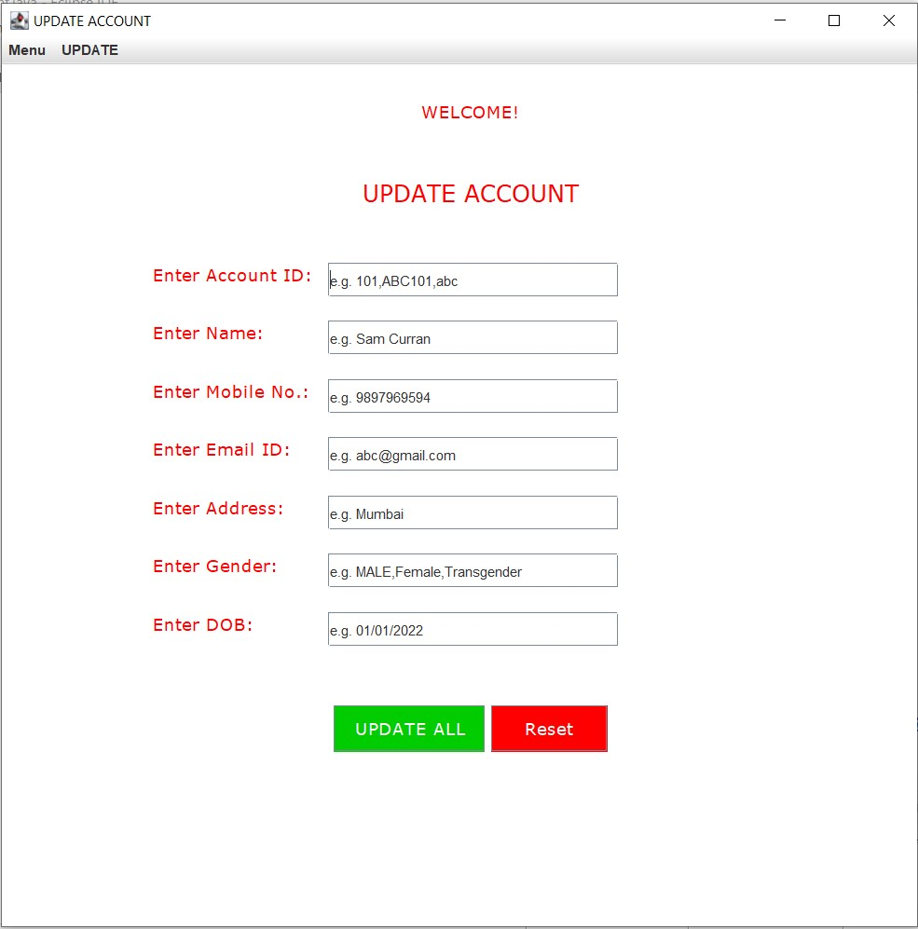

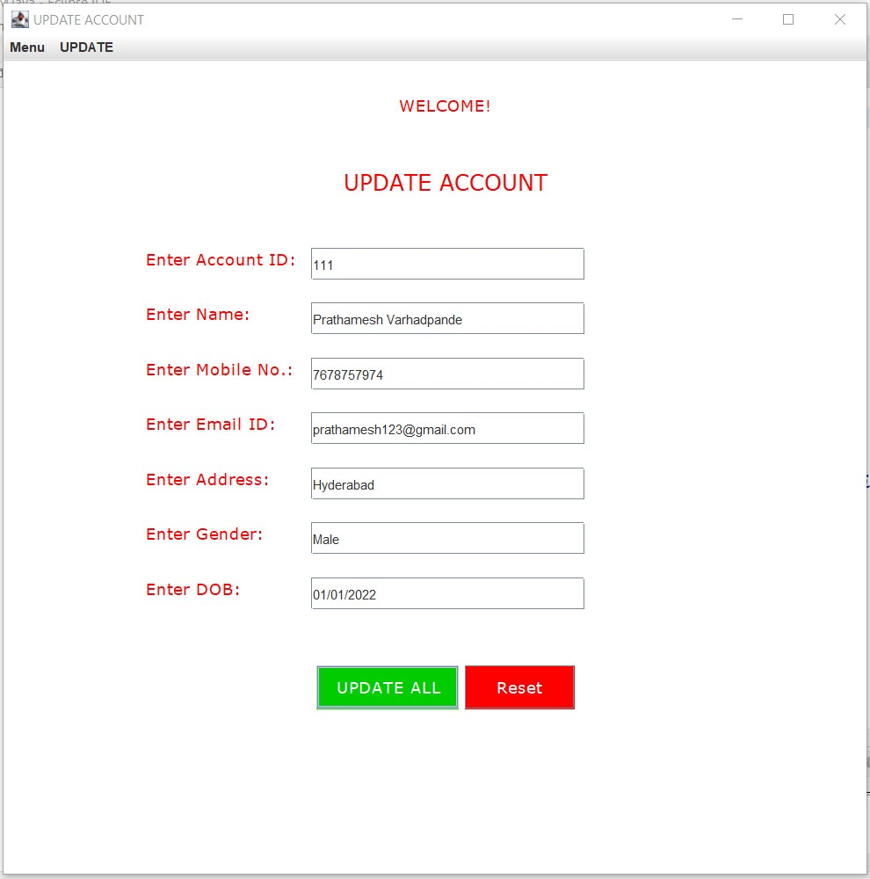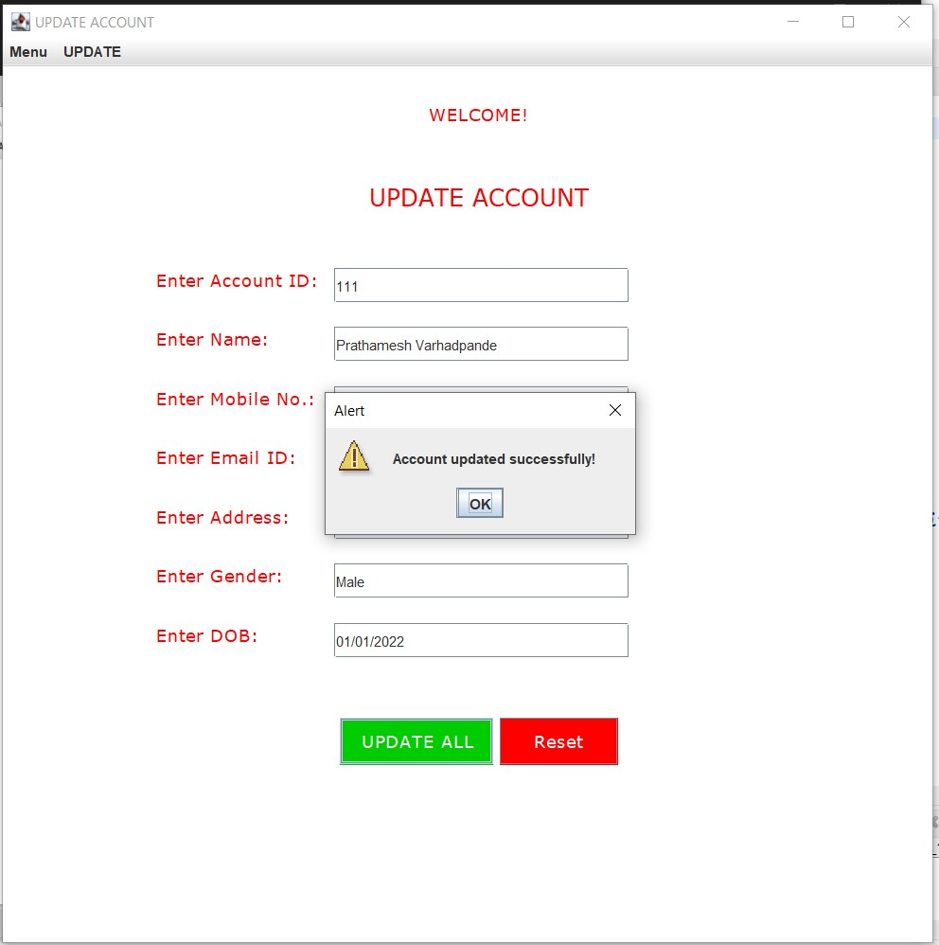



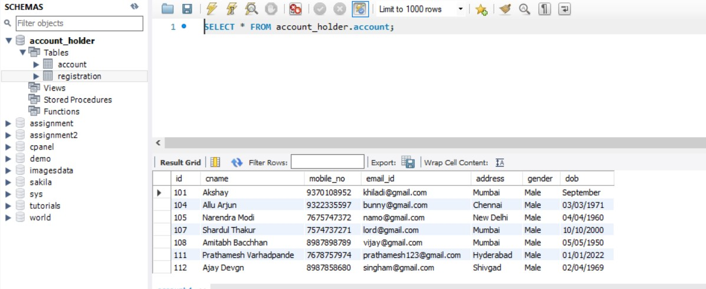

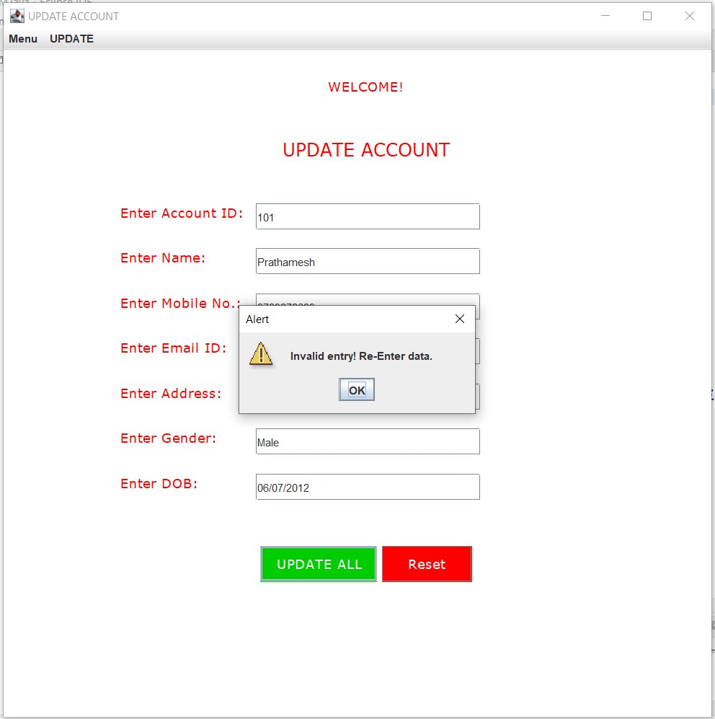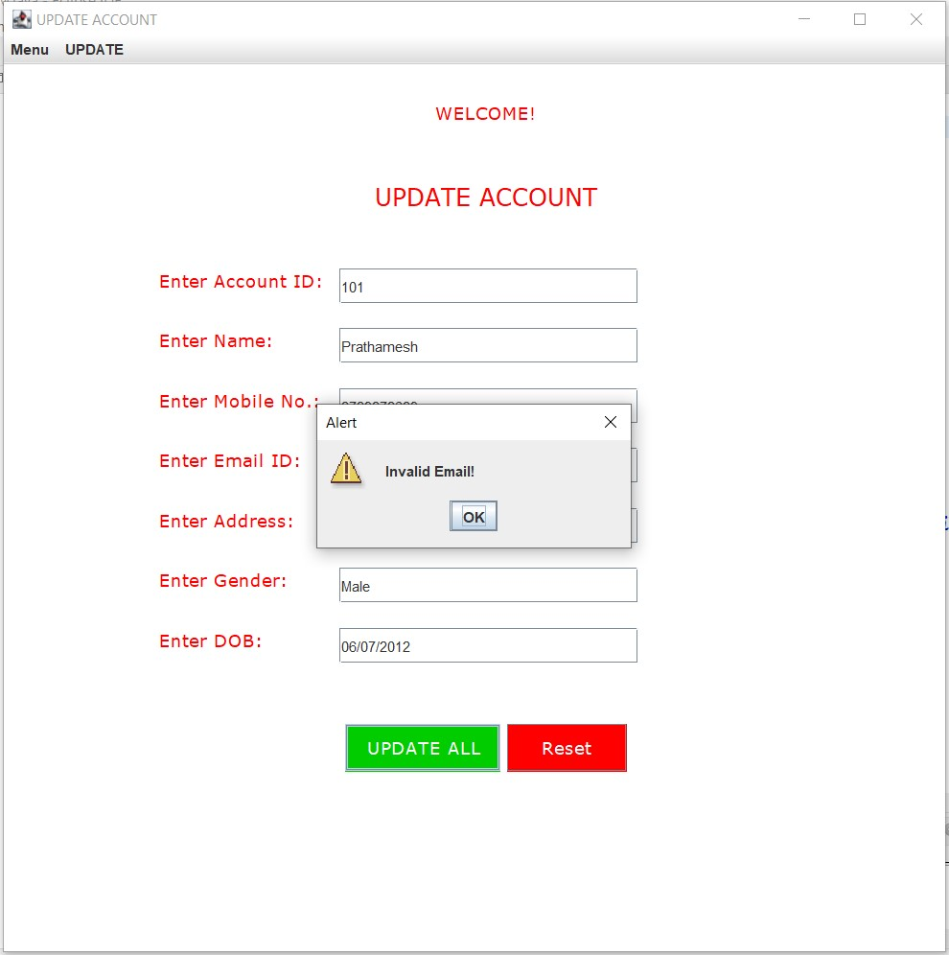

**//UpdateI.java**

**package** com.ahd;

**import** java.awt.Color;

**import** java.awt.Font;

**import** java.awt.event.ActionEvent;

**import** java.awt.event.ActionListener;

**import** java.sql.Connection;

**import** java.sql.DriverManager;

**import** java.sql.PreparedStatement;

**import** java.util.regex.Matcher;

**import** java.util.regex.Pattern;

**import** javax.swing.JButton;

**import** javax.swing.JFrame;

**import** javax.swing.JLabel;

**import** javax.swing.JMenu;

**import** javax.swing.JMenuBar;

**import** javax.swing.JMenuItem;

**import** javax.swing.JOptionPane;

**import** javax.swing.JTextField;

//Main Class

**public** **class** UpdateI **implements** ActionListener{

//Declaring Swing Components

**static** JTextField *tf1*,*tf2*;

**static** JLabel *l1*,*l2*,*l3*,*l4*;

**static** JMenu *menu*,*menu2*;

**static** JMenuBar *mb*;

**static** JMenuItem *item1*, *item2*, *item3*, *item4*,*item01*,*item02*,*item03*,*item04*,*item05*,*item06*,*item07*;

**static** JButton *b1*,*b2*;

**static** JFrame *f*;

//Constructor

**protected** UpdateI() {

//JFrame object creation

*f* = **new** JFrame("UPDATE ID");

//JLabel object creation

*l1*=**new** JLabel("WELCOME!");

*l2*=**new** JLabel("UPDATE ID");

*l3*=**new** JLabel("Enter Name:");

*l4*=**new** JLabel("Enter ID:");

//JMenuBar object creation

*mb*=**new** JMenuBar();

//JMenu object creation

*menu*=**new** JMenu("Menu");

*menu2*=**new** JMenu("UPDATE");

//JMenuItem object creation

*item1*=**new** JMenuItem("CREATE ACCOUNT");

*item2*=**new** JMenuItem("UPDATE ACCOUNT");

*item3*=**new** JMenuItem("DELETE ACCOUNT");

*item4*=**new** JMenuItem("RETRIEVE ACCOUNT");

*item01*=**new** JMenuItem("Update ID");

*item02*=**new** JMenuItem("Update Name");

*item03*=**new** JMenuItem("Update Mobile");

*item04*=**new** JMenuItem("Update Email");

*item05*=**new** JMenuItem("Update Address");

*item06*=**new** JMenuItem("Update Gender");

*item07*=**new** JMenuItem("Update DOB");

//JButton object creation

*b1* = **new** JButton("UPDATE");

*b2* = **new** JButton("Reset");

//JTextField object creation

*tf1* = **new** JTextField("e.g. Sam Curran");

*tf2* = **new** JTextField("e.g. 101,ABC101,abc");

//JLabel properties

*l1*.setBounds(360,-10, 300,100);

*l1*.setFont(**new** Font("Verdana", Font.***PLAIN***, 15));

*l1*.setForeground(**new** Color(255, 0, 0));

*l2*.setBounds(345,10, 300,200);

*l2*.setFont(**new** Font("Verdana", Font.***PLAIN***, 20));

*l2*.setForeground(**new** Color(255, 0, 0));

*l3*.setBounds(130,130, 300,100);

*l3*.setFont(**new** Font("Verdana", Font.***PLAIN***, 15));

*l3*.setForeground(**new** Color(255, 0, 0));

*l4*.setBounds(130,180, 300,100);

*l4*.setFont(**new** Font("Verdana", Font.***PLAIN***, 15));

*l4*.setForeground(**new** Color(255, 0, 0));

//JTextField properties

*tf1*.setBounds(280,170,250,30);

*tf2*.setBounds(280,220,250,30);

//JButton properties

*b1*.setBounds(285, 290, 100, 40);

*b1*.setFont(**new** Font("Verdana", Font.***PLAIN***, 15));

*b1*.setForeground(**new** Color(255,255,255));

*b1*.setBackground(**new** Color(0,204,0));

*b2*.setBounds(420, 290, 100, 40);

*b2*.setFont(**new** Font("Verdana", Font.***PLAIN***, 15));

*b2*.setForeground(**new** Color(255,255,255));

*b2*.setBackground(**new** Color(255,0,0));

//Adding menu and menu items

*mb*.add(*menu*);

*mb*.add(*menu2*);

*menu*.add(*item1*);

*menu*.add(*item2*);

*menu*.add(*item3*);

*menu*.add(*item4*);

*menu2*.add(*item01*);

*menu2*.add(*item02*);

*menu2*.add(*item03*);

*menu2*.add(*item04*);

*menu2*.add(*item05*);

*menu2*.add(*item06*);

*menu2*.add(*item07*);

//Adding and setting components of JFrame

*f*.add(*tf1*);

*f*.add(*tf2*);

*f*.add(*l1*);

*f*.add(*l2*);

*f*.add(*l3*);

*f*.add(*l4*);

*f*.add(*b1*);

*f*.add(*b2*);

*f*.setSize(800,800);

*f*.setLayout(**null**);

*f*.setLocationRelativeTo(**null**);

*f*.getContentPane().setBackground(Color.***WHITE***);

*f*.setJMenuBar(*mb*);

*f*.setVisible(**true**);

//ActionListener for Menu and Update

*item1*.addActionListener(**new** ActionListener(){

**public** **void** actionPerformed(ActionEvent e){

**new** CAccount();

}

});;

*item2*.addActionListener(**new** ActionListener(){

**public** **void** actionPerformed(ActionEvent e){

**new** UAccount();

}

});

*item3*.addActionListener(**new** ActionListener(){

**public** **void** actionPerformed(ActionEvent e){

**new** DAccount();

}

});

*item4*.addActionListener(**new** ActionListener(){

**public** **void** actionPerformed(ActionEvent e){

**new** RAccount();

}

});

*item01*.addActionListener(**new** ActionListener(){

**public** **void** actionPerformed(ActionEvent e){

**new** UpdateI();

}

});;

*item02*.addActionListener(**new** ActionListener(){

**public** **void** actionPerformed(ActionEvent e){

**new** UpdateN();

}

});

*item03*.addActionListener(**new** ActionListener(){

**public** **void** actionPerformed(ActionEvent e){

**new** UpdateM();

}

});

*item04*.addActionListener(**new** ActionListener(){

**public** **void** actionPerformed(ActionEvent e){

**new** UpdateE();

}

});

*item05*.addActionListener(**new** ActionListener(){

**public** **void** actionPerformed(ActionEvent e){

**new** UpdateA();

}

});;

*item06*.addActionListener(**new** ActionListener(){

**public** **void** actionPerformed(ActionEvent e){

**new** UpdateG();

}

});

*item07*.addActionListener(**new** ActionListener(){

**public** **void** actionPerformed(ActionEvent e){

**new** UpdateD();

}

});

//ActionListener for JButton

*b1*.addActionListener(**this**);

*b2*.addActionListener(**this**);

}

//Overridden method for ActionListener

@Override

**public** **void** actionPerformed(ActionEvent e) {

//if-else condition for performing action depending on button clicked

**if**(e.getSource()==*b1*) {

**try**{

String txt1,txt2;

txt1 = *tf1*.getText();

txt2 = *tf2*.getText();

//Regular Expression

Pattern pt1 = Pattern.*compile*("^[a-zA-Z. ]{2,50}$");

Pattern pt2 = Pattern.*compile*("^[a-zA-Z0-9]{1,10}$");

Matcher mtr1 = pt1.matcher(txt1);

Matcher mtr2 = pt2.matcher(txt2);

**boolean** matches1 = mtr1.matches();

**boolean** matches2 = mtr2.matches();

//Database connectivity

Class.*forName*("com.mysql.cj.jdbc.Driver");

Connection con = DriverManager.*getConnection*("jdbc:mysql://localhost:3307/account_holder","root","root");

//Checking Regular Expression

**if**(matches1==**true** && matches2==**true**) {

//DML

PreparedStatement ps = con.prepareStatement("update account set id = ? WHERE cname = ?;");

ps.setString(1,txt2);

ps.setString(2,txt1);

ps.executeUpdate();

JOptionPane.*showMessageDialog*(*f*,"ID updated successfully!","Alert",JOptionPane.***WARNING_MESSAGE***);

}

**else** {

//Error

JOptionPane.*showMessageDialog*(*f*,"Invalid entry! Re-Enter data.","Alert",JOptionPane.***WARNING_MESSAGE***);

**if**(matches1==**false**){

JOptionPane.*showMessageDialog*(*f*,"Invalid Name!","Alert",JOptionPane.***WARNING_MESSAGE***);

}

**else** **if**(matches2==**false**){

JOptionPane.*showMessageDialog*(*f*,"Invalid ID!","Alert",JOptionPane.***WARNING_MESSAGE***);

}

**else** {

System.***out***.println("error");

}

}

con.close();

}

**catch**(Exception e1){

System.***out***.println(e1);

}

}

//Reset Logic

**else** **if**(e.getSource()==*b2*) {

*tf1*.setText("");

*tf2*.setText("");

}

**else** {

System.***out***.println("Error");

}

}

//Main method

**public** **static** **void** main(String[] args) {

//Call to constructor

**new** UpdateI();

}

}

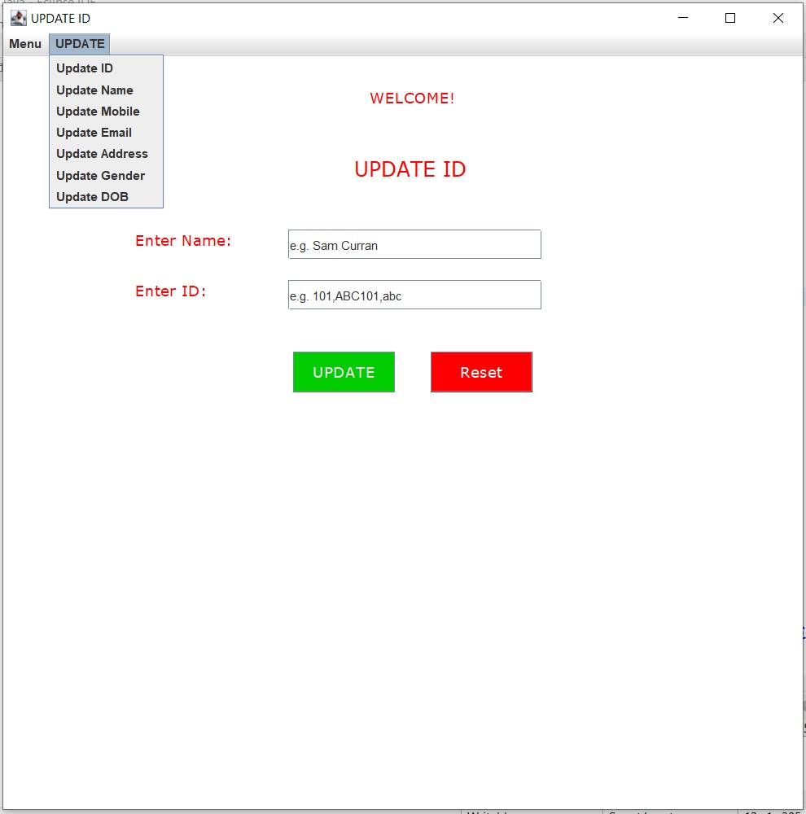

**UpdateN.java**

**package** com.ahd;

**import** java.awt.Color;

**import** java.awt.Font;

**import** java.awt.event.ActionEvent;

**import** java.awt.event.ActionListener;

**import** java.sql.Connection;

**import** java.sql.DriverManager;

**import** java.sql.PreparedStatement;

**import** java.util.regex.Matcher;

**import** java.util.regex.Pattern;

**import** javax.swing.JButton;

**import** javax.swing.JFrame;

**import** javax.swing.JLabel;

**import** javax.swing.JMenu;

**import** javax.swing.JMenuBar;

**import** javax.swing.JMenuItem;

**import** javax.swing.JOptionPane;

**import** javax.swing.JTextField;

//Main Class

**public** **class** UpdateN **implements** ActionListener{

//Declaring Swing Components

**static** JTextField *tf1*,*tf2*;

**static** JLabel *l1*,*l2*,*l3*,*l4*;

**static** JMenu *menu*,*menu2*;

**static** JMenuBar *mb*;

**static** JMenuItem *item1*, *item2*, *item3*, *item4*,*item01*,*item02*,*item03*,*item04*,*item05*,*item06*,*item07*;

**static** JButton *b1*,*b2*;

**static** JFrame *f*;

//Constructor

**protected** UpdateN() {

//JFrame object creation

*f* = **new** JFrame("UPDATE NAME");

//JMenuBar object creation

*mb*=**new** JMenuBar();

//JMenu object creation

*menu*=**new** JMenu("Menu");

*menu2*=**new** JMenu("UPDATE");

//JMenuItem object creation

*item1*=**new** JMenuItem("CREATE ACCOUNT");

*item2*=**new** JMenuItem("UPDATE ACCOUNT");

*item3*=**new** JMenuItem("DELETE ACCOUNT");

*item4*=**new** JMenuItem("RETRIEVE ACCOUNT");

*item01*=**new** JMenuItem("Update ID");

*item02*=**new** JMenuItem("Update Name");

*item03*=**new** JMenuItem("Update Mobile");

*item04*=**new** JMenuItem("Update Email");

*item05*=**new** JMenuItem("Update Address");

*item06*=**new** JMenuItem("Update Gender");

*item07*=**new** JMenuItem("Update DOB");

//JLabel object creation

*l1*=**new** JLabel("WELCOME!");

*l2*=**new** JLabel("UPDATE NAME");

*l3*=**new** JLabel("Enter Account ID:");

*l4*=**new** JLabel("Enter Name:");

//JTextField object creation

*tf1* = **new** JTextField("e.g. 101,ABC101,abc");

*tf2* = **new** JTextField("e.g. Sam Curran");

//JButton object creation

*b1* = **new** JButton("UPDATE");

*b2* = **new** JButton("Reset");

//JLabel properties

*l1*.setBounds(360,-10, 300,100);

*l1*.setFont(**new** Font("Verdana", Font.***PLAIN***, 15));

*l1*.setForeground(**new** Color(255, 0, 0));

*l2*.setBounds(320,10, 300,200);

*l2*.setFont(**new** Font("Verdana", Font.***PLAIN***, 20));

*l2*.setForeground(**new** Color(255, 0, 0));

*l3*.setBounds(130,130, 300,100);

*l3*.setFont(**new** Font("Verdana", Font.***PLAIN***, 15));

*l3*.setForeground(**new** Color(255, 0, 0));

*l4*.setBounds(130,180, 300,100);

*l4*.setFont(**new** Font("Verdana", Font.***PLAIN***, 15));

*l4*.setForeground(**new** Color(255, 0, 0));

//Adding menu and menu items

*mb*.add(*menu*);

*mb*.add(*menu2*);

*menu*.add(*item1*);

*menu*.add(*item2*);

*menu*.add(*item3*);

*menu*.add(*item4*);

*menu2*.add(*item01*);

*menu2*.add(*item02*);

*menu2*.add(*item03*);

*menu2*.add(*item04*);

*menu2*.add(*item05*);

*menu2*.add(*item06*);

*menu2*.add(*item07*);

//JTextField properties

*tf1*.setBounds(280,170,250,30);

*tf2*.setBounds(280,220,250,30);

//JButton properties

*b1*.setBounds(285, 290, 100, 40);

*b1*.setFont(**new** Font("Verdana", Font.***PLAIN***, 15));

*b1*.setForeground(**new** Color(255,255,255));

*b1*.setBackground(**new** Color(0,204,0));

*b2*.setBounds(420, 290, 100, 40);

*b2*.setFont(**new** Font("Verdana", Font.***PLAIN***, 15));

*b2*.setForeground(**new** Color(255,255,255));

*b2*.setBackground(**new** Color(255,0,0));

//Adding and setting JFrame Components

*f*.add(*tf1*);

*f*.add(*tf2*);

*f*.add(*l1*);

*f*.add(*l2*);

*f*.add(*l3*);

*f*.add(*l4*);

*f*.add(*b1*);

*f*.add(*b2*);

*f*.setSize(800,800);

*f*.setLayout(**null**);

*f*.setLocationRelativeTo(**null**);

*f*.getContentPane().setBackground(Color.***WHITE***);

*f*.setJMenuBar(*mb*);

*f*.setVisible(**true**);

//ActionListener for Menu and Update

*item1*.addActionListener(**new** ActionListener(){

**public** **void** actionPerformed(ActionEvent e){

**new** CAccount();

}

});;

*item2*.addActionListener(**new** ActionListener(){

**public** **void** actionPerformed(ActionEvent e){

**new** UAccount();

}

});

*item3*.addActionListener(**new** ActionListener(){

**public** **void** actionPerformed(ActionEvent e){

**new** DAccount();

}

});

*item4*.addActionListener(**new** ActionListener(){

**public** **void** actionPerformed(ActionEvent e){

**new** RAccount();

}

});

*item01*.addActionListener(**new** ActionListener(){

**public** **void** actionPerformed(ActionEvent e){

**new** UpdateI();

}

});;

*item02*.addActionListener(**new** ActionListener(){

**public** **void** actionPerformed(ActionEvent e){

**new** UpdateN();

}

});

*item03*.addActionListener(**new** ActionListener(){

**public** **void** actionPerformed(ActionEvent e){

**new** UpdateM();

}

});

*item04*.addActionListener(**new** ActionListener(){

**public** **void** actionPerformed(ActionEvent e){

**new** UpdateE();

}

});

*item05*.addActionListener(**new** ActionListener(){

**public** **void** actionPerformed(ActionEvent e){

**new** UpdateA();

}

});;

*item06*.addActionListener(**new** ActionListener(){

**public** **void** actionPerformed(ActionEvent e){

**new** UpdateG();

}

});

*item07*.addActionListener(**new** ActionListener(){

**public** **void** actionPerformed(ActionEvent e){

**new** UpdateD();

}

});

//ActionListener for JButton

*b1*.addActionListener(**this**);

*b2*.addActionListener(**this**);

}

//Overridden method for ActionListener

@Override

**public** **void** actionPerformed(ActionEvent e) {

//if-else condition for performing action depending on button clicked

**if**(e.getSource()==*b1*) {

**try**{

String txt1,txt2;

txt1 = *tf1*.getText();

txt2 = *tf2*.getText();

//Regular Expression

Pattern pt1 = Pattern.*compile*("^[a-zA-Z0-9]{1,10}$");

Pattern pt2 = Pattern.*compile*("^[a-zA-Z. ]{2,50}$");

Matcher mtr1 = pt1.matcher(txt1);

Matcher mtr2 = pt2.matcher(txt2);

**boolean** matches1 = mtr1.matches();

**boolean** matches2 = mtr2.matches();

//Database connectivity

Class.*forName*("com.mysql.cj.jdbc.Driver");

Connection con = DriverManager.*getConnection*("jdbc:mysql://localhost:3307/account_holder","root","root");

//Checking Regular Expression

**if**(matches1==**true** && matches2==**true**) {

//DML

PreparedStatement ps = con.prepareStatement("update account set cname = ? WHERE id = ?;");

ps.setString(1,txt2);

ps.setString(2,txt1);

ps.executeUpdate();

JOptionPane.*showMessageDialog*(*f*,"Name updated successfully!","Alert",JOptionPane.***WARNING_MESSAGE***);

}

**else** {

//Error

JOptionPane.*showMessageDialog*(*f*,"Invalid entry! Re-Enter data.","Alert",JOptionPane.***WARNING_MESSAGE***);

**if**(matches1==**false**){

JOptionPane.*showMessageDialog*(*f*,"Invalid ID!","Alert",JOptionPane.***WARNING_MESSAGE***);

}

**else** **if**(matches2==**false**){

JOptionPane.*showMessageDialog*(*f*,"Invalid Name!","Alert",JOptionPane.***WARNING_MESSAGE***);

}

**else** {

System.***out***.println("error");

}

}

con.close();

}

**catch**(Exception e1){

System.***out***.println(e1);

}

}

//Reset Logic

**else** **if**(e.getSource()==*b2*) {

*tf1*.setText("");

*tf2*.setText("");

}

**else** {

System.***out***.println("Error");

}

}

//Main method

**public** **static** **void** main(String[] args) {

//Call to constructor

**new** UpdateN();

}

}

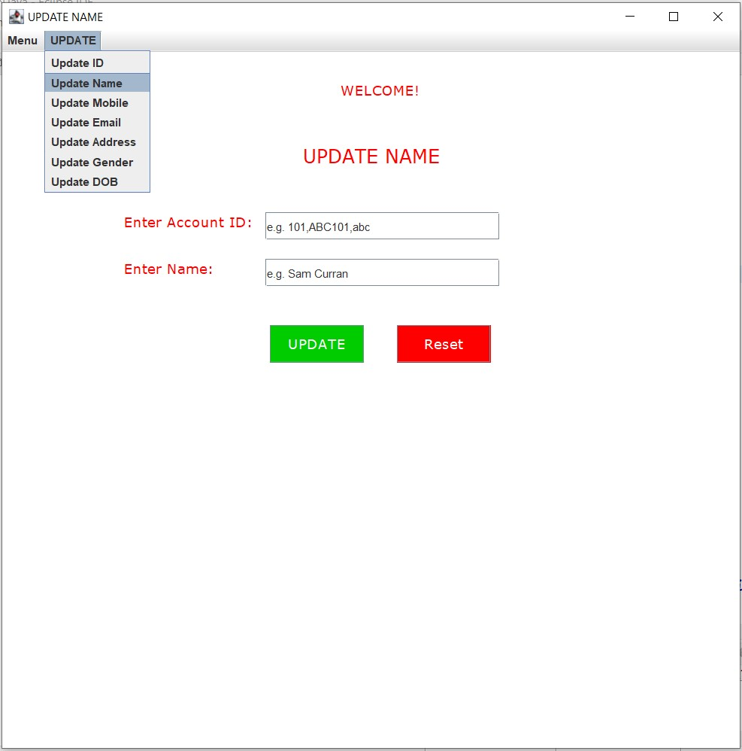

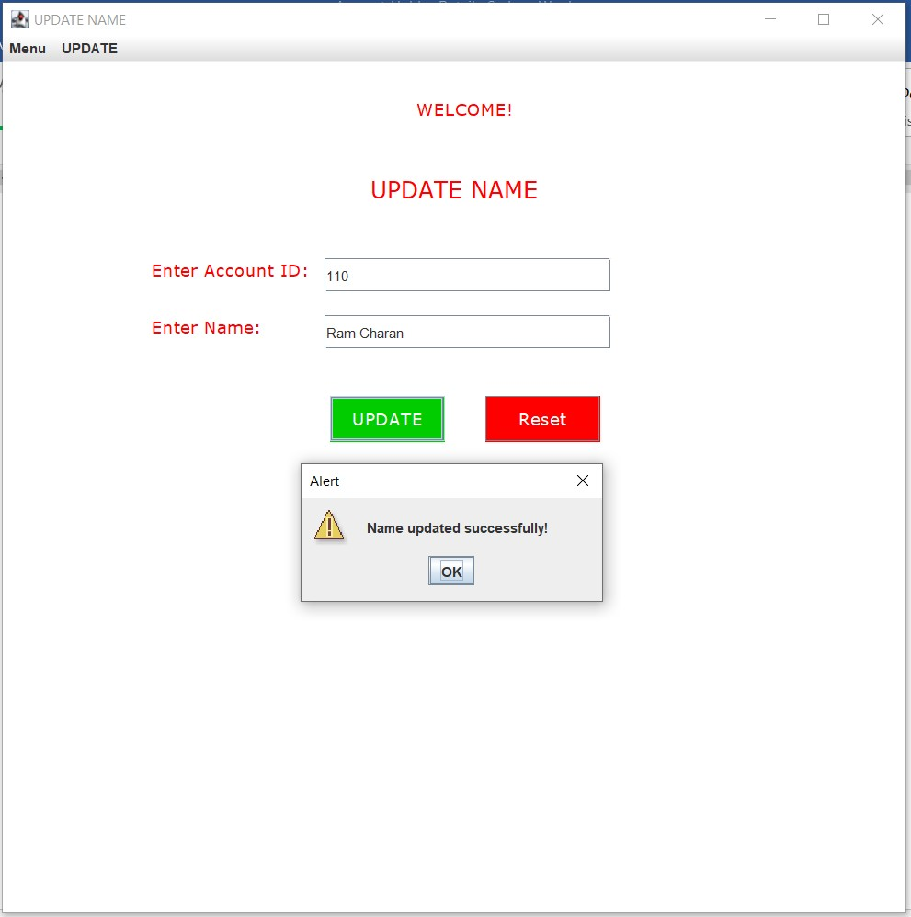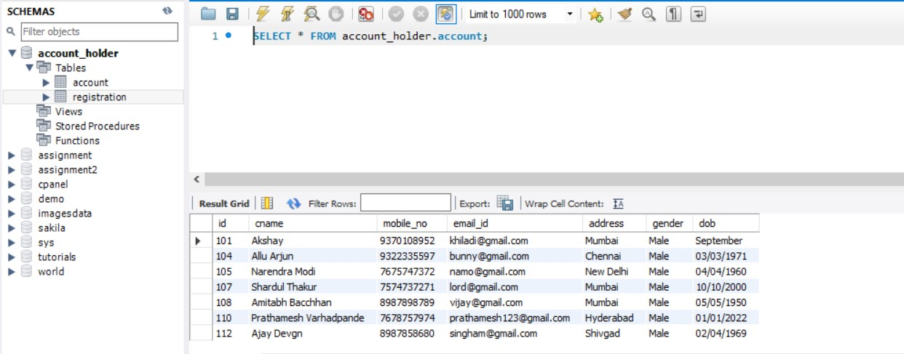

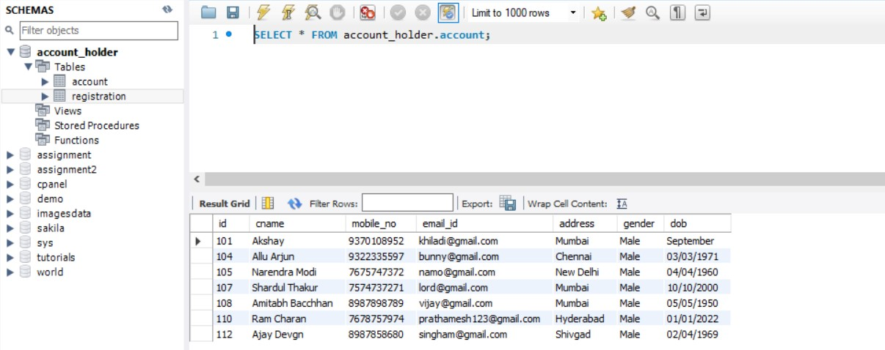

**UpdateM.java**

**package** com.ahd;

**import** java.awt.Color;

**import** java.awt.Font;

**import** java.awt.event.ActionEvent;

**import** java.awt.event.ActionListener;

**import** java.sql.Connection;

**import** java.sql.DriverManager;

**import** java.sql.PreparedStatement;

**import** java.util.regex.Matcher;

**import** java.util.regex.Pattern;

**import** javax.swing.JButton;

**import** javax.swing.JFrame;

**import** javax.swing.JLabel;

**import** javax.swing.JMenu;

**import** javax.swing.JMenuBar;

**import** javax.swing.JMenuItem;

**import** javax.swing.JOptionPane;

**import** javax.swing.JTextField;

//Main Class

**public** **class** UpdateM **implements** ActionListener {

//Declaring Swing Components

**static** JTextField *tf1*,*tf2*;

**static** JLabel *l1*,*l2*,*l3*,*l4*;

**static** JMenu *menu*,*menu2*;

**static** JMenuBar *mb*;

**static** JMenuItem *item1*, *item2*, *item3*, *item4*,*item01*,*item02*,*item03*,*item04*,*item05*,*item06*,*item07*;

**static** JButton *b1*,*b2*;

**static** JFrame *f*;

**protected** UpdateM() {

//JFrame object creation

*f* = **new** JFrame("UPDATE MOBILE");

//JMenuBar object creation

*mb*=**new** JMenuBar();

//JMenu object creation

*menu*=**new** JMenu("Menu");

*menu2*=**new** JMenu("UPDATE");

//JMenuItem object creation

*item1*=**new** JMenuItem("CREATE ACCOUNT");

*item2*=**new** JMenuItem("UPDATE ACCOUNT");

*item3*=**new** JMenuItem("DELETE ACCOUNT");

*item4*=**new** JMenuItem("RETRIEVE ACCOUNT");

*item01*=**new** JMenuItem("Update ID");

*item02*=**new** JMenuItem("Update Name");

*item03*=**new** JMenuItem("Update Mobile");

*item04*=**new** JMenuItem("Update Email");

*item05*=**new** JMenuItem("Update Address");

*item06*=**new** JMenuItem("Update Gender");

*item07*=**new** JMenuItem("Update DOB");

//JLabel object creation

*l1*=**new** JLabel("WELCOME!");

*l2*=**new** JLabel("UPDATE MOBILE");

*l3*=**new** JLabel("Enter Account ID:");

*l4*=**new** JLabel("Enter Mobile:");

//JTextField object creation

*tf1* = **new** JTextField("e.g. 101,ABC101,abc");

*tf2* = **new** JTextField("e.g. 9876543210");

//JButton object creation

*b1* = **new** JButton("UPDATE");

*b2* = **new** JButton("Reset");

//JLabel properties

*l1*.setBounds(360,-10, 300,100);

*l1*.setFont(**new** Font("Verdana", Font.***PLAIN***, 15));

*l1*.setForeground(**new** Color(255, 0, 0));

*l2*.setBounds(320,10, 300,200);

*l2*.setFont(**new** Font("Verdana", Font.***PLAIN***, 20));

*l2*.setForeground(**new** Color(255, 0, 0));

*l3*.setBounds(130,130, 300,100);

*l3*.setFont(**new** Font("Verdana", Font.***PLAIN***, 15));

*l3*.setForeground(**new** Color(255, 0, 0));

*l4*.setBounds(130,180, 300,100);

*l4*.setFont(**new** Font("Verdana", Font.***PLAIN***, 15));

*l4*.setForeground(**new** Color(255, 0, 0));

//Adding menu and menu items

*mb*.add(*menu*);

*mb*.add(*menu2*);

*menu*.add(*item1*);

*menu*.add(*item2*);

*menu*.add(*item3*);

*menu*.add(*item4*);

*menu2*.add(*item01*);

*menu2*.add(*item02*);

*menu2*.add(*item03*);

*menu2*.add(*item04*);

*menu2*.add(*item05*);

*menu2*.add(*item06*);

*menu2*.add(*item07*);

//JTextField properties

*tf1*.setBounds(280,170,250,30);

*tf2*.setBounds(280,220,250,30);

//JButton properties

*b1*.setBounds(285, 290, 100, 40);

*b1*.setFont(**new** Font("Verdana", Font.***PLAIN***, 15));

*b1*.setForeground(**new** Color(255,255,255));

*b1*.setBackground(**new** Color(0,204,0));

*b2*.setBounds(420, 290, 100, 40);

*b2*.setFont(**new** Font("Verdana", Font.***PLAIN***, 15));

*b2*.setForeground(**new** Color(255,255,255));

*b2*.setBackground(**new** Color(255,0,0));

//Adding and setting JFrame Components

*f*.add(*tf1*);

*f*.add(*tf2*);

*f*.add(*l1*);

*f*.add(*l2*);

*f*.add(*l3*);

*f*.add(*l4*);

*f*.add(*b1*);

*f*.add(*b2*);

*f*.setSize(800,800);

*f*.setLayout(**null**);

*f*.setLocationRelativeTo(**null**);

*f*.getContentPane().setBackground(Color.***WHITE***);

*f*.setJMenuBar(*mb*);

*f*.setVisible(**true**);

//ActionListener for Menu and Update

*item1*.addActionListener(**new** ActionListener(){

**public** **void** actionPerformed(ActionEvent e){

**new** CAccount();

}

});;

*item2*.addActionListener(**new** ActionListener(){

**public** **void** actionPerformed(ActionEvent e){

**new** UAccount();

}

});

*item3*.addActionListener(**new** ActionListener(){

**public** **void** actionPerformed(ActionEvent e){

**new** DAccount();

}

});

*item4*.addActionListener(**new** ActionListener(){

**public** **void** actionPerformed(ActionEvent e){

**new** RAccount();

}

});

*item01*.addActionListener(**new** ActionListener(){

**public** **void** actionPerformed(ActionEvent e){

**new** UpdateI();

}

});;

*item02*.addActionListener(**new** ActionListener(){

**public** **void** actionPerformed(ActionEvent e){

**new** UpdateN();

}

});

*item03*.addActionListener(**new** ActionListener(){

**public** **void** actionPerformed(ActionEvent e){

**new** UpdateM();

}

});

*item04*.addActionListener(**new** ActionListener(){

**public** **void** actionPerformed(ActionEvent e){

**new** UpdateE();

}

});

*item05*.addActionListener(**new** ActionListener(){

**public** **void** actionPerformed(ActionEvent e){

**new** UpdateA();

}

});;

*item06*.addActionListener(**new** ActionListener(){

**public** **void** actionPerformed(ActionEvent e){

**new** UpdateG();

}

});

*item07*.addActionListener(**new** ActionListener(){

**public** **void** actionPerformed(ActionEvent e){

**new** UpdateD();

}

});

//ActionListener for JButton

*b1*.addActionListener(**this**);

*b2*.addActionListener(**this**);

}

//Overridden method for ActionListener

@Override

**public** **void** actionPerformed(ActionEvent e) {

//if-else condition for performing action depending on button clicked

**if**(e.getSource()==*b1*) {

**try**{

String txt1,txt2;

txt1 = *tf1*.getText();

txt2 = *tf2*.getText();

//Regular Expression

Pattern pt1 = Pattern.*compile*("^[a-zA-Z0-9]{1,10}$");

Pattern pt2 = Pattern.*compile*("[6-9]{1}[0-9]{9}");

Matcher mtr1 = pt1.matcher(txt1);

Matcher mtr2 = pt2.matcher(txt2);

**boolean** matches1 = mtr1.matches();

**boolean** matches2 = mtr2.matches();

//Database connectivity

Class.*forName*("com.mysql.cj.jdbc.Driver");

Connection con = DriverManager.*getConnection*("jdbc:mysql://localhost:3307/account_holder","root","root");

//Checking Regular Expression

**if**(matches1==**true** && matches2==**true**) {

//DML

PreparedStatement ps = con.prepareStatement("update account set mobile_no = ? WHERE id = ?;");

ps.setString(1,txt2);

ps.setString(2,txt1);

ps.executeUpdate();

JOptionPane.*showMessageDialog*(*f*,"Mobile updated successfully!","Alert",JOptionPane.***WARNING_MESSAGE***);

}

**else** {

//Error

JOptionPane.*showMessageDialog*(*f*,"Invalid entry! Re-Enter data.","Alert",JOptionPane.***WARNING_MESSAGE***);

**if**(matches1==**false**){

JOptionPane.*showMessageDialog*(*f*,"Invalid ID!","Alert",JOptionPane.***WARNING_MESSAGE***);

}

**else** **if**(matches2==**false**){

JOptionPane.*showMessageDialog*(*f*,"Invalid Mobile!","Alert",JOptionPane.***WARNING_MESSAGE***);

}

**else** {

System.***out***.println("error");

}

}

con.close();

}

**catch**(Exception e1){

System.***out***.println(e1);

}

}

//Reset Logic

**else** **if**(e.getSource()==*b2*) {

*tf1*.setText("");

*tf2*.setText("");

}

**else** {

System.***out***.println("Error");

}

}

//Main method

**public** **static** **void** main(String[] args) {

//Call to constructor

**new** UpdateM();

}

}

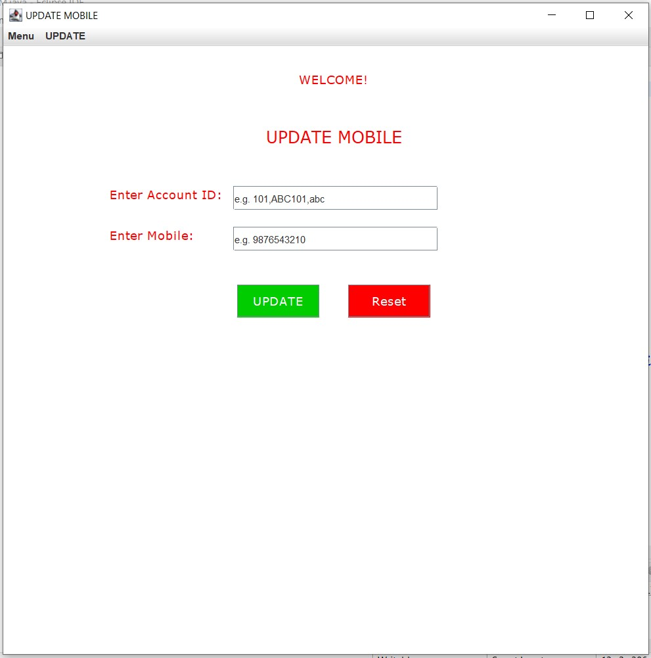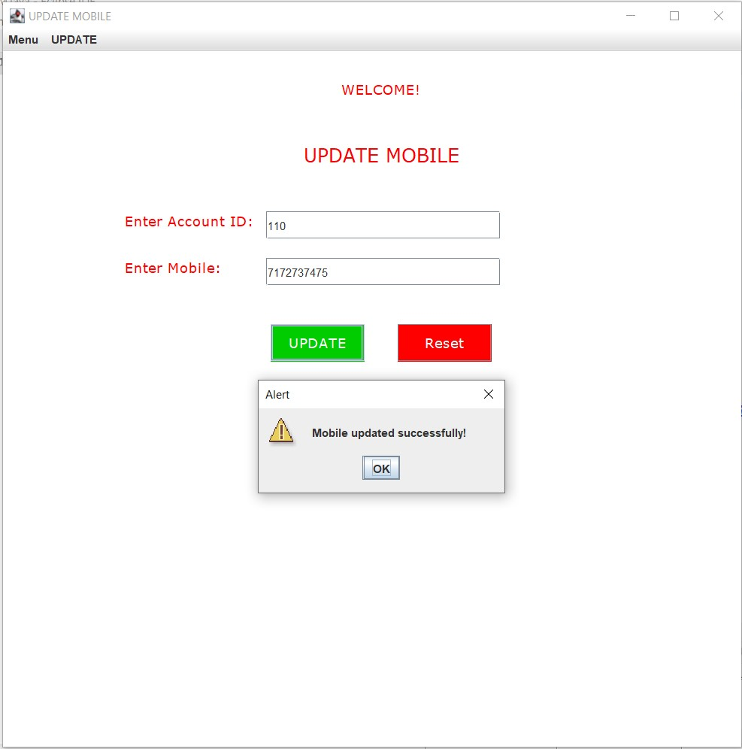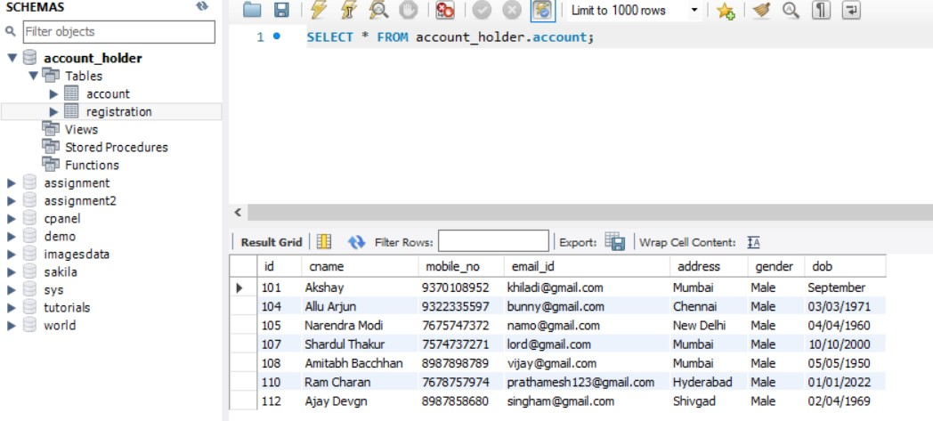

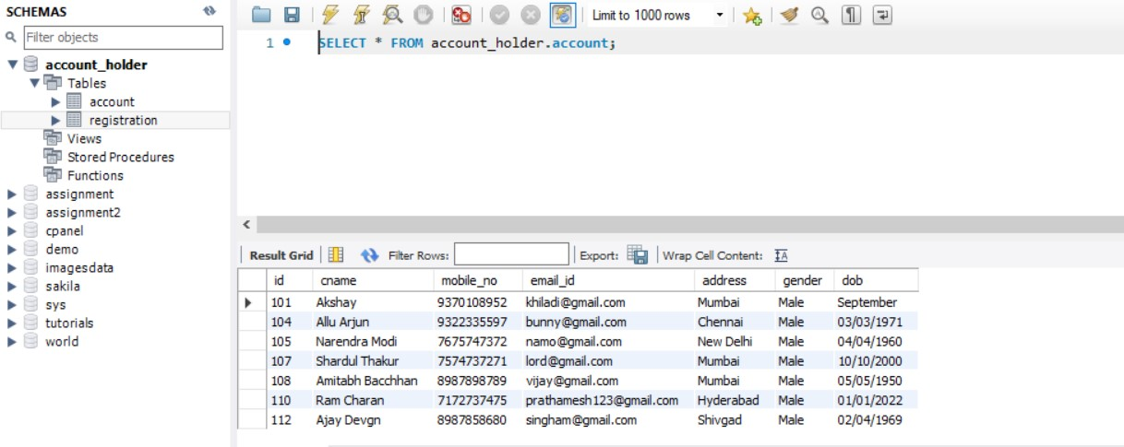

**//UpdateE.java**

**package** com.ahd;

**import** java.awt.Color;

**import** java.awt.Font;

**import** java.awt.event.ActionEvent;

**import** java.awt.event.ActionListener;

**import** java.sql.Connection;

**import** java.sql.DriverManager;

**import** java.sql.PreparedStatement;

**import** java.util.regex.Matcher;

**import** java.util.regex.Pattern;

**import** javax.swing.JButton;

**import** javax.swing.JFrame;

**import** javax.swing.JLabel;

**import** javax.swing.JMenu;

**import** javax.swing.JMenuBar;

**import** javax.swing.JMenuItem;

**import** javax.swing.JOptionPane;

**import** javax.swing.JTextField;

//Main Class

**public** **class** UpdateE **implements** ActionListener{

//Declaring Swing Components

**static** JTextField *tf1*,*tf2*;

**static** JLabel *l1*,*l2*,*l3*,*l4*;

**static** JMenu *menu*,*menu2*;

**static** JMenuBar *mb*;

**static** JMenuItem *item1*, *item2*, *item3*, *item4*,*item01*,*item02*,*item03*,*item04*,*item05*,*item06*,*item07*;

**static** JButton *b1*,*b2*;

**static** JFrame *f*;

//Constructor

**protected** UpdateE() {

//JFrame object creation

*f* = **new** JFrame("UPDATE EMAIL");

//JMenuBar object creation

*mb*=**new** JMenuBar();

//JMenu object creation

*menu*=**new** JMenu("Menu");

*menu2*=**new** JMenu("UPDATE");

//JMenuItem object creation

*item1*=**new** JMenuItem("CREATE ACCOUNT");

*item2*=**new** JMenuItem("UPDATE ACCOUNT");

*item3*=**new** JMenuItem("DELETE ACCOUNT");

*item4*=**new** JMenuItem("RETRIEVE ACCOUNT");

*item01*=**new** JMenuItem("Update ID");

*item02*=**new** JMenuItem("Update Name");

*item03*=**new** JMenuItem("Update Mobile");

*item04*=**new** JMenuItem("Update Email");

*item05*=**new** JMenuItem("Update Address");

*item06*=**new** JMenuItem("Update Gender");

*item07*=**new** JMenuItem("Update DOB");

//JLabel object creation

*l1*=**new** JLabel("WELCOME!");

*l2*=**new** JLabel("UPDATE EMAIL");

*l3*=**new** JLabel("Enter Account ID:");

*l4*=**new** JLabel("Enter Email:");

//JTextField object creation

*tf1* = **new** JTextField("e.g. 101,ABC101,abc");

*tf2* = **new** JTextField("e.g. abc@gmail.com");

//JButton object creation

*b1* = **new** JButton("UPDATE");

*b2* = **new** JButton("Reset");

//JLabel properties

*l1*.setBounds(360,-10, 300,100);

*l1*.setFont(**new** Font("Verdana", Font.***PLAIN***, 15));

*l1*.setForeground(**new** Color(255, 0, 0));

*l2*.setBounds(320,10, 300,200);

*l2*.setFont(**new** Font("Verdana", Font.***PLAIN***, 20));

*l2*.setForeground(**new** Color(255, 0, 0));

*l3*.setBounds(130,130, 300,100);

*l3*.setFont(**new** Font("Verdana", Font.***PLAIN***, 15));

*l3*.setForeground(**new** Color(255, 0, 0));

*l4*.setBounds(130,180, 300,100);

*l4*.setFont(**new** Font("Verdana", Font.***PLAIN***, 15));

*l4*.setForeground(**new** Color(255, 0, 0));

//Adding menu and menu items

*mb*.add(*menu*);

*mb*.add(*menu2*);

*menu*.add(*item1*);

*menu*.add(*item2*);

*menu*.add(*item3*);

*menu*.add(*item4*);

*menu2*.add(*item01*);

*menu2*.add(*item02*);

*menu2*.add(*item03*);

*menu2*.add(*item04*);

*menu2*.add(*item05*);

*menu2*.add(*item06*);

*menu2*.add(*item07*);

//JTextField properties

*tf1*.setBounds(280,170,250,30);

*tf2*.setBounds(280,220,250,30);

//JButton properties

*b1*.setBounds(285, 290, 100, 40);

*b1*.setFont(**new** Font("Verdana", Font.***PLAIN***, 15));

*b1*.setForeground(**new** Color(255,255,255));

*b1*.setBackground(**new** Color(0,204,0));

*b2*.setBounds(420, 290, 100, 40);

*b2*.setFont(**new** Font("Verdana", Font.***PLAIN***, 15));

*b2*.setForeground(**new** Color(255,255,255));

*b2*.setBackground(**new** Color(255,0,0));

//Adding and setting JFrame Components

*f*.add(*tf1*);

*f*.add(*tf2*);

*f*.add(*l1*);

*f*.add(*l2*);

*f*.add(*l3*);

*f*.add(*l4*);

*f*.add(*b1*);

*f*.add(*b2*);

*f*.setSize(800,800);

*f*.setLayout(**null**);

*f*.setLocationRelativeTo(**null**);

*f*.getContentPane().setBackground(Color.***WHITE***);

*f*.setJMenuBar(*mb*);

*f*.setVisible(**true**);

//ActionListener for Menu and Update

*item1*.addActionListener(**new** ActionListener(){

**public** **void** actionPerformed(ActionEvent e){

**new** CAccount();

}

});;

*item2*.addActionListener(**new** ActionListener(){

**public** **void** actionPerformed(ActionEvent e){

**new** UAccount();

}

});

*item3*.addActionListener(**new** ActionListener(){

**public** **void** actionPerformed(ActionEvent e){

**new** DAccount();

}

});

*item4*.addActionListener(**new** ActionListener(){

**public** **void** actionPerformed(ActionEvent e){

**new** RAccount();

}

});

*item01*.addActionListener(**new** ActionListener(){

**public** **void** actionPerformed(ActionEvent e){

**new** UpdateI();

}

});;

*item02*.addActionListener(**new** ActionListener(){

**public** **void** actionPerformed(ActionEvent e){

**new** UpdateN();

}

});

*item03*.addActionListener(**new** ActionListener(){

**public** **void** actionPerformed(ActionEvent e){

**new** UpdateM();

}

});

*item04*.addActionListener(**new** ActionListener(){

**public** **void** actionPerformed(ActionEvent e){

**new** UpdateE();

}

});

*item05*.addActionListener(**new** ActionListener(){

**public** **void** actionPerformed(ActionEvent e){

**new** UpdateA();

}

});;

*item06*.addActionListener(**new** ActionListener(){

**public** **void** actionPerformed(ActionEvent e){

**new** UpdateG();

}

});

*item07*.addActionListener(**new** ActionListener(){

**public** **void** actionPerformed(ActionEvent e){

**new** UpdateD();

}

});

//ActionListener for JButton

*b1*.addActionListener(**this**);

*b2*.addActionListener(**this**);

}

//Overridden method for ActionListener

@Override

**public** **void** actionPerformed(ActionEvent e) {

//if-else condition for performing action depending on button clicked

**if**(e.getSource()==*b1*) {

**try**{

String txt1,txt2;

txt1 = *tf1*.getText();

txt2 = *tf2*.getText();

//Regular Expression

Pattern pt1 = Pattern.*compile*("^[a-zA-Z0-9]{1,10}$");

Pattern pt2 = Pattern.*compile*("^[a-z0-9]+@[a-z]+\\.[a-z]{2,3}$");

Matcher mtr1 = pt1.matcher(txt1);

Matcher mtr2 = pt2.matcher(txt2);

**boolean** matches1 = mtr1.matches();

**boolean** matches2 = mtr2.matches();

//Database connectivity

Class.*forName*("com.mysql.cj.jdbc.Driver");

Connection con = DriverManager.*getConnection*("jdbc:mysql://localhost:3307/account_holder","root","root");

//Checking Regular Expression

**if**(matches1==**true** && matches2==**true**) {

//DML

PreparedStatement ps = con.prepareStatement("update account set email_id = ? WHERE id = ?;");

ps.setString(1,txt2);

ps.setString(2,txt1);

ps.executeUpdate();

JOptionPane.*showMessageDialog*(*f*,"Email updated successfully!","Alert",JOptionPane.***WARNING_MESSAGE***);

}

**else** {

//Error

JOptionPane.*showMessageDialog*(*f*,"Invalid entry! Re-Enter data.","Alert",JOptionPane.***WARNING_MESSAGE***);

**if**(matches1==**false**){

JOptionPane.*showMessageDialog*(*f*,"Invalid ID!","Alert",JOptionPane.***WARNING_MESSAGE***);

}

**else** **if**(matches2==**false**){

JOptionPane.*showMessageDialog*(*f*,"Invalid Email!","Alert",JOptionPane.***WARNING_MESSAGE***);

}

**else** {

System.***out***.println("error");

}

}

con.close();

}

**catch**(Exception e1){

System.***out***.println(e1);

}

}

//Reset Logic

**else** **if**(e.getSource()==*b2*) {

*tf1*.setText("");

*tf2*.setText("");

}

**else** {

System.***out***.println("Error");

}

}

//Main method

**public** **static** **void** main(String[] args) {

//Call to constructor

**new** UpdateE();

}

}

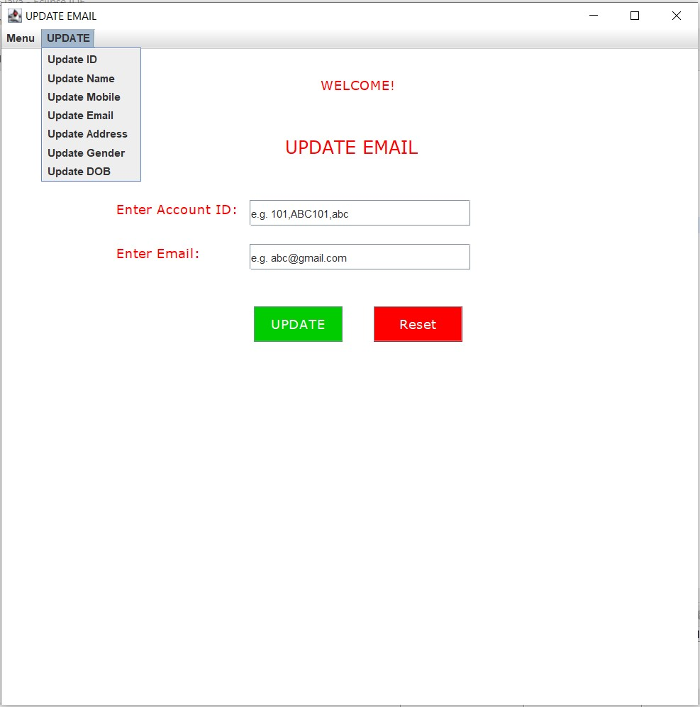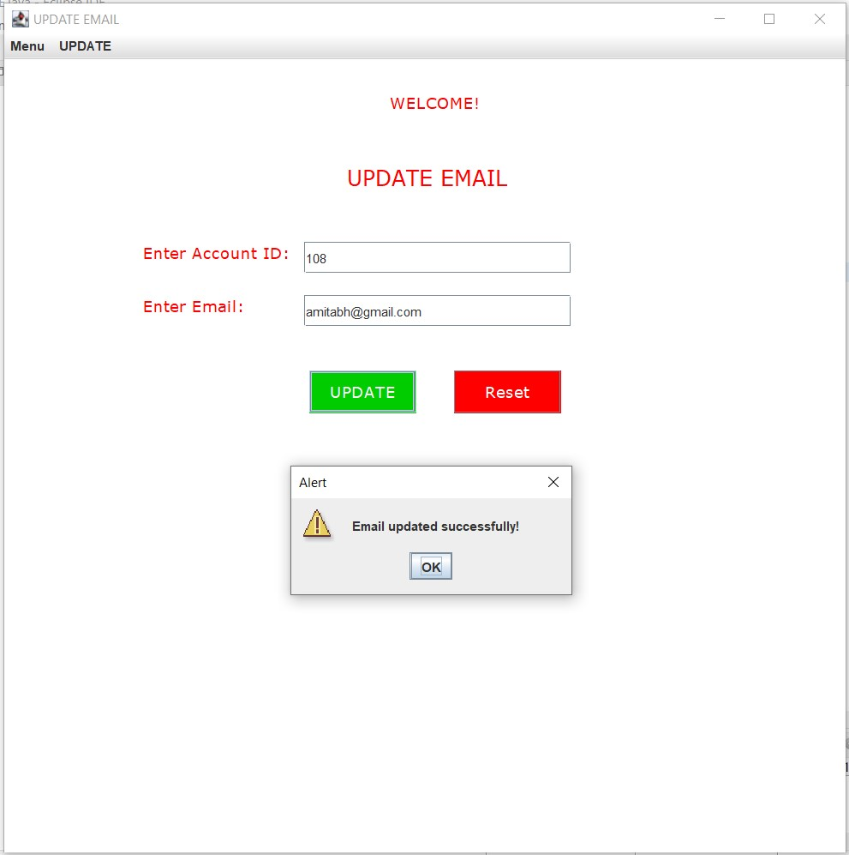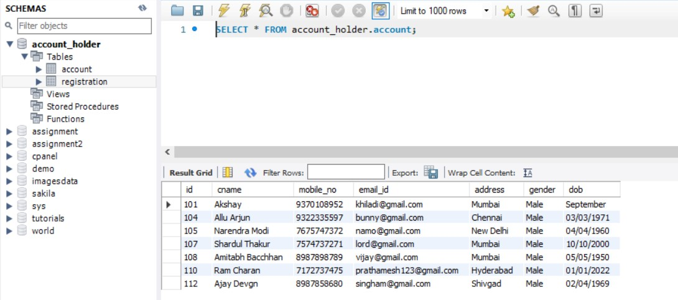

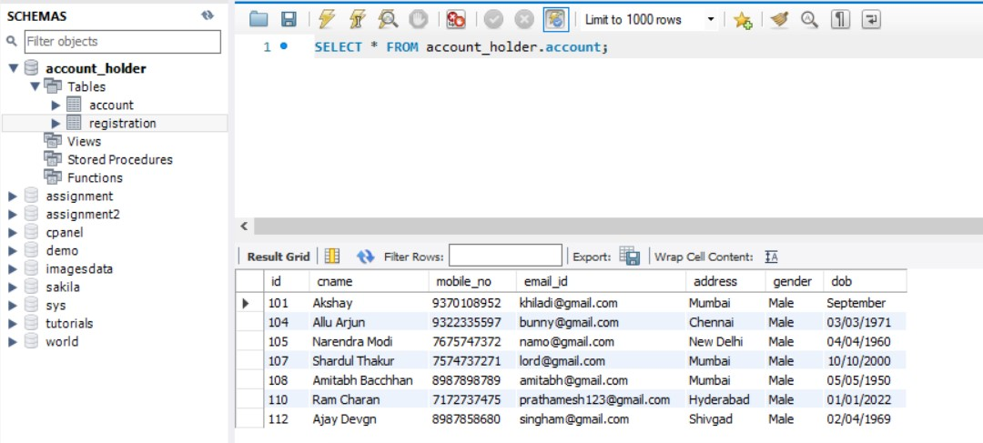

**//UpdateA.java**

**package** com.ahd;

**import** java.awt.Color;

**import** java.awt.Font;

**import** java.awt.event.ActionEvent;

**import** java.awt.event.ActionListener;

**import** java.sql.Connection;

**import** java.sql.DriverManager;

**import** java.sql.PreparedStatement;

**import** java.util.regex.Matcher;

**import** java.util.regex.Pattern;

**import** javax.swing.JButton;

**import** javax.swing.JFrame;

**import** javax.swing.JLabel;

**import** javax.swing.JMenu;

**import** javax.swing.JMenuBar;

**import** javax.swing.JMenuItem;

**import** javax.swing.JOptionPane;

**import** javax.swing.JTextField;

//Main Class

**public** **class** UpdateA **implements** ActionListener{

//Declaring Swing Components

**static** JTextField *tf1*,*tf2*;

**static** JLabel *l1*,*l2*,*l3*,*l4*;

**static** JMenu *menu*,*menu2*;

**static** JMenuBar *mb*;

**static** JMenuItem *item1*, *item2*, *item3*, *item4*,*item01*,*item02*,*item03*,*item04*,*item05*,*item06*,*item07*;

**static** JButton *b1*,*b2*;

**static** JFrame *f*;

//Constructor

**protected** UpdateA() {

//JFrame object creation

*f* = **new** JFrame("UPDATE Address");

//JMenuBar object creation

*mb*=**new** JMenuBar();

//JMenu object creation

*menu*=**new** JMenu("Menu");

*menu2*=**new** JMenu("UPDATE");

//JMenuItem object creation

*item1*=**new** JMenuItem("CREATE ACCOUNT");

*item2*=**new** JMenuItem("UPDATE ACCOUNT");

*item3*=**new** JMenuItem("DELETE ACCOUNT");

*item4*=**new** JMenuItem("RETRIEVE ACCOUNT");

*item01*=**new** JMenuItem("Update ID");

*item02*=**new** JMenuItem("Update Name");

*item03*=**new** JMenuItem("Update Mobile");

*item04*=**new** JMenuItem("Update Email");

*item05*=**new** JMenuItem("Update Address");

*item06*=**new** JMenuItem("Update Gender");

*item07*=**new** JMenuItem("Update DOB");

//JLabel object creation

*l1*=**new** JLabel("WELCOME!");

*l2*=**new** JLabel("UPDATE Address");

*l3*=**new** JLabel("Enter Account ID:");

*l4*=**new** JLabel("Enter Address:");

//JTextField object creation

*tf1* = **new** JTextField("e.g. 101,ABC101,abc");

*tf2* = **new** JTextField("e.g. Mumbai");

//JButton object creation

*b1* = **new** JButton("UPDATE");

*b2* = **new** JButton("Reset");

//JLabel properties

*l1*.setBounds(360,-10, 300,100);

*l1*.setFont(**new** Font("Verdana", Font.***PLAIN***, 15));

*l1*.setForeground(**new** Color(255, 0, 0));

*l2*.setBounds(320,10, 300,200);

*l2*.setFont(**new** Font("Verdana", Font.***PLAIN***, 20));

*l2*.setForeground(**new** Color(255, 0, 0));

*l3*.setBounds(130,130, 300,100);

*l3*.setFont(**new** Font("Verdana", Font.***PLAIN***, 15));

*l3*.setForeground(**new** Color(255, 0, 0));

*l4*.setBounds(130,180, 300,100);

*l4*.setFont(**new** Font("Verdana", Font.***PLAIN***, 15));

*l4*.setForeground(**new** Color(255, 0, 0));

//Adding menu and menu items

*mb*.add(*menu*);

*mb*.add(*menu2*);

*menu*.add(*item1*);

*menu*.add(*item2*);

*menu*.add(*item3*);

*menu*.add(*item4*);

*menu2*.add(*item01*);

*menu2*.add(*item02*);

*menu2*.add(*item03*);

*menu2*.add(*item04*);

*menu2*.add(*item05*);

*menu2*.add(*item06*);

*menu2*.add(*item07*);

//JTextField properties

*tf1*.setBounds(280,170,250,30);

*tf2*.setBounds(280,220,250,30);

//JButton properties

*b1*.setBounds(285, 290, 100, 40);

*b1*.setFont(**new** Font("Verdana", Font.***PLAIN***, 15));

*b1*.setForeground(**new** Color(255,255,255));

*b1*.setBackground(**new** Color(0,204,0));

*b2*.setBounds(420, 290, 100, 40);

*b2*.setFont(**new** Font("Verdana", Font.***PLAIN***, 15));

*b2*.setForeground(**new** Color(255,255,255));

*b2*.setBackground(**new** Color(255,0,0));

//Adding and setting JFrame Components

*f*.add(*tf1*);

*f*.add(*tf2*);

*f*.add(*l1*);

*f*.add(*l2*);

*f*.add(*l3*);

*f*.add(*l4*);

*f*.add(*b1*);

*f*.add(*b2*);

*f*.setSize(800,800);

*f*.setLayout(**null**);

*f*.setLocationRelativeTo(**null**);

*f*.getContentPane().setBackground(Color.***WHITE***);

*f*.setJMenuBar(*mb*);

*f*.setVisible(**true**);

//ActionListener for Menu and Update

*item1*.addActionListener(**new** ActionListener(){

**public** **void** actionPerformed(ActionEvent e){

**new** CAccount();

}

});;

*item2*.addActionListener(**new** ActionListener(){

**public** **void** actionPerformed(ActionEvent e){

**new** UAccount();

}

});

*item3*.addActionListener(**new** ActionListener(){

**public** **void** actionPerformed(ActionEvent e){

**new** DAccount();

}

});

*item4*.addActionListener(**new** ActionListener(){

**public** **void** actionPerformed(ActionEvent e){

**new** RAccount();

}

});

*item01*.addActionListener(**new** ActionListener(){

**public** **void** actionPerformed(ActionEvent e){

**new** UpdateI();

}

});;

*item02*.addActionListener(**new** ActionListener(){

**public** **void** actionPerformed(ActionEvent e){

**new** UpdateN();

}

});

*item03*.addActionListener(**new** ActionListener(){

**public** **void** actionPerformed(ActionEvent e){

**new** UpdateM();

}

});

*item04*.addActionListener(**new** ActionListener(){

**public** **void** actionPerformed(ActionEvent e){

**new** UpdateE();

}

});

*item05*.addActionListener(**new** ActionListener(){

**public** **void** actionPerformed(ActionEvent e){

**new** UpdateA();

}

});;

*item06*.addActionListener(**new** ActionListener(){

**public** **void** actionPerformed(ActionEvent e){

**new** UpdateG();

}

});

*item07*.addActionListener(**new** ActionListener(){

**public** **void** actionPerformed(ActionEvent e){

**new** UpdateD();

}

});

//ActionListener for JButton

*b1*.addActionListener(**this**);

*b2*.addActionListener(**this**);

}

//Overridden method for ActionListener

@Override

**public** **void** actionPerformed(ActionEvent e) {

//if-else condition for performing action depending on button clicked

**if**(e.getSource()==*b1*) {

**try**{

String txt1,txt2;

txt1 = *tf1*.getText();

txt2 = *tf2*.getText();

//Regular Expression

Pattern pt1 = Pattern.*compile*("^[a-zA-Z0-9]{1,10}$");

Pattern pt2 = Pattern.*compile*("^[a-zA-Z. ,0-9]{2,50}$");

Matcher mtr1 = pt1.matcher(txt1);

Matcher mtr2 = pt2.matcher(txt2);

**boolean** matches1 = mtr1.matches();

**boolean** matches2 = mtr2.matches();

//Database connectivity

Class.*forName*("com.mysql.cj.jdbc.Driver");

Connection con = DriverManager.*getConnection*("jdbc:mysql://localhost:3307/account_holder","root","root");

//Checking Regular Expression

**if**(matches1==**true** && matches2==**true**) {

//DML

PreparedStatement ps = con.prepareStatement("update account set address = ? WHERE id = ?;");

ps.setString(1,txt2);

ps.setString(2,txt1);

ps.executeUpdate();

JOptionPane.*showMessageDialog*(*f*,"Address updated successfully!","Alert",JOptionPane.***WARNING_MESSAGE***);

}

**else** {

//Error

JOptionPane.*showMessageDialog*(*f*,"Invalid entry! Re-Enter data.","Alert",JOptionPane.***WARNING_MESSAGE***);

**if**(matches1==**false**){

JOptionPane.*showMessageDialog*(*f*,"Invalid ID!","Alert",JOptionPane.***WARNING_MESSAGE***);

}

**else** **if**(matches2==**false**){

JOptionPane.*showMessageDialog*(*f*,"Invalid Address!","Alert",JOptionPane.***WARNING_MESSAGE***);

}

**else** {

System.***out***.println("error");

}

}

con.close();

}

**catch**(Exception e1){

System.***out***.println(e1);

}

}

//Reset Logic

**else** **if**(e.getSource()==*b2*) {

*tf1*.setText("");

*tf2*.setText("");

}

**else** {

System.***out***.println("Error");

}

}

//Main method

**public** **static** **void** main(String[] args) {

//Call to Constructor

**new** UpdateA();

}

}

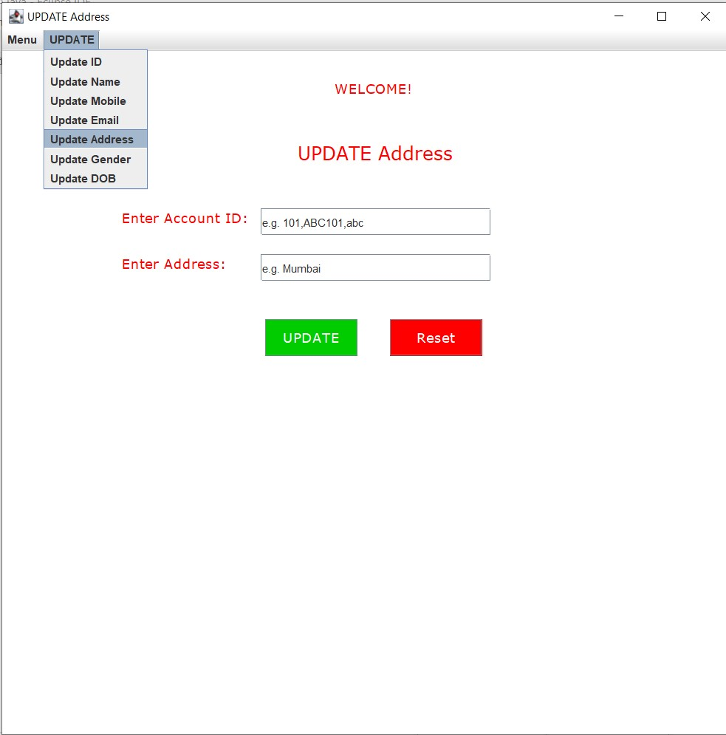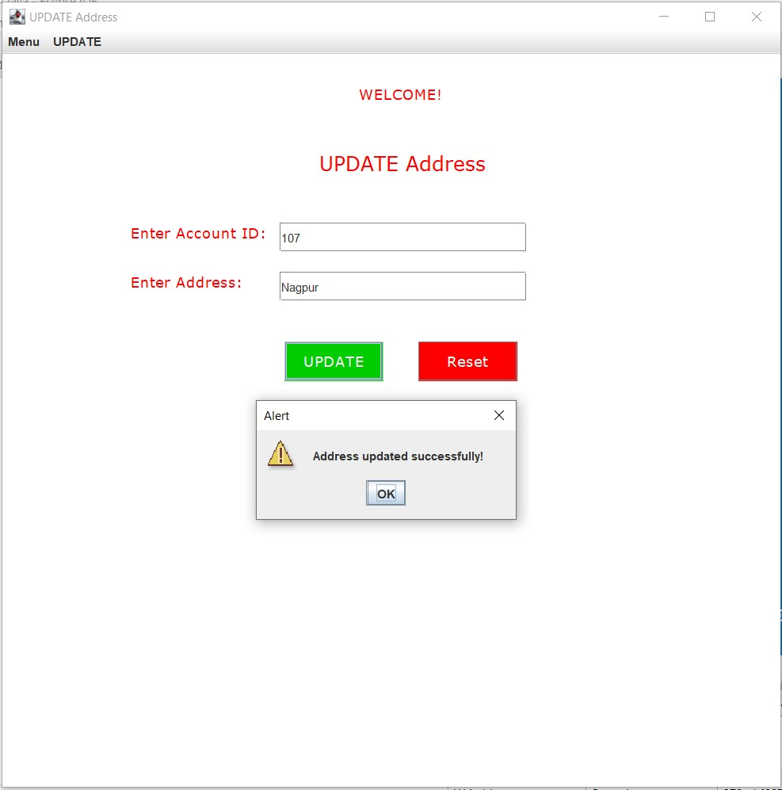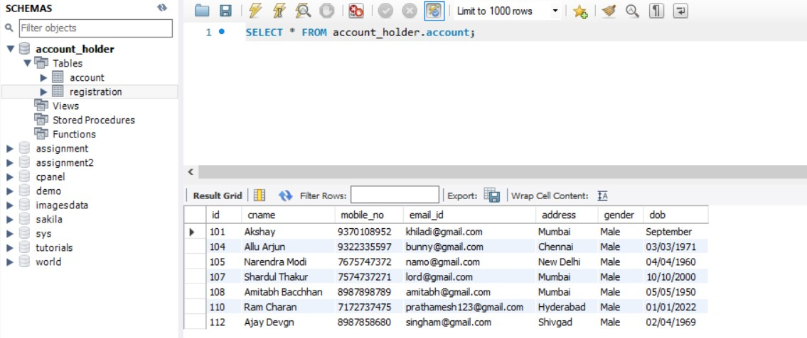

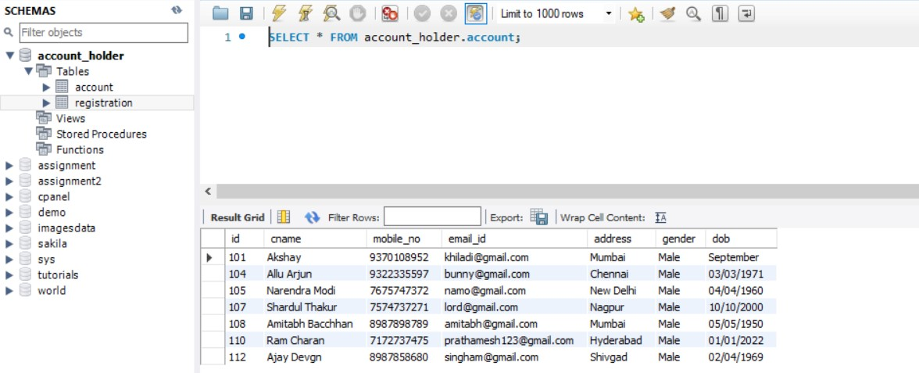

**//UpdateG.java**

**package** com.ahd;

**import** java.awt.Color;

**import** java.awt.Font;

**import** java.awt.event.ActionEvent;

**import** java.awt.event.ActionListener;

**import** java.sql.Connection;

**import** java.sql.DriverManager;

**import** java.sql.PreparedStatement;

**import** java.util.regex.Matcher;

**import** java.util.regex.Pattern;

**import** javax.swing.JButton;

**import** javax.swing.JFrame;

**import** javax.swing.JLabel;

**import** javax.swing.JMenu;

**import** javax.swing.JMenuBar;

**import** javax.swing.JMenuItem;

**import** javax.swing.JOptionPane;

**import** javax.swing.JTextField;

//Main Class

**public** **class** UpdateG **implements** ActionListener{

//Declaring Swing Components

**static** JTextField *tf1*,*tf2*;

**static** JLabel *l1*,*l2*,*l3*,*l4*;

**static** JMenu *menu*,*menu2*;

**static** JMenuBar *mb*;

**static** JMenuItem *item1*, *item2*, *item3*, *item4*,*item01*,*item02*,*item03*,*item04*,*item05*,*item06*,*item07*;

**static** JButton *b1*,*b2*;

**static** JFrame *f*;

//Constructor

**protected** UpdateG() {

//JFrame object creation

*f* = **new** JFrame("UPDATE GENDER");

//JMenuBar object creation

*mb*=**new** JMenuBar();

//JMenu object creation

*menu*=**new** JMenu("Menu");

*menu2*=**new** JMenu("UPDATE");

//JMenuItem object creation

*item1*=**new** JMenuItem("CREATE ACCOUNT");

*item2*=**new** JMenuItem("UPDATE ACCOUNT");

*item3*=**new** JMenuItem("DELETE ACCOUNT");

*item4*=**new** JMenuItem("RETRIEVE ACCOUNT");

*item01*=**new** JMenuItem("Update ID");

*item02*=**new** JMenuItem("Update Name");

*item03*=**new** JMenuItem("Update Mobile");

*item04*=**new** JMenuItem("Update Email");

*item05*=**new** JMenuItem("Update Address");

*item06*=**new** JMenuItem("Update Gender");

*item07*=**new** JMenuItem("Update DOB");

//JLabel object creation

*l1*=**new** JLabel("WELCOME!");

*l2*=**new** JLabel("UPDATE GENDER");

*l3*=**new** JLabel("Enter Account ID:");

*l4*=**new** JLabel("Enter Gender:");

//JTextField object creation

*tf1* = **new** JTextField("e.g. 101,ABC101,abc");

*tf2* = **new** JTextField("e.g. MALE,Female,Transgender");

//JButton object creation

*b1* = **new** JButton("UPDATE");

*b2* = **new** JButton("Reset");

//JLabel properties

*l1*.setBounds(360,-10, 300,100);

*l1*.setFont(**new** Font("Verdana", Font.***PLAIN***, 15));

*l1*.setForeground(**new** Color(255, 0, 0));

*l2*.setBounds(320,10, 300,200);

*l2*.setFont(**new** Font("Verdana", Font.***PLAIN***, 20));

*l2*.setForeground(**new** Color(255, 0, 0));

*l3*.setBounds(130,130, 300,100);

*l3*.setFont(**new** Font("Verdana", Font.***PLAIN***, 15));

*l3*.setForeground(**new** Color(255, 0, 0));

*l4*.setBounds(130,180, 300,100);

*l4*.setFont(**new** Font("Verdana", Font.***PLAIN***, 15));

*l4*.setForeground(**new** Color(255, 0, 0));

//Adding menu and menu items

*mb*.add(*menu*);

*mb*.add(*menu2*);

*menu*.add(*item1*);

*menu*.add(*item2*);

*menu*.add(*item3*);

*menu*.add(*item4*);

*menu2*.add(*item01*);

*menu2*.add(*item02*);

*menu2*.add(*item03*);

*menu2*.add(*item04*);

*menu2*.add(*item05*);

*menu2*.add(*item06*);

*menu2*.add(*item07*);

//JTextField properties

*tf1*.setBounds(280,170,250,30);

*tf2*.setBounds(280,220,250,30);

//JButton properties

*b1*.setBounds(285, 290, 100, 40);

*b1*.setFont(**new** Font("Verdana", Font.***PLAIN***, 15));

*b1*.setForeground(**new** Color(255,255,255));

*b1*.setBackground(**new** Color(0,204,0));

*b2*.setBounds(420, 290, 100, 40);

*b2*.setFont(**new** Font("Verdana", Font.***PLAIN***, 15));

*b2*.setForeground(**new** Color(255,255,255));

*b2*.setBackground(**new** Color(255,0,0));

//Adding and setting JFrame Components

*f*.add(*tf1*);

*f*.add(*tf2*);

*f*.add(*l1*);

*f*.add(*l2*);

*f*.add(*l3*);

*f*.add(*l4*);

*f*.add(*b1*);

*f*.add(*b2*);

*f*.setSize(800,800);

*f*.setLayout(**null**);

*f*.setLocationRelativeTo(**null**);

*f*.getContentPane().setBackground(Color.***WHITE***);

*f*.setJMenuBar(*mb*);

*f*.setVisible(**true**);

//ActionListener for Menu and Update

*item1*.addActionListener(**new** ActionListener(){

**public** **void** actionPerformed(ActionEvent e){

**new** CAccount();

}

});;

*item2*.addActionListener(**new** ActionListener(){

**public** **void** actionPerformed(ActionEvent e){

**new** UAccount();

}

});

*item3*.addActionListener(**new** ActionListener(){

**public** **void** actionPerformed(ActionEvent e){

**new** DAccount();

}

});

*item4*.addActionListener(**new** ActionListener(){

**public** **void** actionPerformed(ActionEvent e){

**new** RAccount();

}

});

*item01*.addActionListener(**new** ActionListener(){

**public** **void** actionPerformed(ActionEvent e){

**new** UpdateI();

}

});;

*item02*.addActionListener(**new** ActionListener(){

**public** **void** actionPerformed(ActionEvent e){

**new** UpdateN();

}

});

*item03*.addActionListener(**new** ActionListener(){

**public** **void** actionPerformed(ActionEvent e){

**new** UpdateM();

}

});

*item04*.addActionListener(**new** ActionListener(){

**public** **void** actionPerformed(ActionEvent e){

**new** UpdateE();

}

});

*item05*.addActionListener(**new** ActionListener(){

**public** **void** actionPerformed(ActionEvent e){

**new** UpdateA();

}

});;

*item06*.addActionListener(**new** ActionListener(){

**public** **void** actionPerformed(ActionEvent e){

**new** UpdateG();

}

});

*item07*.addActionListener(**new** ActionListener(){

**public** **void** actionPerformed(ActionEvent e){

**new** UpdateD();

}

});

//ActionListener for JButton

*b1*.addActionListener(**this**);

*b2*.addActionListener(**this**);

}

//Overridden method for ActionListener

@Override

**public** **void** actionPerformed(ActionEvent e) {

//if-else condition for performing action depending on button clicked

**if**(e.getSource()==*b1*) {

**try**{

String txt1,txt2;

txt1 = *tf1*.getText();

txt2 = *tf2*.getText();

//Regular Expression

Pattern pt1 = Pattern.*compile*("^[a-zA-Z0-9]{1,10}$");

Pattern pt2 = Pattern.*compile*("^(male)|(Male)|(MALE)|(Female)|(FEMALE)|(female)|(Transgender)|(TRANSGENDER)|(transgender)|$");

Matcher mtr1 = pt1.matcher(txt1);

Matcher mtr2 = pt2.matcher(txt2);

**boolean** matches1 = mtr1.matches();

**boolean** matches2 = mtr2.matches();

//Database connectivity

Class.*forName*("com.mysql.cj.jdbc.Driver");

Connection con = DriverManager.*getConnection*("jdbc:mysql://localhost:3307/account_holder","root","root");

//Checking Regular Expression

**if**(matches1==**true** && matches2==**true**) {

//DML

PreparedStatement ps = con.prepareStatement("update account set gender = ? WHERE id = ?;");

ps.setString(1,txt2);

ps.setString(2,txt1);

ps.executeUpdate();

JOptionPane.*showMessageDialog*(*f*,"Gender updated successfully!","Alert",JOptionPane.***WARNING_MESSAGE***);

}

**else** {

//Error

JOptionPane.*showMessageDialog*(*f*,"Invalid entry! Re-Enter data.","Alert",JOptionPane.***WARNING_MESSAGE***);

**if**(matches1==**false**){

JOptionPane.*showMessageDialog*(*f*,"Invalid ID!","Alert",JOptionPane.***WARNING_MESSAGE***);

}

**else** **if**(matches2==**false**){

JOptionPane.*showMessageDialog*(*f*,"Invalid Gender!","Alert",JOptionPane.***WARNING_MESSAGE***);

}

**else** {

System.***out***.println("error");

}

}

con.close();

}

**catch**(Exception e1){

System.***out***.println(e1);

}

}

//Reset Logic

**else** **if**(e.getSource()==*b2*) {

*tf1*.setText("");

*tf2*.setText("");

}

**else** {

System.***out***.println("Error");

}

}

//Main method

**public** **static** **void** main(String[] args) {

//Call to constructor

**new** UpdateG();

}

}

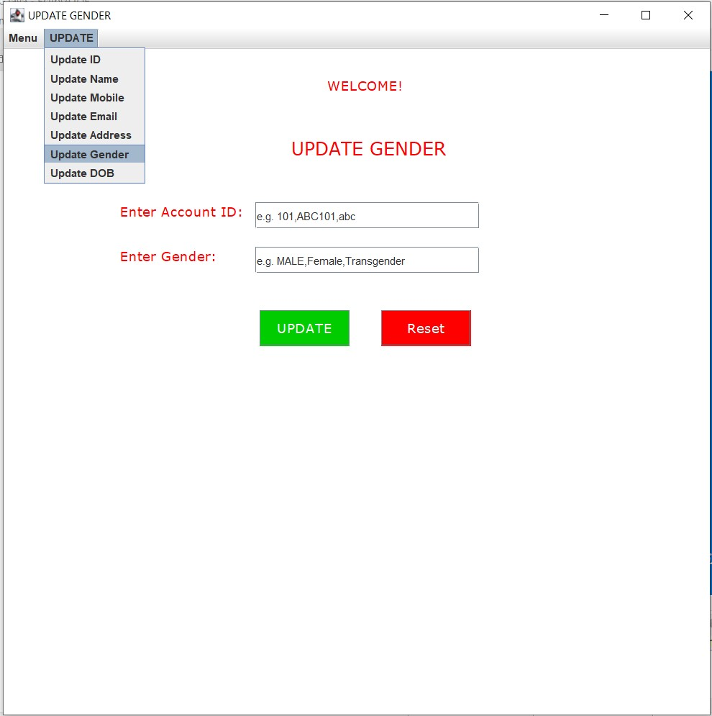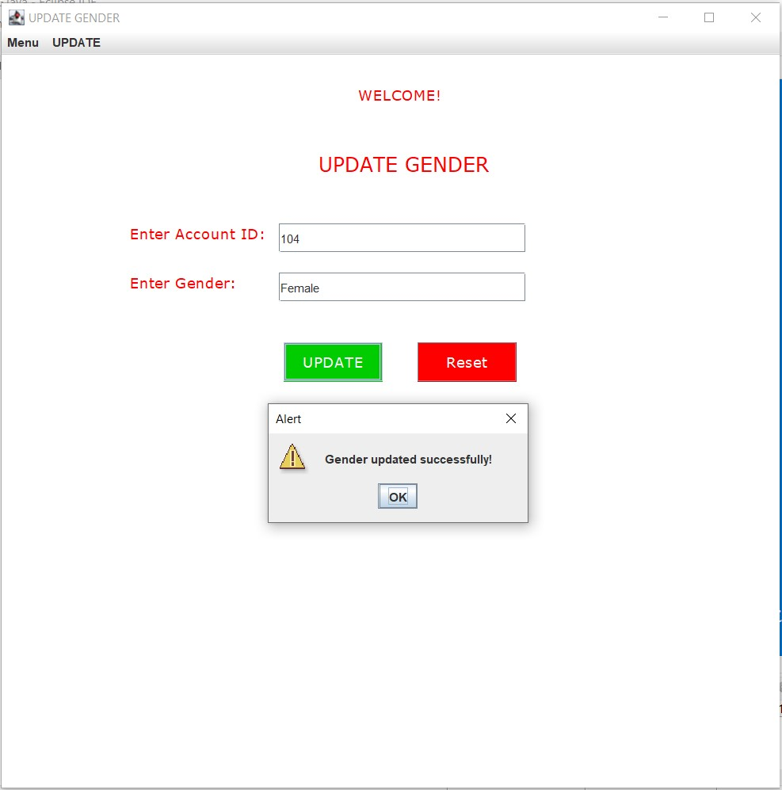

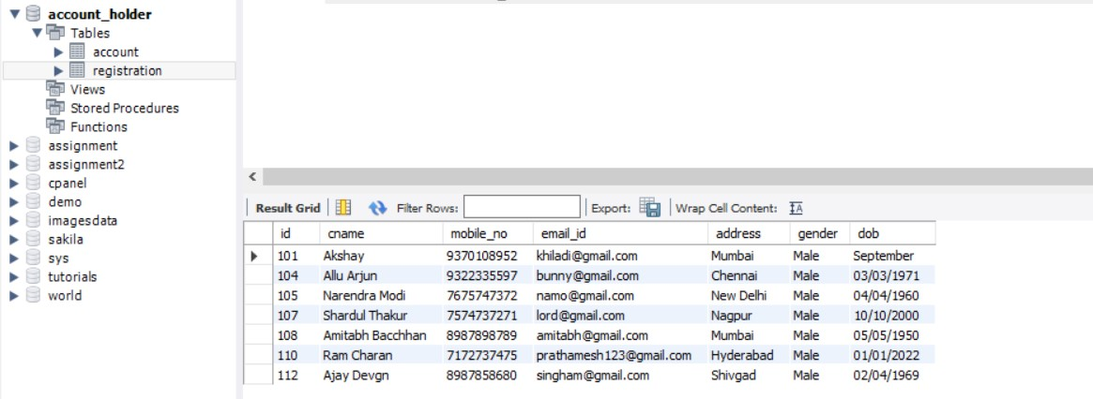

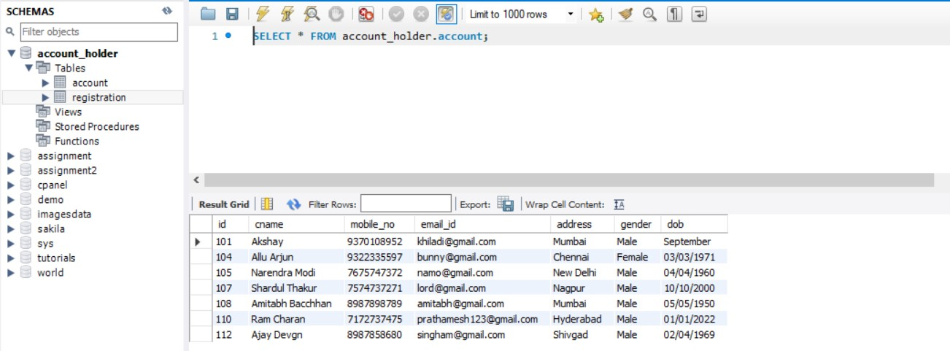

**//UpdateD.java**

**package** com.ahd;

**import** java.awt.Color;

**import** java.awt.Font;

**import** java.awt.event.ActionEvent;

**import** java.awt.event.ActionListener;

**import** java.sql.Connection;

**import** java.sql.DriverManager;

**import** java.sql.PreparedStatement;

**import** java.util.regex.Matcher;

**import** java.util.regex.Pattern;

**import** javax.swing.JButton;

**import** javax.swing.JFrame;

**import** javax.swing.JLabel;

**import** javax.swing.JMenu;

**import** javax.swing.JMenuBar;

**import** javax.swing.JMenuItem;

**import** javax.swing.JOptionPane;

**import** javax.swing.JTextField;

//Main Class

**public** **class** UpdateD **implements** ActionListener{

//Declaring Swing Components

**static** JTextField *tf1*,*tf2*;

**static** JLabel *l1*,*l2*,*l3*,*l4*;

**static** JMenu *menu*,*menu2*;

**static** JMenuBar *mb*;

**static** JMenuItem *item1*, *item2*, *item3*, *item4*,*item01*,*item02*,*item03*,*item04*,*item05*,*item06*,*item07*;

**static** JButton *b1*,*b2*;

**static** JFrame *f*;

//Constructor

**protected** UpdateD() {

//JFrame object declaration

*f* = **new** JFrame("UPDATE DOB");

//JLabel object declaration

*l1*=**new** JLabel("WELCOME!");

*l2*=**new** JLabel("UPDATE DOB");

*l3*=**new** JLabel("Enter Account ID:");

*l4*=**new** JLabel("Enter DOB:");

//JMenuBar object creation

*mb*=**new** JMenuBar();

//JMenu object creation

*menu*=**new** JMenu("Menu");

*menu2*=**new** JMenu("UPDATE");

//JMenuItem object creation

*item1*=**new** JMenuItem("CREATE ACCOUNT");

*item2*=**new** JMenuItem("UPDATE ACCOUNT");

*item3*=**new** JMenuItem("DELETE ACCOUNT");

*item4*=**new** JMenuItem("RETRIEVE ACCOUNT");

*item01*=**new** JMenuItem("Update ID");

*item02*=**new** JMenuItem("Update Name");

*item03*=**new** JMenuItem("Update Mobile");

*item04*=**new** JMenuItem("Update Email");

*item05*=**new** JMenuItem("Update Address");

*item06*=**new** JMenuItem("Update Gender");

*item07*=**new** JMenuItem("Update DOB");

//JTextField object creation

*tf1* = **new** JTextField("e.g. 101,ABC101,abc");

*tf2* = **new** JTextField("e.g. 01/01/2022");

//JButton object creation

*b1* = **new** JButton("UPDATE");

*b2* = **new** JButton("Reset");

//JTextField properties

*tf1*.setBounds(280,170,250,30);

*tf2*.setBounds(280,220,250,30);

//JLabel properties

*l1*.setBounds(360,-10, 300,100);

*l1*.setFont(**new** Font("Verdana", Font.***PLAIN***, 15));

*l1*.setForeground(**new** Color(255, 0, 0));

*l2*.setBounds(330,10, 300,200);

*l2*.setFont(**new** Font("Verdana", Font.***PLAIN***, 20));

*l2*.setForeground(**new** Color(255, 0, 0));

*l3*.setBounds(130,130, 300,100);

*l3*.setFont(**new** Font("Verdana", Font.***PLAIN***, 15));

*l3*.setForeground(**new** Color(255, 0, 0));

*l4*.setBounds(130,180, 300,100);

*l4*.setFont(**new** Font("Verdana", Font.***PLAIN***, 15));

*l4*.setForeground(**new** Color(255, 0, 0));

//JButton properties

*b1*.setBounds(285, 290, 100, 40);

*b1*.setFont(**new** Font("Verdana", Font.***PLAIN***, 15));

*b1*.setForeground(**new** Color(255,255,255));

*b1*.setBackground(**new** Color(0,204,0));

*b2*.setBounds(420, 290, 100, 40);

*b2*.setFont(**new** Font("Verdana", Font.***PLAIN***, 15));

*b2*.setForeground(**new** Color(255,255,255));

*b2*.setBackground(**new** Color(255,0,0));

//Adding menu and menu items

*mb*.add(*menu*);

*mb*.add(*menu2*);

*menu*.add(*item1*);

*menu*.add(*item2*);

*menu*.add(*item3*);

*menu*.add(*item4*);

*menu2*.add(*item01*);

*menu2*.add(*item02*);

*menu2*.add(*item03*);

*menu2*.add(*item04*);

*menu2*.add(*item05*);

*menu2*.add(*item06*);

*menu2*.add(*item07*);

//Adding and setting components of JFrame

*f*.add(*tf1*);

*f*.add(*tf2*);

*f*.add(*l1*);

*f*.add(*l2*);

*f*.add(*l3*);

*f*.add(*l4*);

*f*.add(*b1*);

*f*.add(*b2*);

*f*.setSize(800,800);

*f*.setLayout(**null**);

*f*.setLocationRelativeTo(**null**);

*f*.getContentPane().setBackground(Color.***WHITE***);

*f*.setJMenuBar(*mb*);

*f*.setVisible(**true**);

//ActionListener for Menu and Update

*item1*.addActionListener(**new** ActionListener(){

**public** **void** actionPerformed(ActionEvent e){

**new** CAccount();

}

});;

*item2*.addActionListener(**new** ActionListener(){

**public** **void** actionPerformed(ActionEvent e){

**new** UAccount();

}

});

*item3*.addActionListener(**new** ActionListener(){

**public** **void** actionPerformed(ActionEvent e){

**new** DAccount();

}

});

*item4*.addActionListener(**new** ActionListener(){

**public** **void** actionPerformed(ActionEvent e){

**new** RAccount();

}

});

*item01*.addActionListener(**new** ActionListener(){

**public** **void** actionPerformed(ActionEvent e){

**new** UpdateI();

}

});;

*item02*.addActionListener(**new** ActionListener(){

**public** **void** actionPerformed(ActionEvent e){

**new** UpdateN();

}

});

*item03*.addActionListener(**new** ActionListener(){

**public** **void** actionPerformed(ActionEvent e){

**new** UpdateM();

}

});

*item04*.addActionListener(**new** ActionListener(){

**public** **void** actionPerformed(ActionEvent e){

**new** UpdateE();

}

});

*item05*.addActionListener(**new** ActionListener(){

**public** **void** actionPerformed(ActionEvent e){

**new** UpdateA();

}

});;

*item06*.addActionListener(**new** ActionListener(){

**public** **void** actionPerformed(ActionEvent e){

**new** UpdateG();

}

});

*item07*.addActionListener(**new** ActionListener(){

**public** **void** actionPerformed(ActionEvent e){

**new** UpdateD();

}

});

//ActionListener for JButton

*b1*.addActionListener(**this**);

*b2*.addActionListener(**this**);

}

//Overridden method for ActionListener

@Override

**public** **void** actionPerformed(ActionEvent e) {

//if else condition for performing action depending on button clicked

**if**(e.getSource()==*b1*) {

**try**{

String txt1,txt2;

txt1 = *tf1*.getText();

txt2 = *tf2*.getText();

//Regular Expression

Pattern pt1 = Pattern.*compile*("^[a-zA-Z0-9]{1,10}$");

Pattern pt2 = Pattern.*compile*("^(1[0-2]|0[1-9])\\/(3[01]|[12][0-9]|0[1-9])\\/[0-9]{4}$");

Matcher mtr1 = pt1.matcher(txt1);

Matcher mtr2 = pt2.matcher(txt2);

**boolean** matches1 = mtr1.matches();

**boolean** matches2 = mtr2.matches();

//Database connectivity

Class.*forName*("com.mysql.cj.jdbc.Driver");

Connection con = DriverManager.*getConnection*("jdbc:mysql://localhost:3307/account_holder","root","root");

//Checking Regular Expression

**if**(matches1==**true** && matches2==**true**) {

//DML

PreparedStatement ps = con.prepareStatement("update account set dob = ? WHERE id = ?;");

ps.setString(1,txt2);

ps.setString(2,txt1);

ps.executeUpdate();

JOptionPane.*showMessageDialog*(*f*,"DOB updated successfully!","Alert",JOptionPane.***WARNING_MESSAGE***);

}

**else** {

//Error

JOptionPane.*showMessageDialog*(*f*,"Invalid entry! Re-Enter data.","Alert",JOptionPane.***WARNING_MESSAGE***);

**if**(matches1==**false**){

JOptionPane.*showMessageDialog*(*f*,"Invalid ID!","Alert",JOptionPane.***WARNING_MESSAGE***);

}

**else** **if**(matches2==**false**){

JOptionPane.*showMessageDialog*(*f*,"Invalid DOB!","Alert",JOptionPane.***WARNING_MESSAGE***);

}

**else** {

System.***out***.println("error");

}

}

con.close();

}

**catch**(Exception e1){

System.***out***.println(e1);

}

}

//Reset Logic

**else** **if**(e.getSource()==*b2*) {

*tf1*.setText("");

*tf2*.setText("");

}

**else** {

System.***out***.println("Error");

}

}

//Main method

**public** **static** **void** main(String[] args) {

//Call to constructor

**new** UpdateD();

}

}

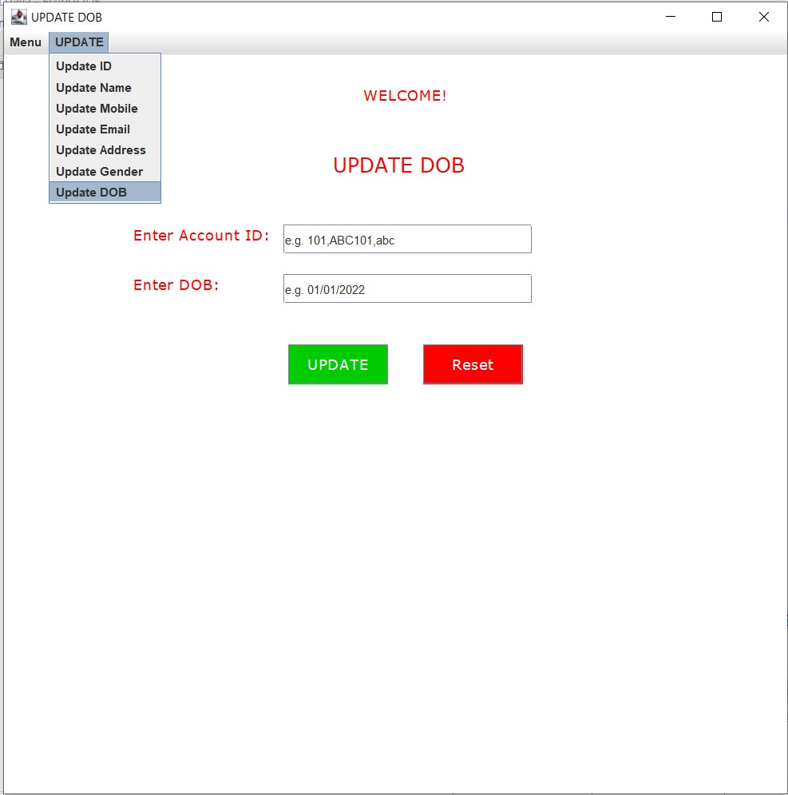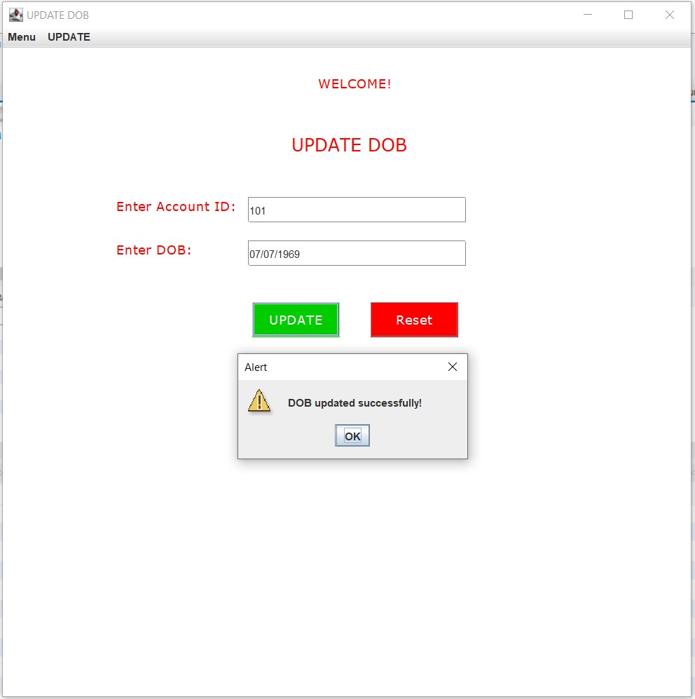

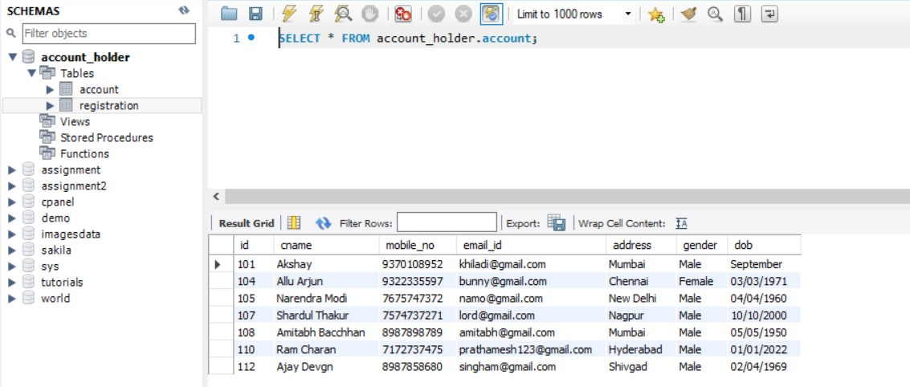

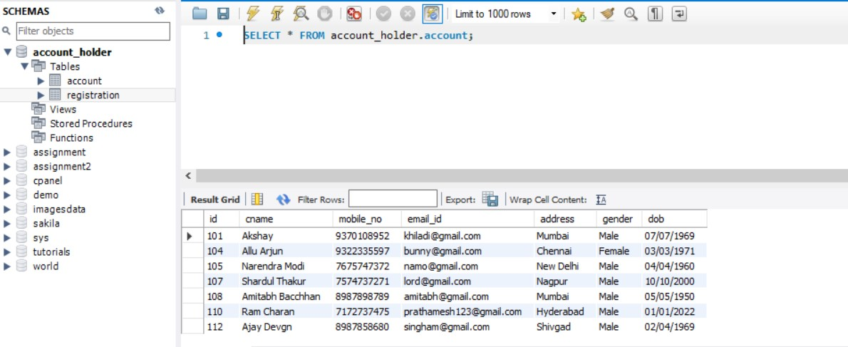

**//DAccount.java**

**package** com.ahd;

**import** java.awt.Color;

**import** java.awt.Font;

**import** java.awt.event.ActionEvent;

**import** java.awt.event.ActionListener;

**import** java.sql.Connection;

**import** java.sql.DriverManager;

**import** java.sql.PreparedStatement;

**import** javax.swing.JButton;

**import** javax.swing.JFrame;

**import** javax.swing.JLabel;

**import** javax.swing.JMenu;

**import** javax.swing.JMenuBar;

**import** javax.swing.JMenuItem;

**import** javax.swing.JOptionPane;

**import** javax.swing.JTextField;

//Main Class

**public** **class** DAccount **implements** ActionListener{

//Declaring Swing Components

**static** JTextField *tf1*;

**static** JLabel *l1*,*l2*,*l3*;

**static** JMenu *menu*;

**static** JMenuBar *mb*;

**static** JMenuItem *item1*, *item2*, *item3*, *item4*;

**static** JButton *b1*,*b2*,*b3*;

**static** JFrame *f*;

//Constructor

**protected** DAccount(){

//JFrame object creation

*f* = **new** JFrame("DELETE ACCOUNT");

//JMenuBar object creation

*mb*=**new** JMenuBar();

//JMenu object creation

*menu*=**new** JMenu("Menu");

//JMenu object creation

*item1*=**new** JMenuItem("CREATE ACCOUNT");

*item2*=**new** JMenuItem("UPDATE ACCOUNT");

*item3*=**new** JMenuItem("DELETE ACCOUNT");

*item4*=**new** JMenuItem("RETRIEVE ACCOUNT");

//JLabel object creation

*l1*=**new** JLabel("WELCOME!");

*l2*=**new** JLabel("DELETE ACCOUNT");

*l3*=**new** JLabel("Enter Account ID:");

//JTextField object creation

*tf1* = **new** JTextField();

//JButton object creation

*b1* = **new** JButton("Delete Specific");

*b2* = **new** JButton("Delete All");

*b3* = **new** JButton("Reset");

//JLabel properties

*l1*.setBounds(360,-10, 300,100);

*l1*.setFont(**new** Font("Verdana", Font.***PLAIN***, 15));

*l1*.setForeground(**new** Color(255, 0, 0));

*l2*.setBounds(310,10, 300,200);

*l2*.setFont(**new** Font("Verdana", Font.***PLAIN***, 20));

*l2*.setForeground(**new** Color(255, 0, 0));

*l3*.setBounds(130,230, 300,100);

*l3*.setFont(**new** Font("Verdana", Font.***PLAIN***, 15));

*l3*.setForeground(**new** Color(255, 0, 0));

//JTextField properties

*tf1*.setBounds(280,270,250,30);

//JButton properties

*b1*.setBounds(100, 370, 160, 40);

*b1*.setFont(**new** Font("Verdana", Font.***PLAIN***, 15));

*b1*.setForeground(**new** Color(255,255,255));

*b1*.setBackground(**new** Color(255,0,0));

*b2*.setBounds(290, 370, 140, 40);

*b2*.setFont(**new** Font("Verdana", Font.***PLAIN***, 15));

*b2*.setForeground(**new** Color(255,255,255));

*b2*.setBackground(**new** Color(255,0,0));

*b3*.setBounds(480, 370, 130, 40);

*b3*.setFont(**new** Font("Verdana", Font.***PLAIN***, 15));

*b3*.setForeground(**new** Color(255,255,255));

*b3*.setBackground(**new** Color(255,0,0));

//Adding menu and menu items

*menu*.add(*item1*);

*menu*.add(*item2*);

*menu*.add(*item3*);

*menu*.add(*item4*);

*mb*.add(*menu*);

//Adding and setting components of JFrame

*f*.add(*tf1*);

*f*.add(*l1*);

*f*.add(*l2*);

*f*.add(*l3*);

*f*.add(*b1*);

*f*.add(*b2*);

*f*.add(*b3*);

*f*.setSize(800,800);

*f*.setLayout(**null**);

*f*.setLocationRelativeTo(**null**);

*f*.getContentPane().setBackground(Color.***WHITE***);

*f*.setJMenuBar(*mb*);

*f*.setVisible(**true**);

//ActionListener for Menu

*item1*.addActionListener(**new** ActionListener(){

**public** **void** actionPerformed(ActionEvent e){

**new** CAccount();

}

});;

*item2*.addActionListener(**new** ActionListener(){

**public** **void** actionPerformed(ActionEvent e){

**new** UAccount();

}

});

*item3*.addActionListener(**new** ActionListener(){

**public** **void** actionPerformed(ActionEvent e){

**new** DAccount();

}

});

*item4*.addActionListener(**new** ActionListener(){

**public** **void** actionPerformed(ActionEvent e){

**new** RAccount();

}

});

//ActionListener for JButton

*b1*.addActionListener(**this**);

*b2*.addActionListener(**this**);

*b3*.addActionListener(**this**);

}

//Overridden method for ActionListener

@Override

**public** **void** actionPerformed(ActionEvent e) {

//if-else condition for performing action depending on button clicked

//Deleting specific record

**if**(e.getSource()==*b1*) {

**try**{

String txt1;

txt1 = *tf1*.getText();

//Database connectivity

Class.*forName*("com.mysql.cj.jdbc.Driver");

Connection con = DriverManager.*getConnection*("jdbc:mysql://localhost:3307/account_holder","root","root");

//DML

PreparedStatement ps = con.prepareStatement("delete from account where id=?");

ps.setString(1,txt1);

ps.executeUpdate();

JOptionPane.*showMessageDialog*(*f*,"Account deleted successfully!","Alert",JOptionPane.***WARNING_MESSAGE***);

con.close();

}

**catch**(Exception e1){

System.***out***.println(e1);

}

}

//Deleting all records

**else** **if**(e.getSource()==*b2*) {

**try**{

//Database connectivity

Class.*forName*("com.mysql.cj.jdbc.Driver");

Connection con = DriverManager.*getConnection*("jdbc:mysql://localhost:3307/account_holder","root","root");

//DML

PreparedStatement ps = con.prepareStatement("delete from account");

ps.executeUpdate();

JOptionPane.*showMessageDialog*(*f*,"All accounts deleted successfully!","Alert",JOptionPane.***WARNING_MESSAGE***);

con.close();

}

**catch**(Exception e1){

System.***out***.println(e1);

}

}

//Reset Logic

**else** **if**(e.getSource()==*b3*){

*tf1*.setText("");

}

**else** {

System.***out***.println("Error");

}

}

//Main method

**public** **static** **void** main(String args[]) {

//Call to constructor

**new** DAccount();

}

}

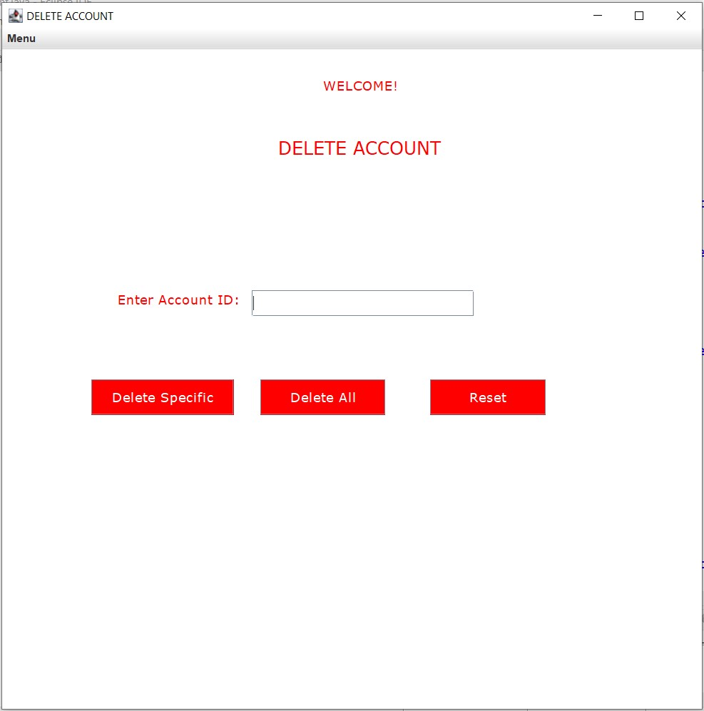

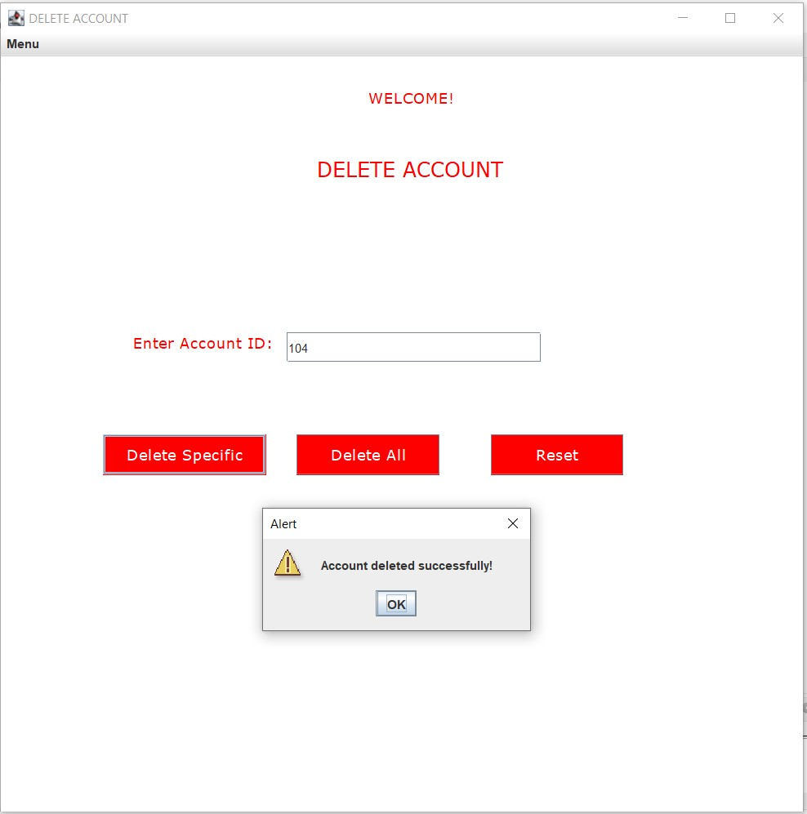

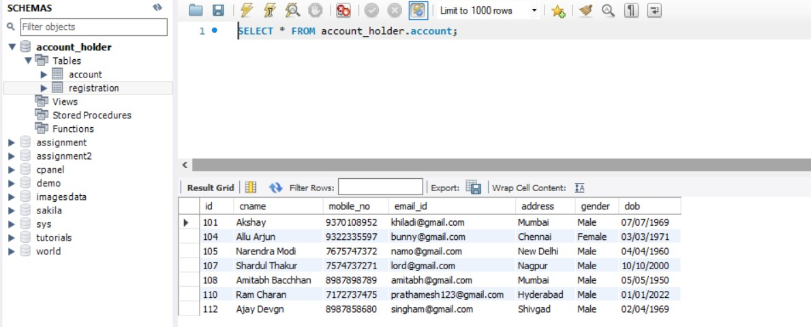

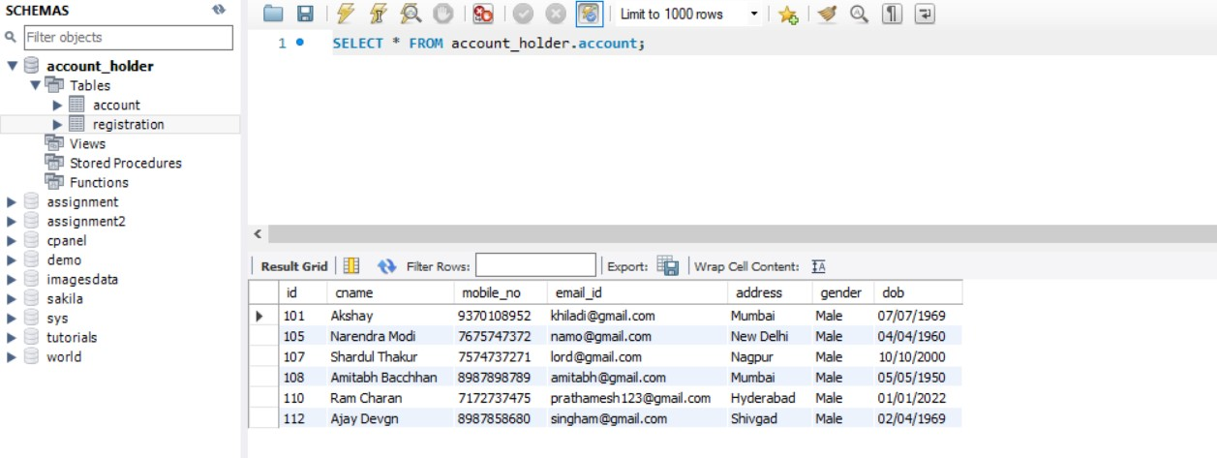

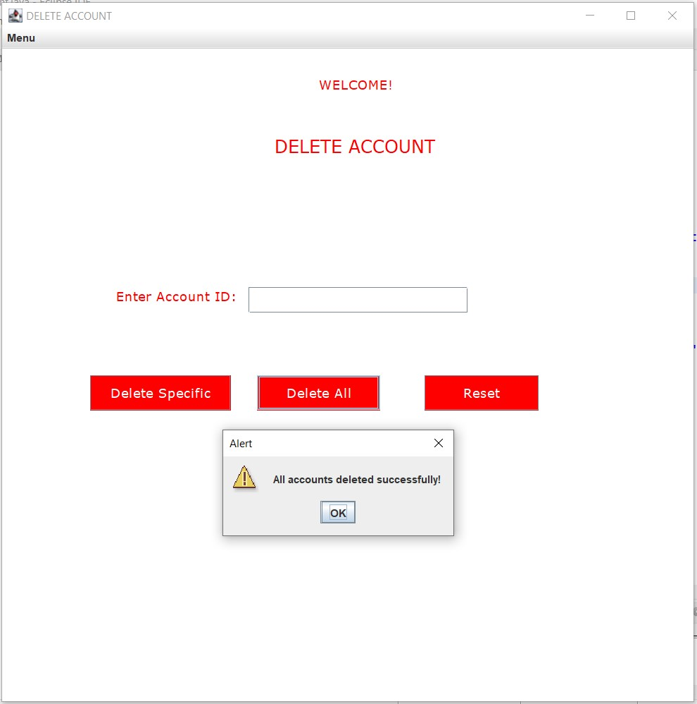

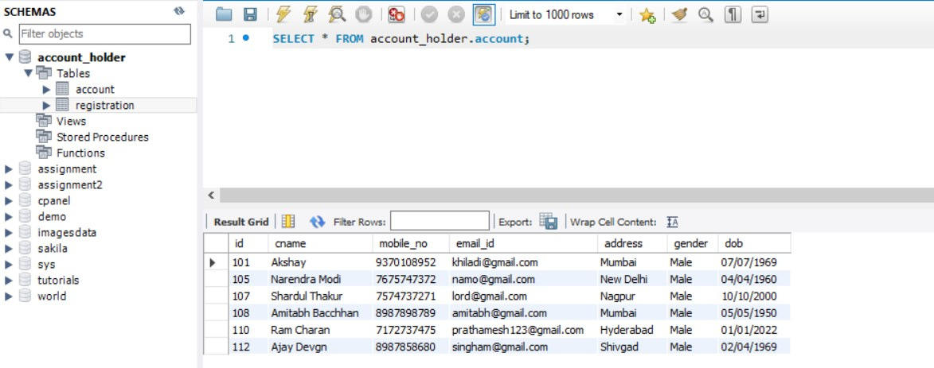

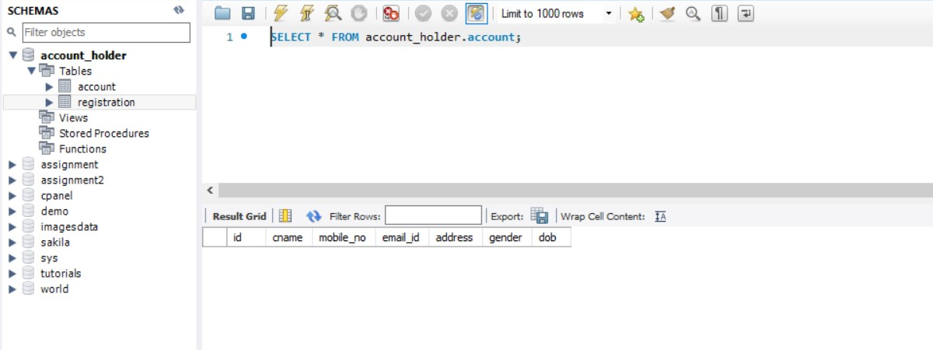

**//RAccount.java**

**package** com.ahd;

**import** java.awt.Color;

**import** java.awt.Font;

**import** java.awt.event.ActionEvent;

**import** java.awt.event.ActionListener;

**import** java.sql.Connection;

**import** java.sql.DriverManager;

**import** java.sql.PreparedStatement;

**import** java.sql.ResultSet;

**import** javax.swing.JButton;

**import** javax.swing.JFrame;

**import** javax.swing.JLabel;

**import** javax.swing.JMenu;

**import** javax.swing.JMenuBar;

**import** javax.swing.JMenuItem;

**import** javax.swing.JTable;

**import** javax.swing.JTextField;

//Main Class

**public** **class** RAccount **implements** ActionListener{

//Declaring Swing Components

**static** JLabel *l1*,*l2*,*l3*;

**static** JMenu *menu*;

**static** JMenuBar *mb*;

**static** JMenuItem *item1*, *item2*, *item3*, *item4*;

**static** JButton *b1*,*b2*,*b3*;

**static** JTextField *tf1*;

**static** JTable *jt*;

**static** JFrame *f*;

//Constructor

**protected** RAccount(){

//JFrame object creation

*f* = **new** JFrame("RETRIEVE ACCOUNTS");

//JMenuBar object creation

*mb*=**new** JMenuBar();

//JMenu object creation

*menu*=**new** JMenu("Menu");

//JMenuItem object creation

*item1*=**new** JMenuItem("CREATE ACCOUNT");

*item2*=**new** JMenuItem("UPDATE ACCOUNT");

*item3*=**new** JMenuItem("DELETE ACCOUNT");

*item4*=**new** JMenuItem("RETRIEVE ACCOUNT");

//JLabel object creation

*l1*=**new** JLabel("WELCOME!");

*l2*=**new** JLabel("RETRIEVE ACCOUNTS");

*l3*=**new** JLabel("Enter Account ID:");

//JTextField object creation

*tf1* = **new** JTextField();

//JButton object creation

*b1* = **new** JButton("Retrieve Specific");

*b2* = **new** JButton("Retrieve All");

*b3* = **new** JButton("Reset");

//JLabel properties

*l1*.setBounds(360,-10, 300,100);

*l1*.setFont(**new** Font("Verdana", Font.***PLAIN***, 15));

*l1*.setForeground(**new** Color(255, 0, 0));

*l2*.setBounds(300,10, 300,200);

*l2*.setFont(**new** Font("Verdana", Font.***PLAIN***, 20));

*l2*.setForeground(**new** Color(255, 0, 0));

*l3*.setBounds(130,130, 300,100);

*l3*.setFont(**new** Font("Verdana", Font.***PLAIN***, 15));

*l3*.setForeground(**new** Color(255, 0, 0));

//JTextField properties

*tf1*.setBounds(280,170,250,30);

//JButton properties

*b1*.setBounds(130, 250, 180, 40);

*b1*.setFont(**new** Font("Verdana", Font.***PLAIN***, 15));

*b1*.setForeground(**new** Color(255,255,255));

*b1*.setBackground(**new** Color(0,204,0));

*b2*.setBounds(330, 250, 150, 40);

*b2*.setFont(**new** Font("Verdana", Font.***PLAIN***, 15));

*b2*.setForeground(**new** Color(255,255,255));

*b2*.setBackground(**new** Color(0,204,0));

*b3*.setBounds(530, 250, 150, 40);

*b3*.setFont(**new** Font("Verdana", Font.***PLAIN***, 15));

*b3*.setForeground(**new** Color(255,255,255));

*b3*.setBackground(**new** Color(255,0,0));

//Adding menu bar and menu items to menu

*menu*.add(*item1*);

*menu*.add(*item2*);

*menu*.add(*item3*);

*menu*.add(*item4*);

*mb*.add(*menu*);

//Adding and setting components to JFrame

*f*.add(*l1*);

*f*.add(*l2*);

*f*.add(*l3*);

*f*.add(*tf1*);

*f*.add(*b1*);

*f*.add(*b2*);

*f*.add(*b3*);

*f*.setSize(800,800);

*f*.setLayout(**null**);

*f*.setLocationRelativeTo(**null**);

*f*.getContentPane().setBackground(Color.***WHITE***);

*f*.setJMenuBar(*mb*);

*f*.setVisible(**true**);

//ActionListener for menu items

*item1*.addActionListener(**new** ActionListener(){

**public** **void** actionPerformed(ActionEvent e){

**new** CAccount();

}

});;

*item2*.addActionListener(**new** ActionListener(){

**public** **void** actionPerformed(ActionEvent e){

**new** UAccount();

}

});

*item3*.addActionListener(**new** ActionListener(){

**public** **void** actionPerformed(ActionEvent e){

**new** DAccount();

}

});

*item4*.addActionListener(**new** ActionListener(){

**public** **void** actionPerformed(ActionEvent e){

**new** RAccount();

}

});

//ActionListener for buttons

*b1*.addActionListener(**this**);

*b2*.addActionListener(**this**);

*b3*.addActionListener(**this**);

}

//Overridden method for ActionListener

@Override

**public** **void** actionPerformed(ActionEvent e) {

//if-else condition to perform action depending on button clicked

//Retrieving only specific user details

**if**(e.getSource()==*b1*) {

**try**{

String txt1;

//Retrieving account id

txt1 = *tf1*.getText();

//Storing columns names present in db table in array to pass it to JTable

String columns[] = {"id","cname","mobile_no","email_id","address","gender","dob"};

//Database Connectivity

Class.*forName*("com.mysql.cj.jdbc.Driver");

Connection con = DriverManager.*getConnection*("jdbc:mysql://localhost:3307/account_holder","root","root");

//DML

PreparedStatement ps1 = con.prepareStatement("select * from account where id=?");

PreparedStatement ps2 = con.prepareStatement("select count(*) from account");

ps1.setString(1,txt1);

ResultSet rs1 = ps1.executeQuery();

ResultSet rs2 = ps2.executeQuery();

rs2.next();

//Storing DB data record

String data[][] = **new** String[1][7];

//Creating object of JTable

*jt* = **new** JTable(data,columns);

//Adding JTable to JFrame

*f*.add(*jt*);

//Properties of JTable

*jt*.setBounds(30,320,700,1000);

*jt*.getColumnModel().getColumn(0).setPreferredWidth(200);

*jt*.getColumnModel().getColumn(1).setPreferredWidth(600);

*jt*.getColumnModel().getColumn(2).setPreferredWidth(600);

*jt*.getColumnModel().getColumn(3).setPreferredWidth(900);

*jt*.getColumnModel().getColumn(4).setPreferredWidth(600);

*jt*.getColumnModel().getColumn(5).setPreferredWidth(600);

*jt*.getColumnModel().getColumn(6).setPreferredWidth(600);

**int** i=0;

//Retrieving data from DB

**while**(rs1.next()) {

String id = rs1.getString("id");

String cname = rs1.getString("cname");

String mobile_no = rs1.getString("mobile_no");

String email_id = rs1.getString("email_id");

String address = rs1.getString("address");

String gender = rs1.getString("gender");

String dob = rs1.getString("dob");

data[i][0] = id;

data[i][1] = cname;

data[i][2] = mobile_no;

data[i][3] = email_id;

data[i][4] = address;

data[i][5] = gender;

data[i][6] = dob;

i++;

}

con.close();

}

**catch**(Exception e1){

System.***out***.println(e1);

}

}

//Retrieving all users data

**else** **if**(e.getSource()==*b2*) {

**try**{

**int** rowscount=0;

//Storing columns names present in db table in array to pass it to JTable

String columns[] = {"id","cname","mobile_no","email_id","address","gender","dob"};

//Database Connectivity

Class.*forName*("com.mysql.cj.jdbc.Driver");

Connection con = DriverManager.*getConnection*("jdbc:mysql://localhost:3307/account_holder","root","root");

//DML

PreparedStatement ps1 = con.prepareStatement("select * from account");

PreparedStatement ps2 = con.prepareStatement("select count(*) from account");

ResultSet rs1 = ps1.executeQuery();

ResultSet rs2 = ps2.executeQuery();

rs2.next();

//Getting rows count for setting row size

rowscount = rs2.getInt("count(*)");

//Storing DB data record

String data[][] = **new** String[rowscount][7];

//Creating object of JTable

*jt* = **new** JTable(data,columns);

//Adding JTable to JFrame

*f*.add(*jt*);

//Properties of JTable

*jt*.setBounds(30,320,700,1000);

*jt*.getColumnModel().getColumn(0).setPreferredWidth(200);

*jt*.getColumnModel().getColumn(1).setPreferredWidth(600);

*jt*.getColumnModel().getColumn(2).setPreferredWidth(600);

*jt*.getColumnModel().getColumn(3).setPreferredWidth(900);

*jt*.getColumnModel().getColumn(4).setPreferredWidth(600);

*jt*.getColumnModel().getColumn(5).setPreferredWidth(600);

*jt*.getColumnModel().getColumn(6).setPreferredWidth(600);

**int** i=0;

//Retrieving data from DB

**while**(rs1.next()) {

String id = rs1.getString("id");

String cname = rs1.getString("cname");

String mobile_no = rs1.getString("mobile_no");

String email_id = rs1.getString("email_id");

String address = rs1.getString("address");

String gender = rs1.getString("gender");

String dob = rs1.getString("dob");

data[i][0] = id;

data[i][1] = cname;

data[i][2] = mobile_no;

data[i][3] = email_id;

data[i][4] = address;

data[i][5] = gender;

data[i][6] = dob;

i++;

}

con.close();

}

**catch**(Exception e1){

System.***out***.println(e1);

}

}

//Reset Logic

**else** **if**(e.getSource()==*b3*){

*tf1*.setText("");

}

**else** {

System.***out***.println("Error");

}

}

//Main method

**public** **static** **void** main(String args[]) {

//Call to constructor

**new** RAccount();

}

}

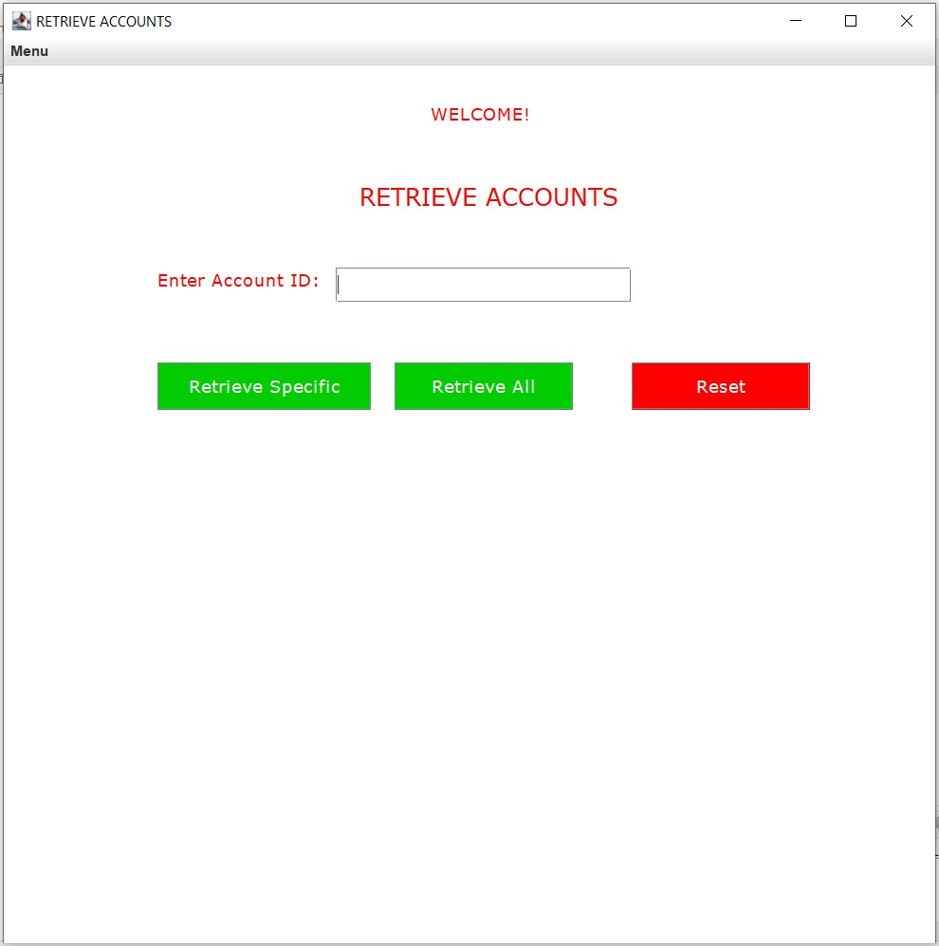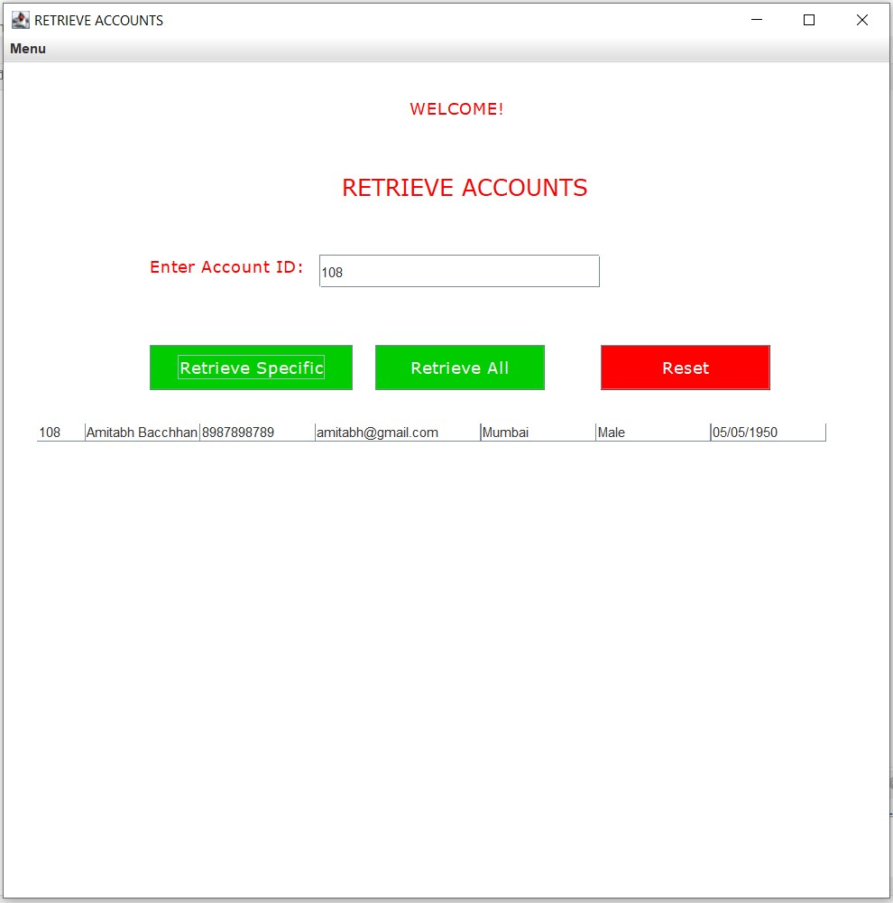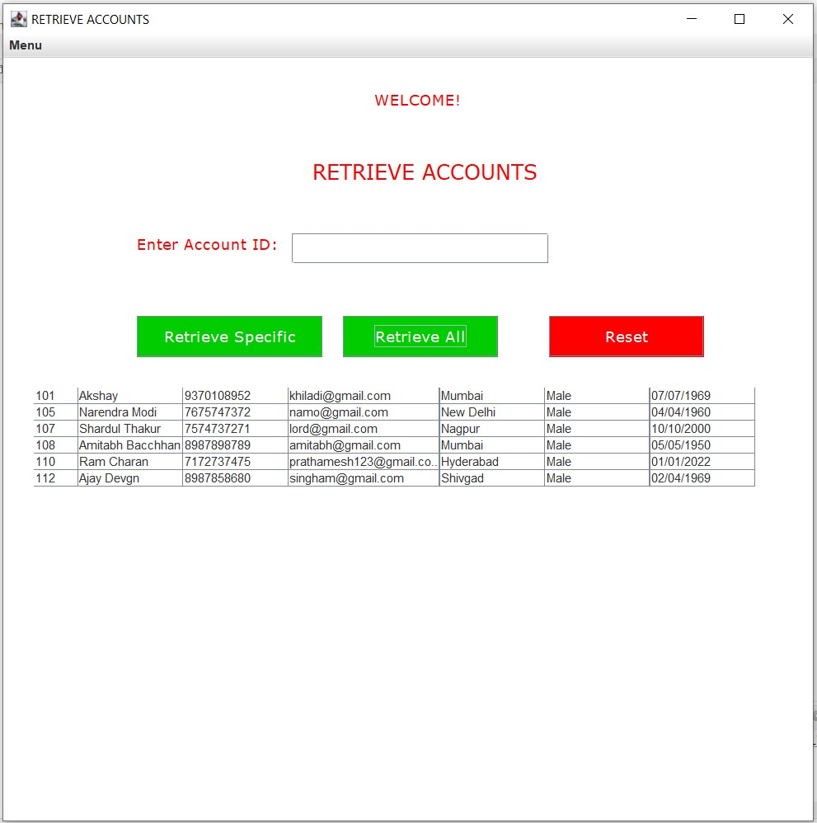

END